Python for Data Science and AI

**About this Course**

This introduction to Python will kickstart your learning of Python for data science, as well as programming in general. This beginner-friendly Python course will take you from zero to programming in Python in a matter of hours.

Module 1 - Python Basics o Your first program o Types o Expressions and Variables o String Operations.

Module 2 - Python Data Structures o Lists and Tuples o Sets o Dictionaries.

Module 3 - Python Programming Fundamentals o Conditions and Branching o Loops o Functions o Objects and Classes.

Module 4 - Working with Data in Python o Reading files with open o Writing files with open o Loading data with Pandas o Numpy.

Finally, you will create a project to test your skills.

Data Types-

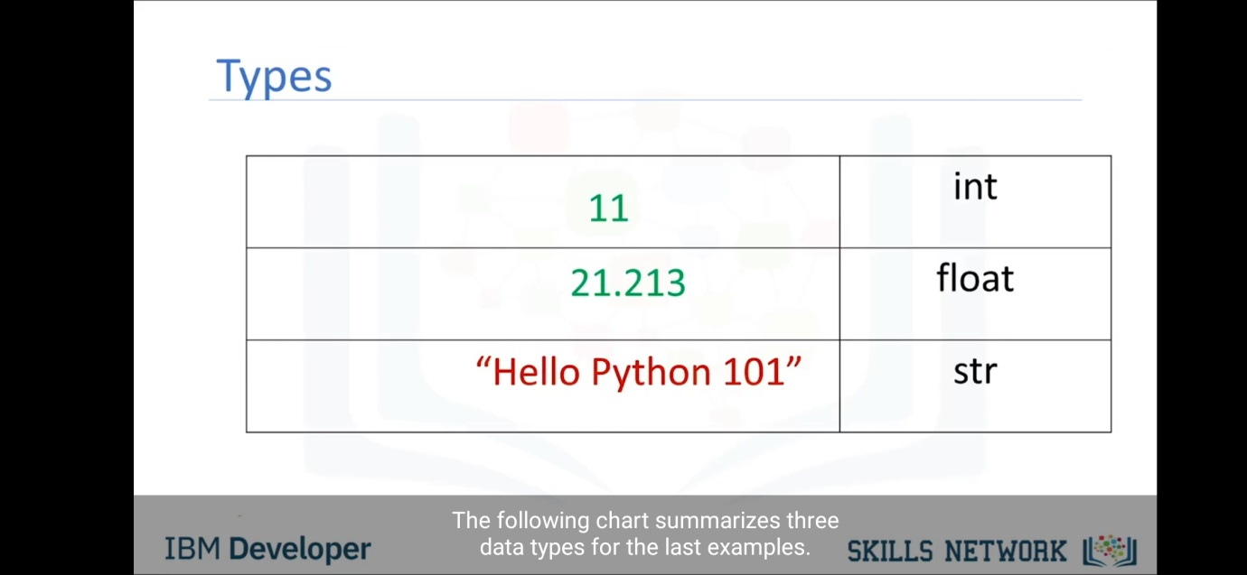

11 is expression and int is data type.

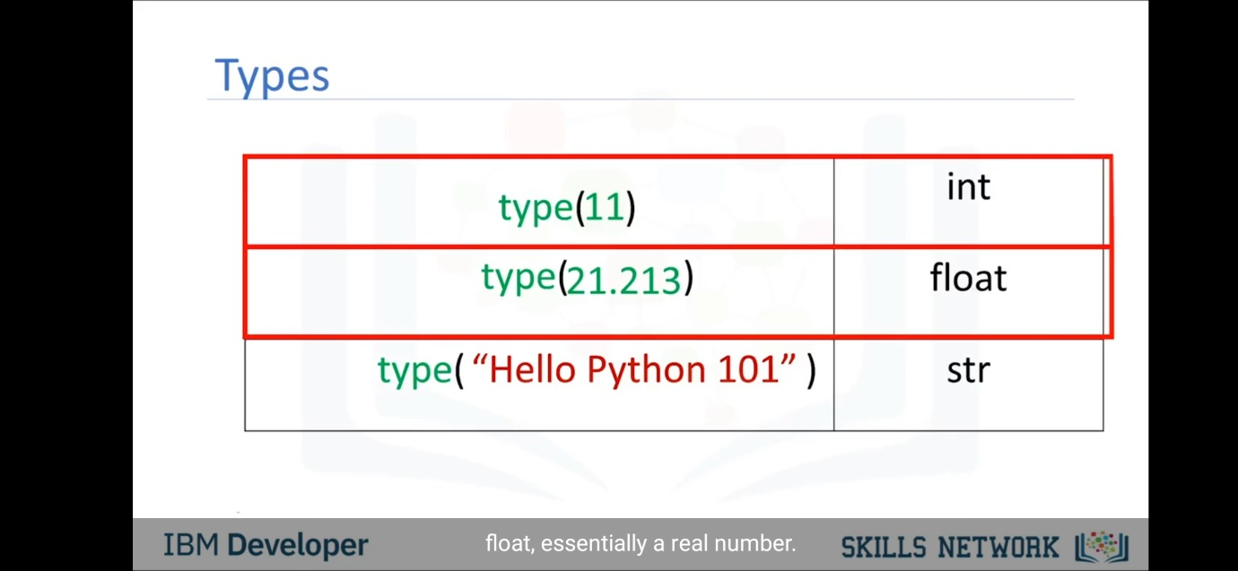

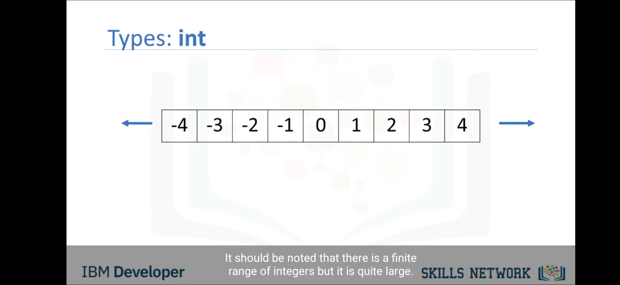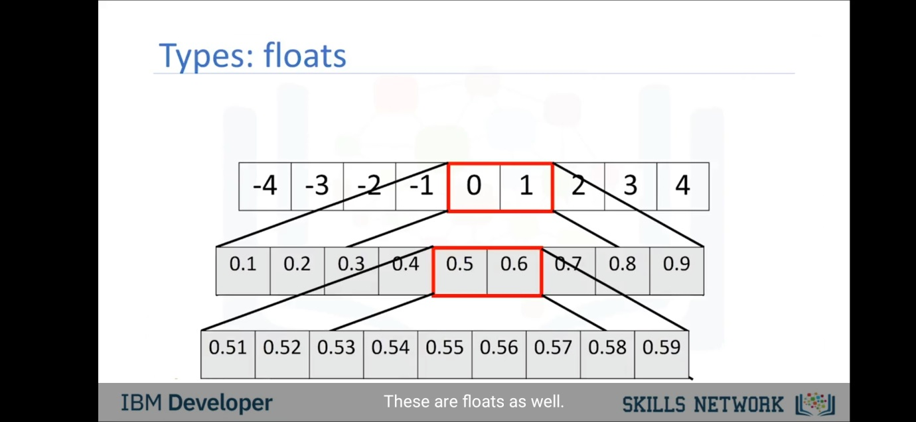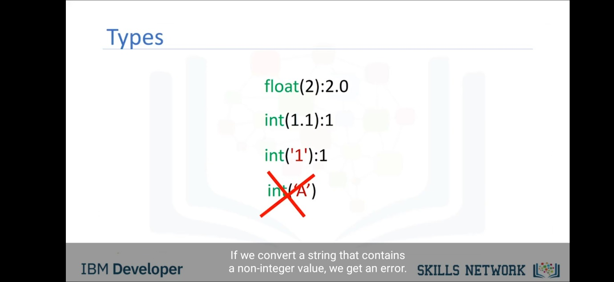

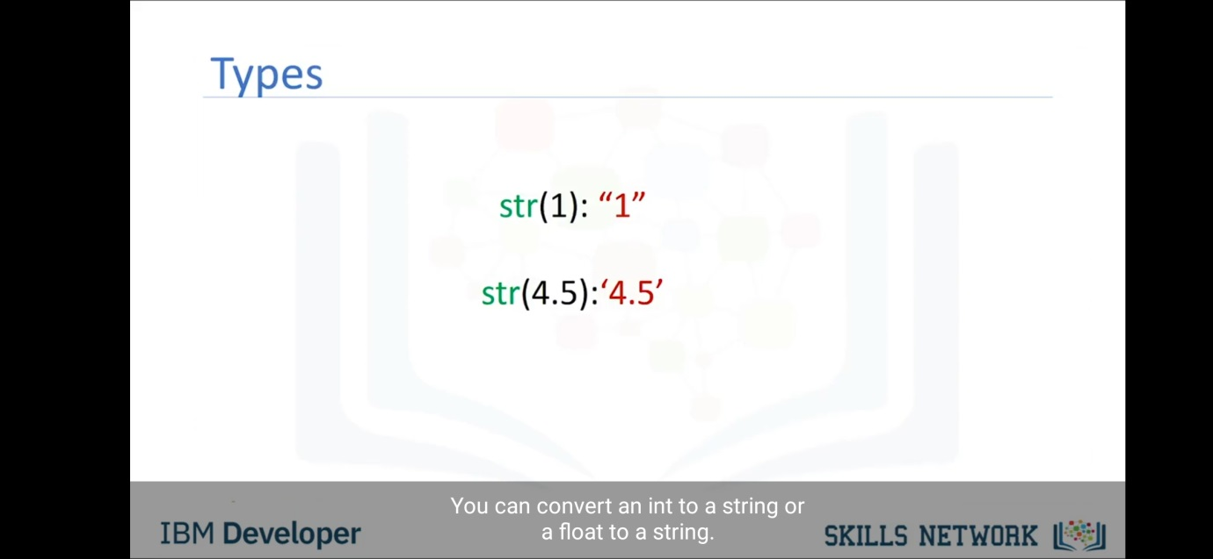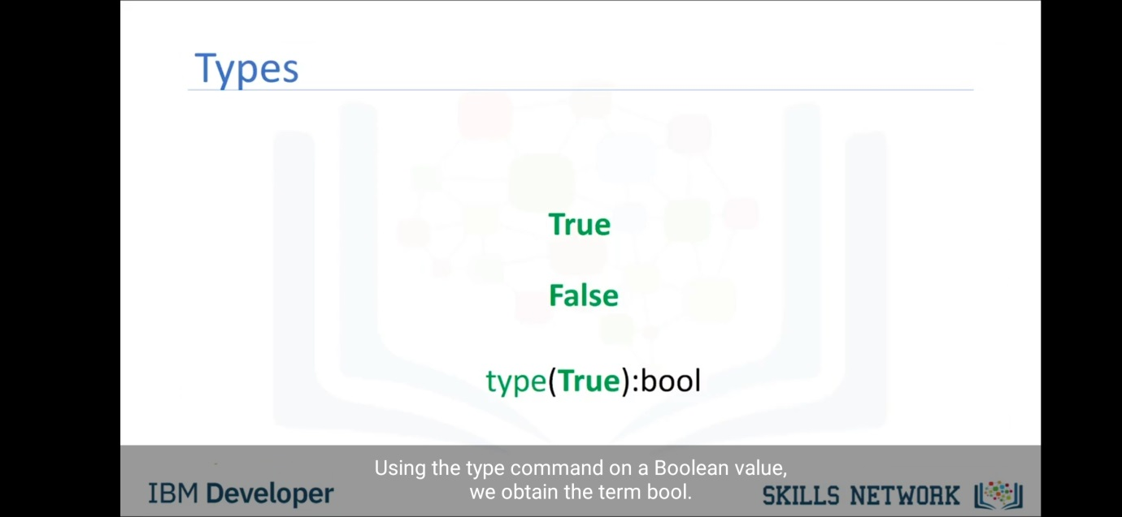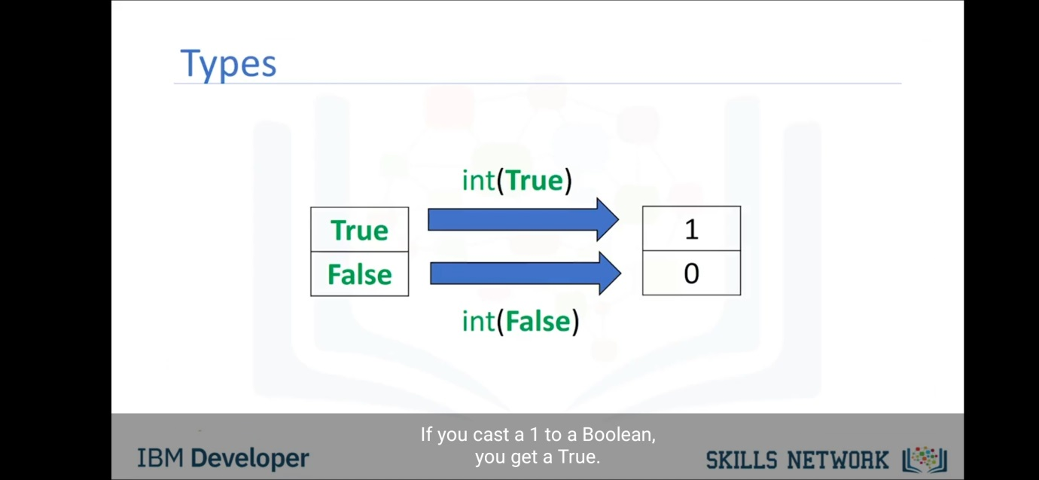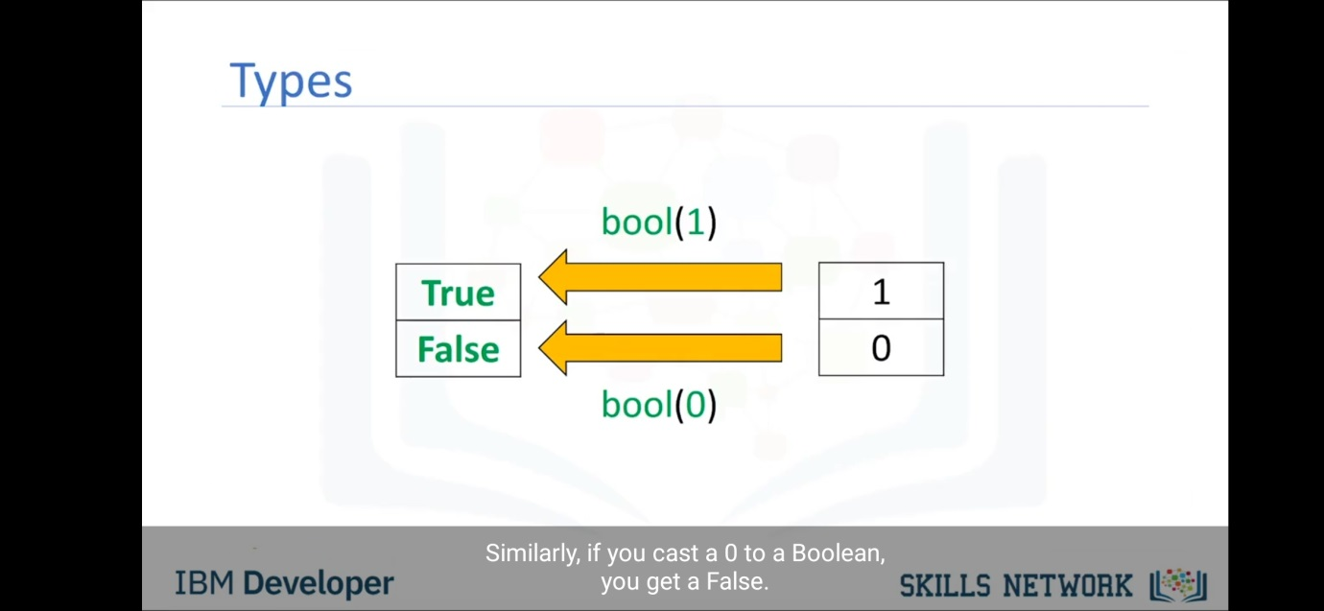

**Arithmetic Operators**

The following table lists the arithmetic operators supported by Python:

| **Operator** | **Example** | **Meaning** | **Result** |
| --- | --- | --- | --- |
| + (unary) | +a | **Unary Positive** | a In other words, it doesn’t really do anything. It mostly exists for the sake of completeness, to complement **Unary Negation**. |
| + (binary) | a + b | **Addition** | Sum of a and b |
| - (unary) | -a | **Unary Negation** | Value equal to a but opposite in sign |
| - (binary) | a - b | **Subtraction** | b subtracted from a |
| * | a * b | **Multiplication** | Product of a and b |
| / | a / b | **Division** | Quotient when a is divided by b. The result always has type float. |
| % | a % b | **Modulo** | Remainder when a is divided by b |
| // | a // b | **Floor Division** (also called **Integer Division**) | Quotient when a is divided by b, rounded to the next smallest whole number |
| ** | a ** b | **Exponentiation** | a raised to the power of b |

**Comparison Operators**

| **Operator** | **Example** | **Meaning** | **Result** |
| --- | --- | --- | --- |
| == | a == b | **Equal to** | True if the value of a is equal to the value of b False otherwise |
| != | a != b | **Not equal to** | True if a is not equal to b False otherwise |
| < | a < b | **Less than** | True if a is less than b False otherwise |
| <= | a <= b | **Less than or equal to** | True if a is less than or equal to b False otherwise |
| > | a > b | **Greater than** | True if a is greater than b False otherwise |
| >= | a >= b | **Greater than or equal to** | True if a is greater than or equal to b False otherwise |

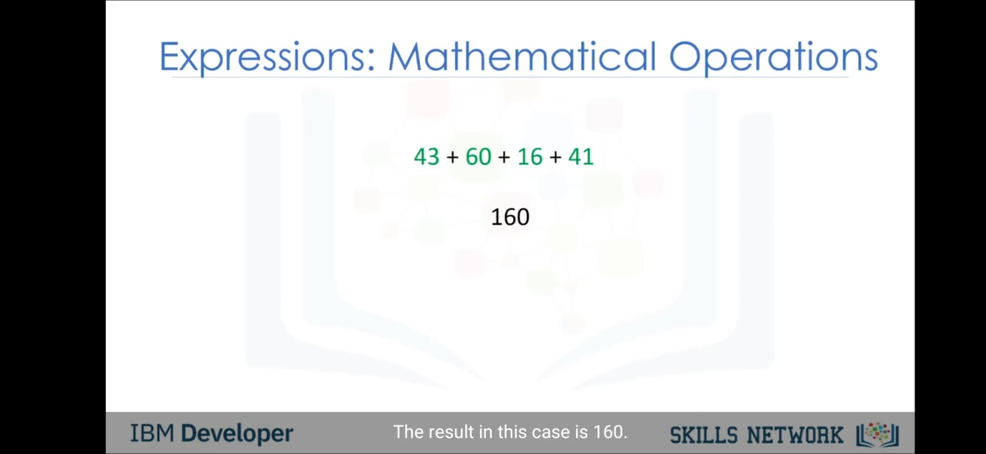

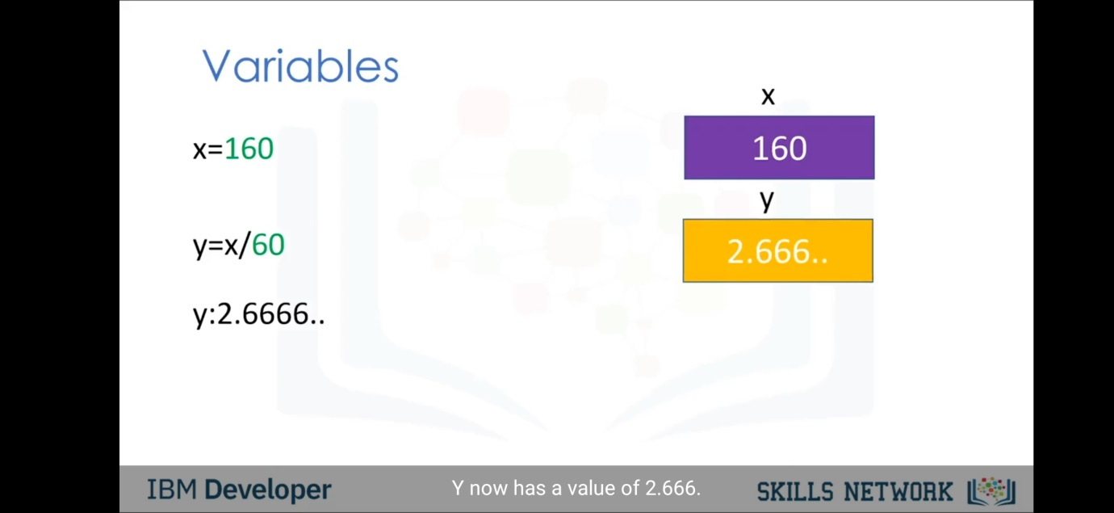

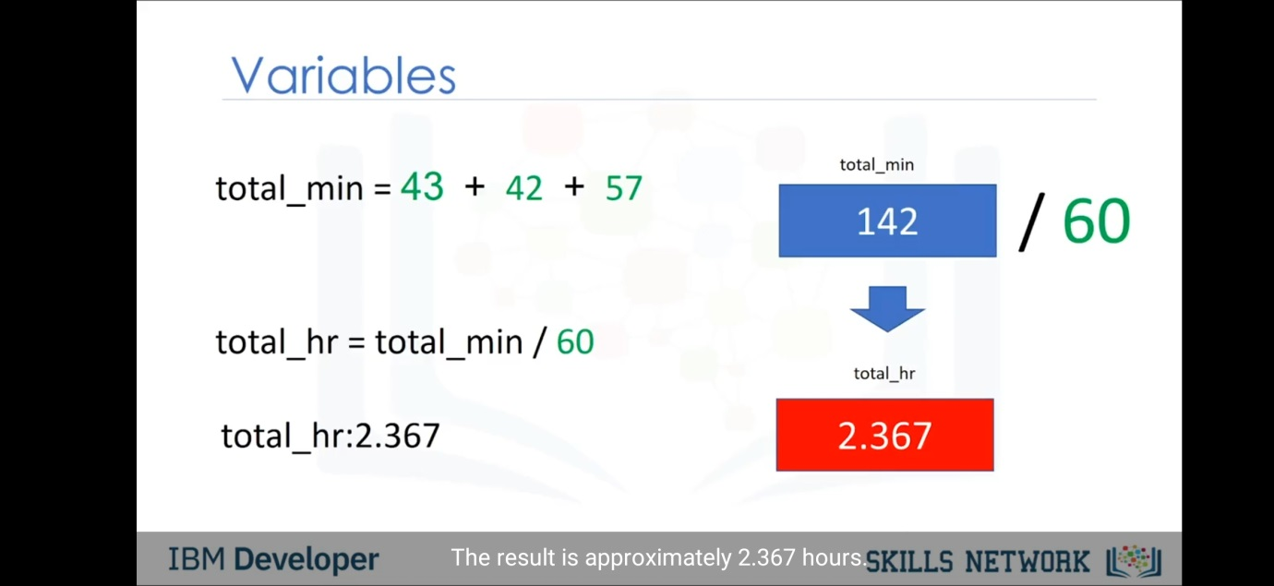

Strings-

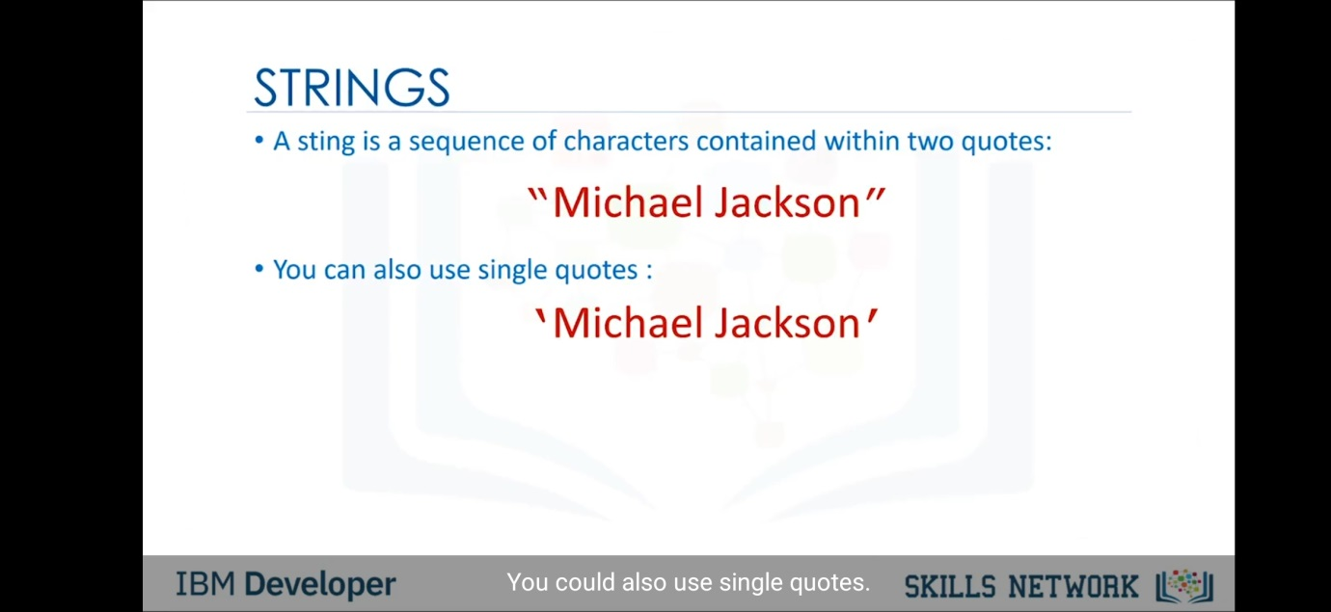

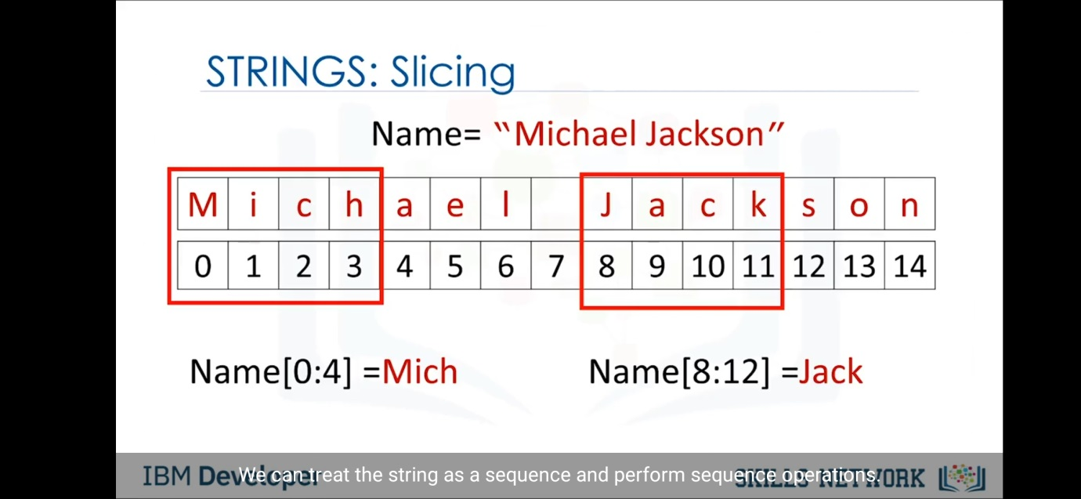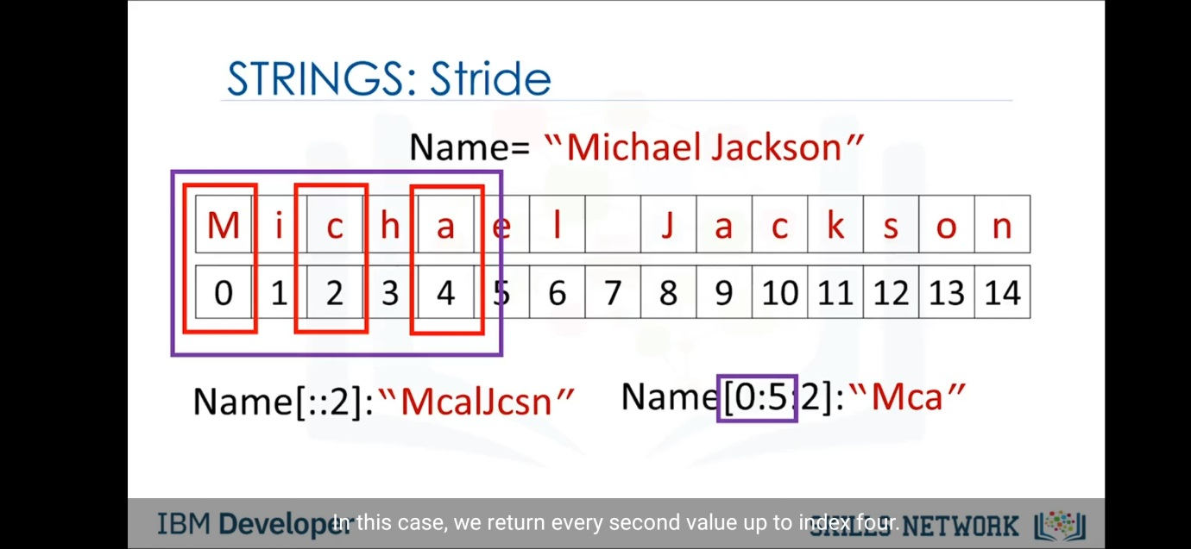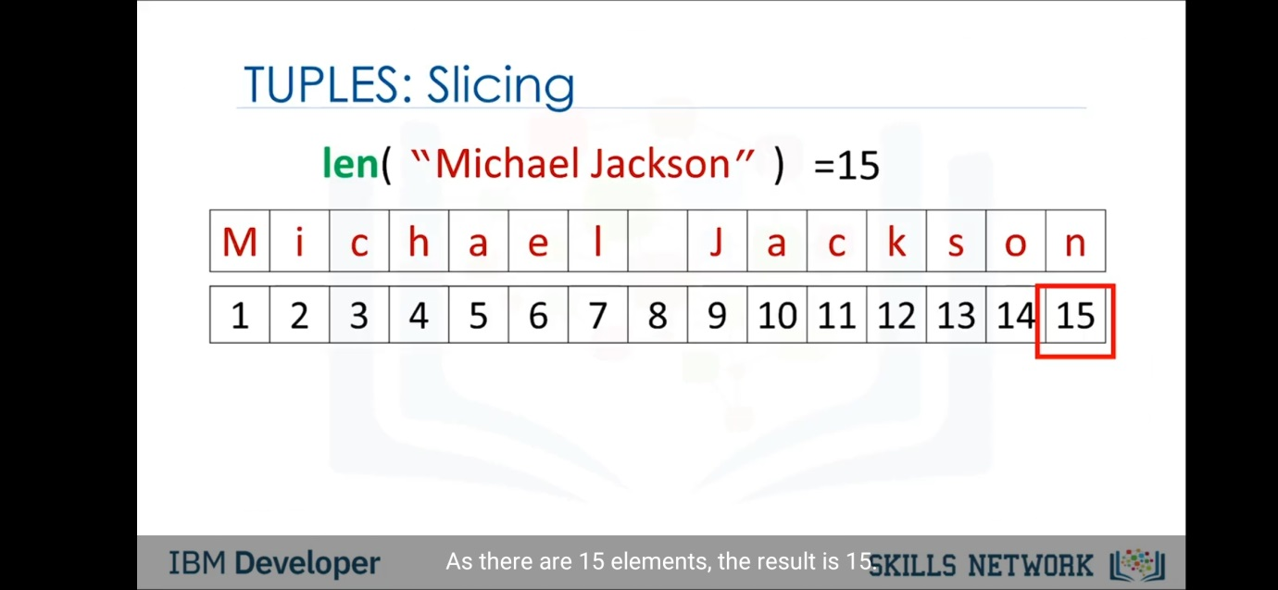

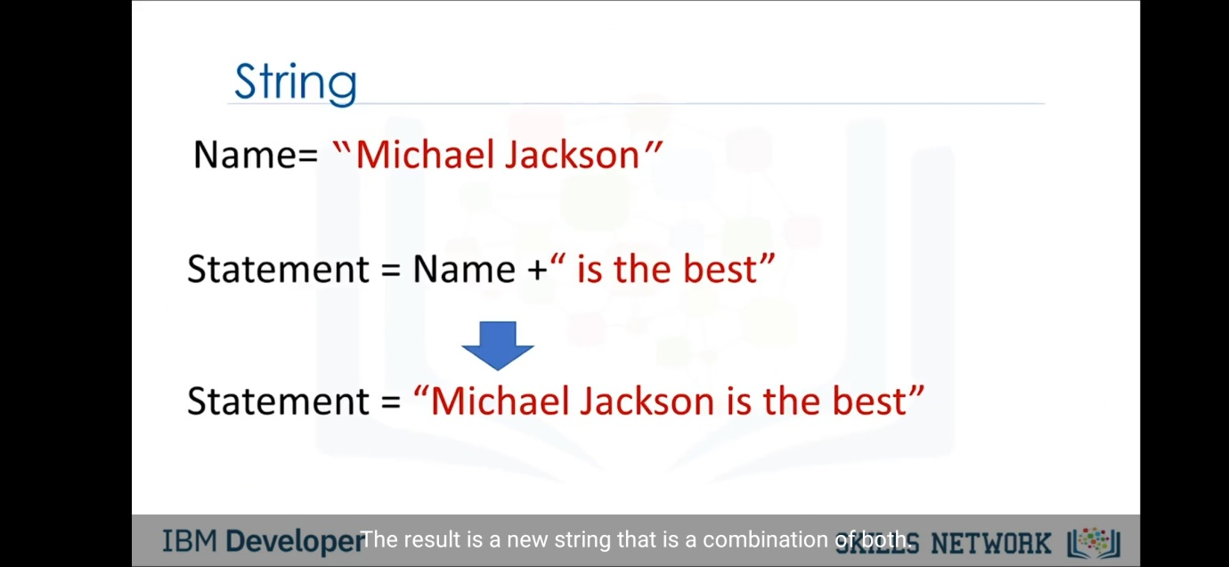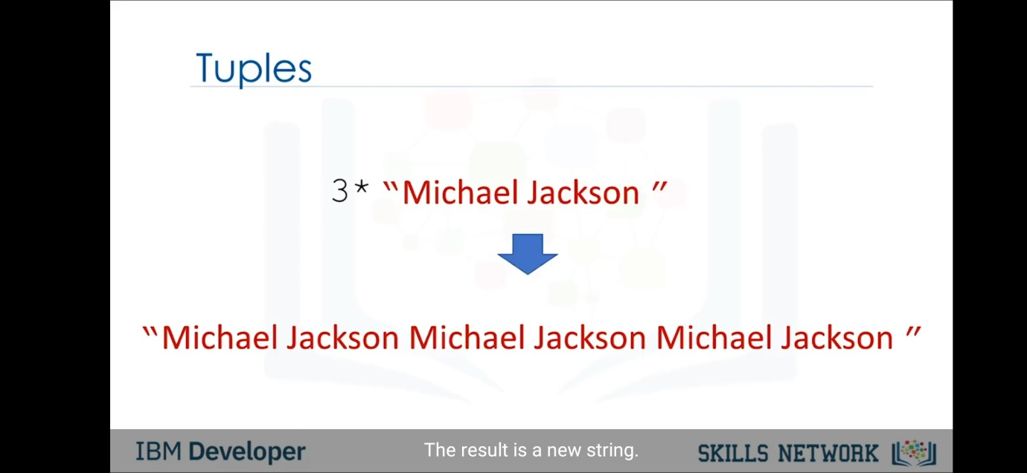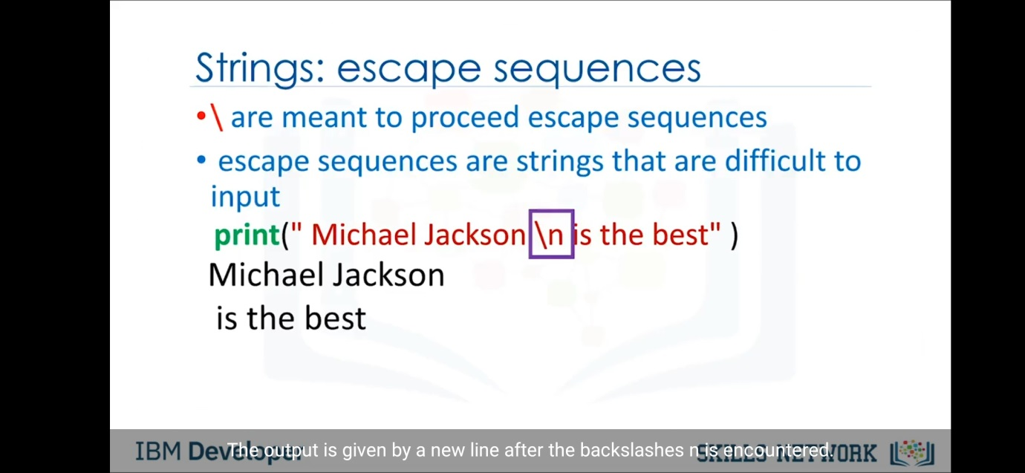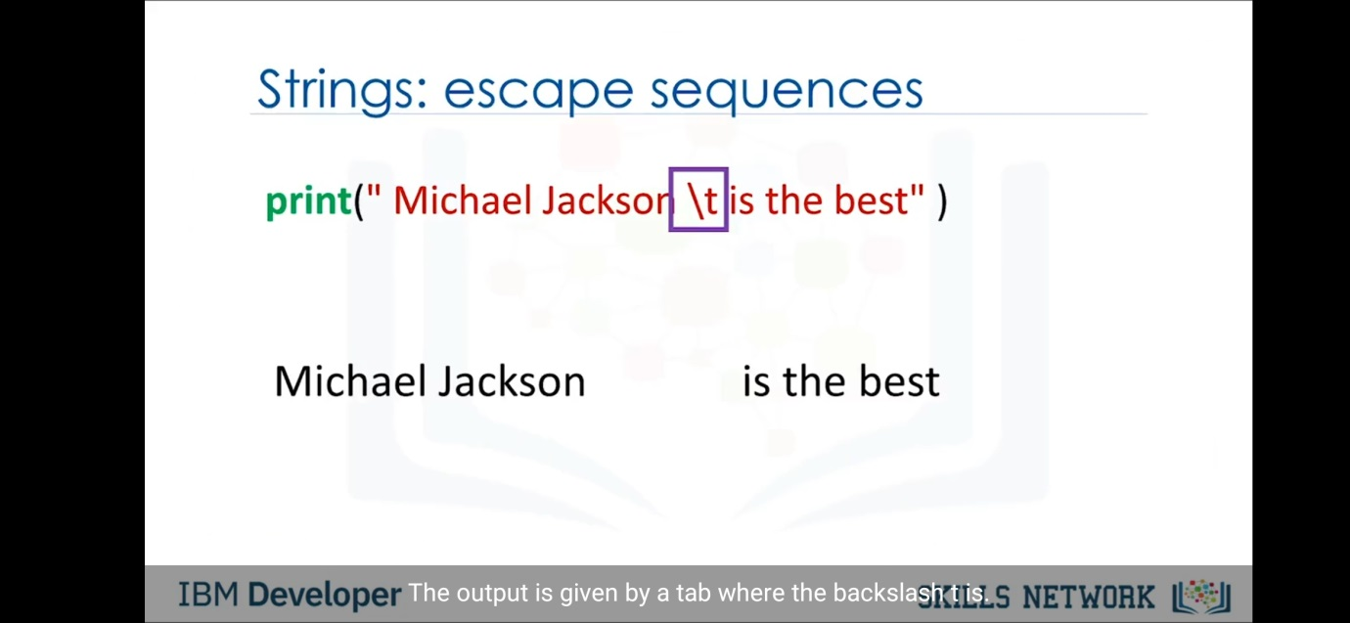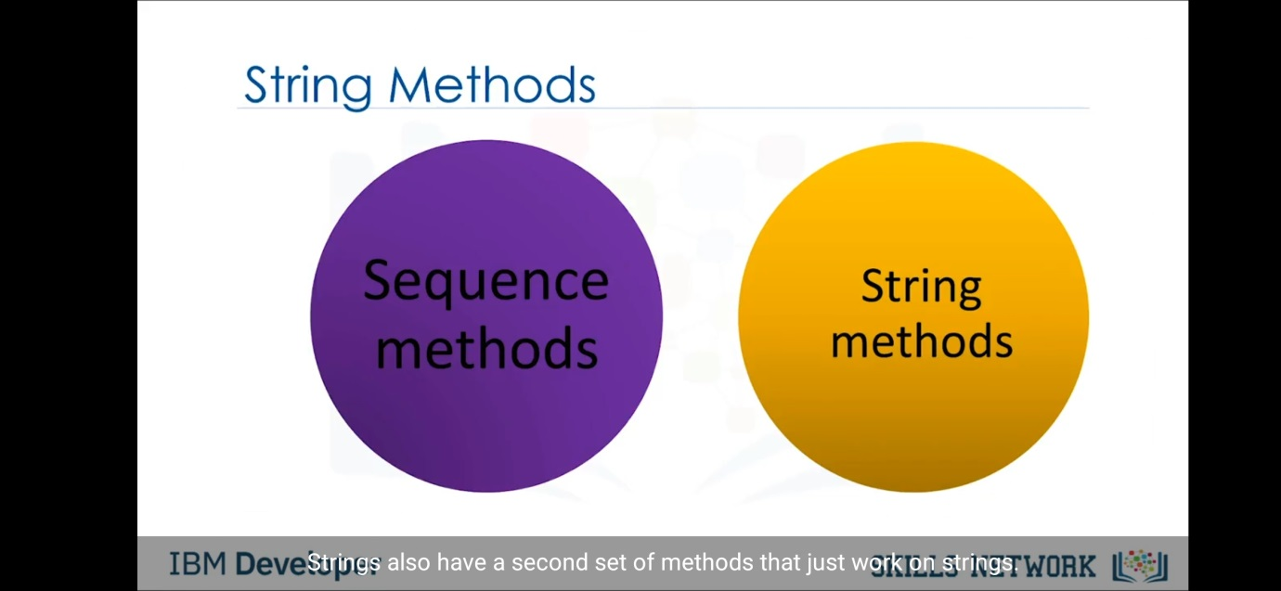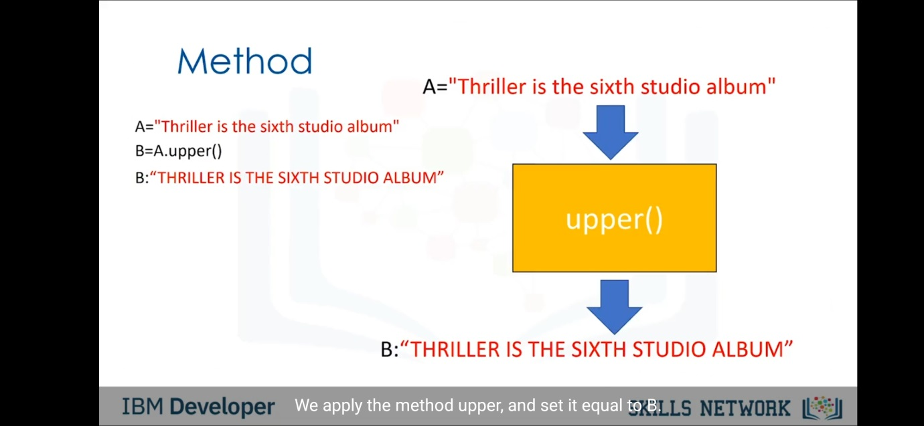

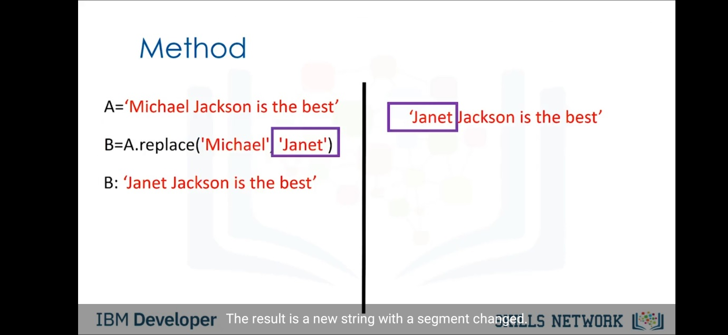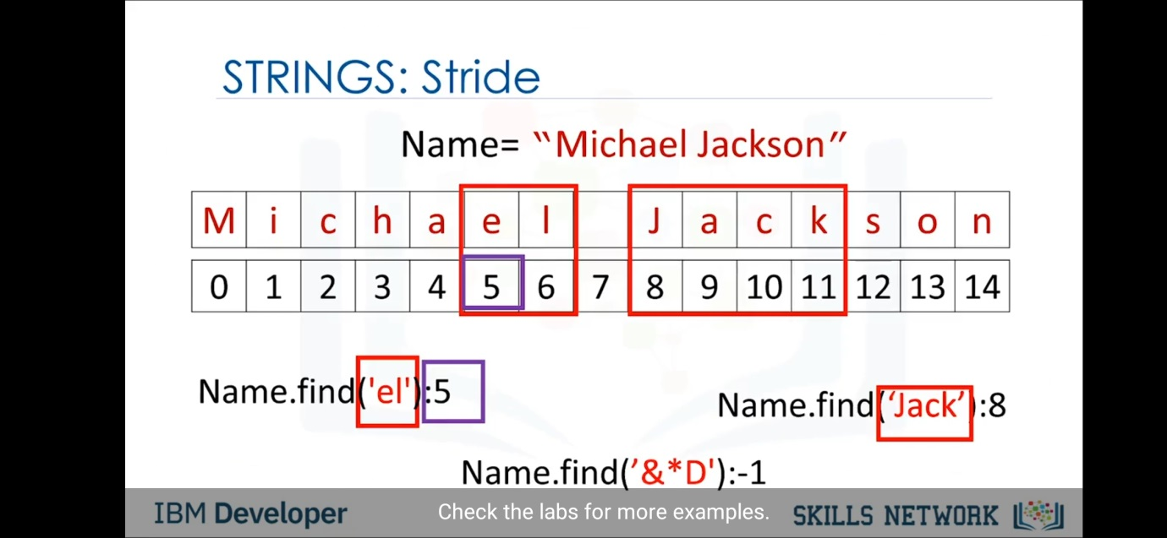

List & Tuples-

The main difference between lists and tuples is the fact that lists are mutable whereas tuples are immutable.

What does that even mean, you say?

A mutable data type means that a python object of this type can be modified.

An immutable object can’t.

Let’s see what this means in action.

Let’s create a list and assign it to a variable.

>>> a = ["apples", "bananas", "oranges"]

Now let’s see what happens when we try to modify the first item of the list.

Let’s change “apples” to “berries”.

>>> a[0] = "berries"

>>> a

['berries', 'bananas', 'oranges']

Perfect! the first item of a has changed.

Now, what if we want to try the same thing with a tuple instead of a list? Let’s see.

>>> a = ("apples", "bananas", "oranges")

>>> a[0] = "berries"

Traceback (most recent call last):

File "", line 1, in

TypeError: 'tuple' object does not support item assignment

We get an error saying that a tuple object doesn’t support item assignment.

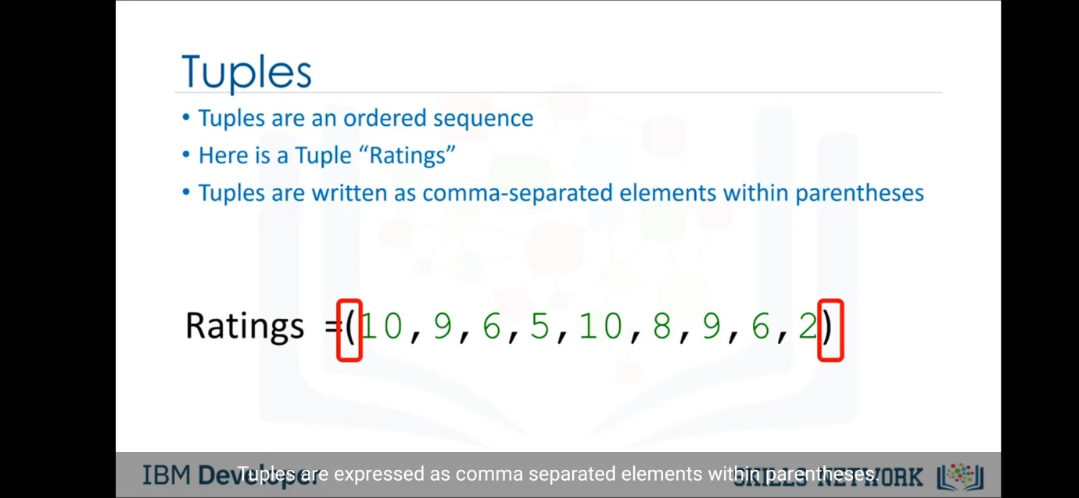

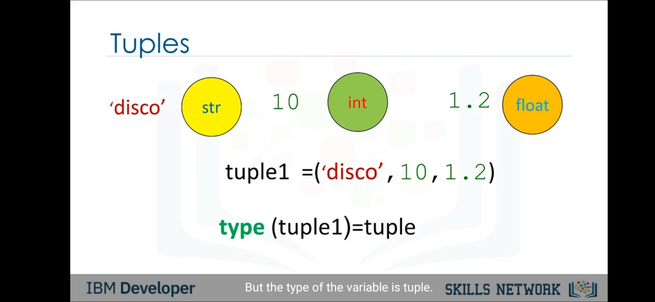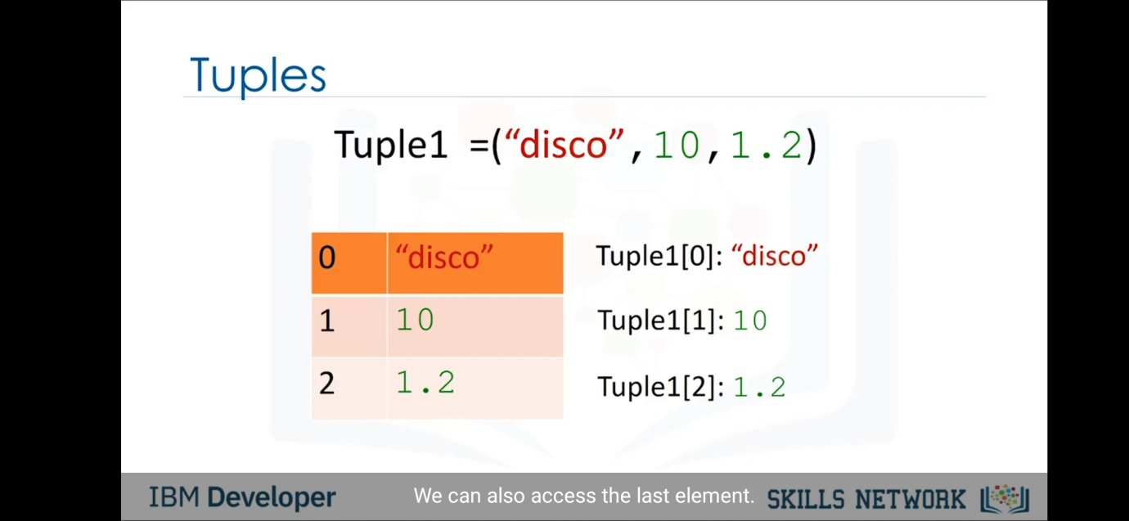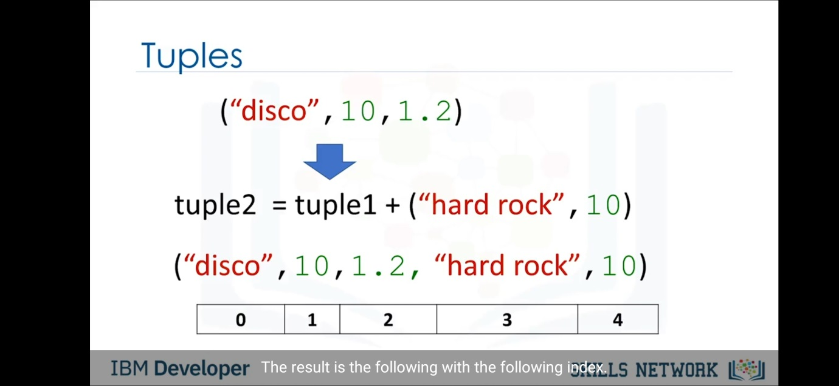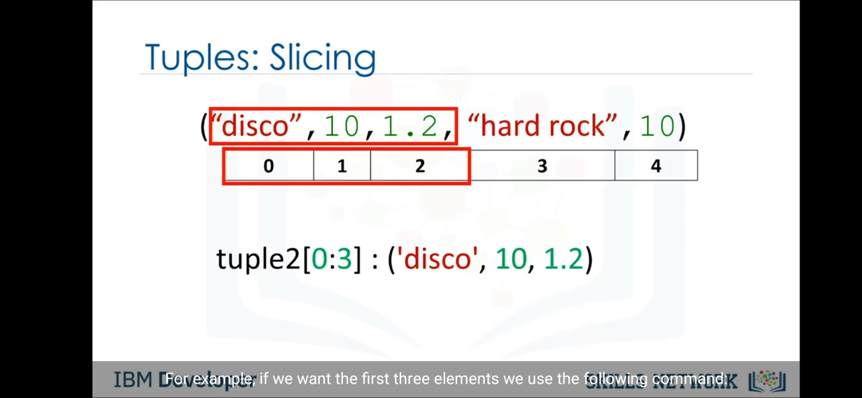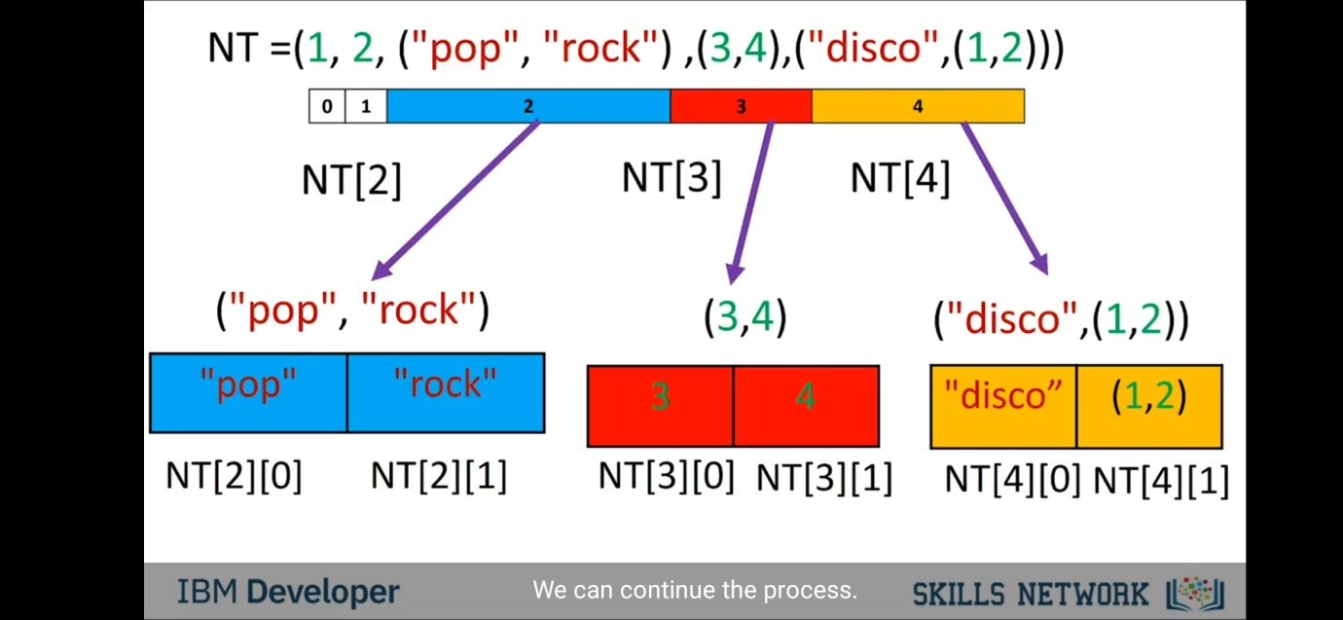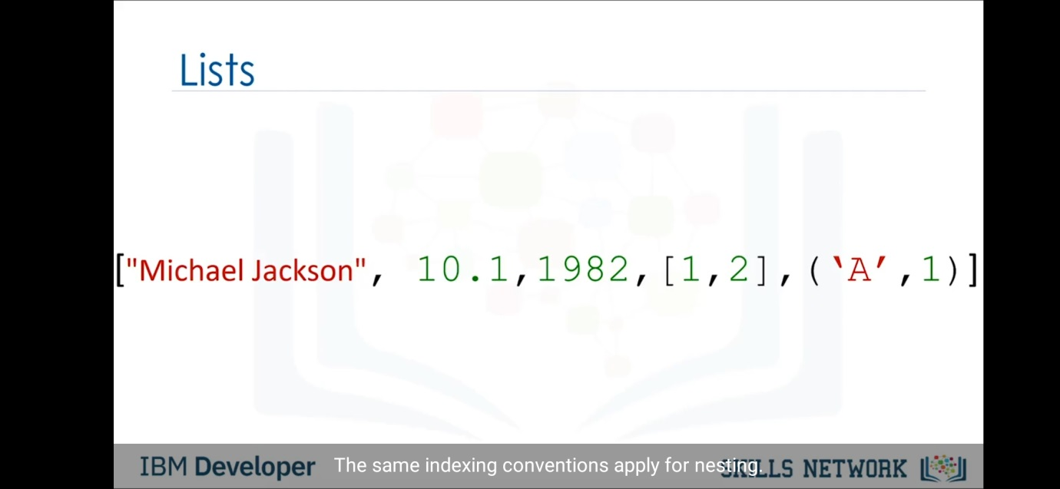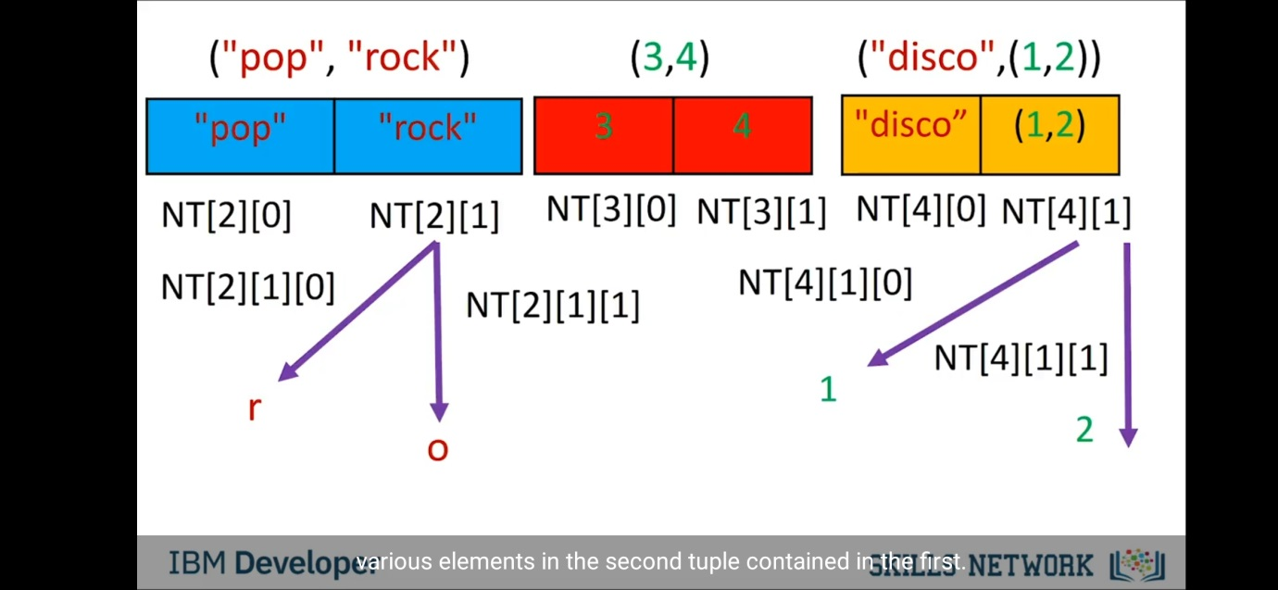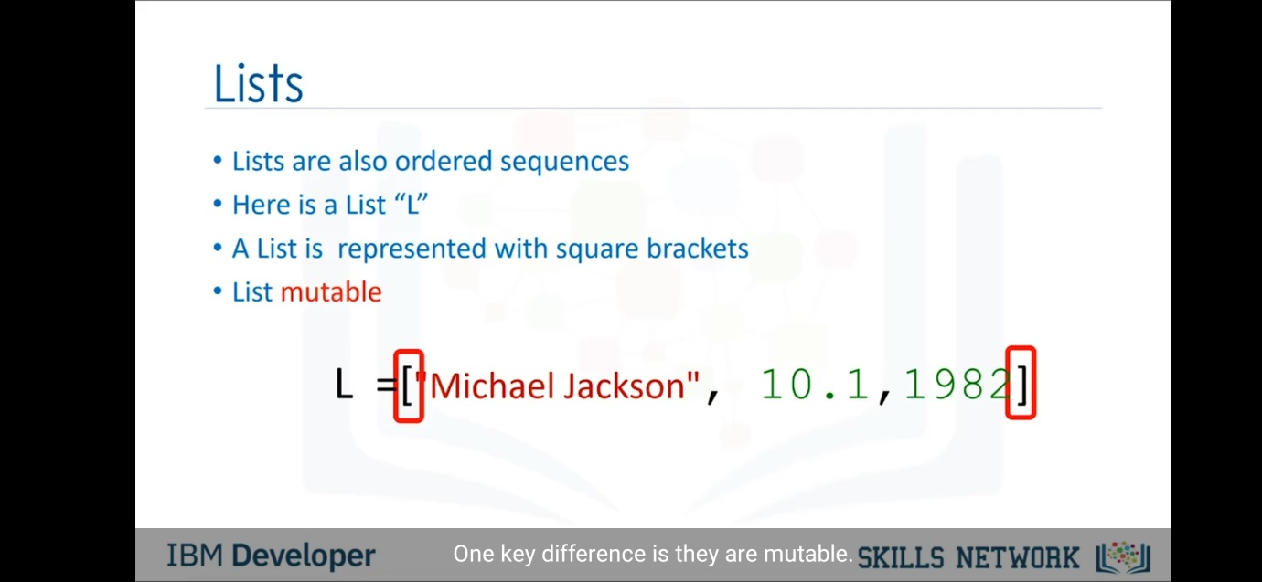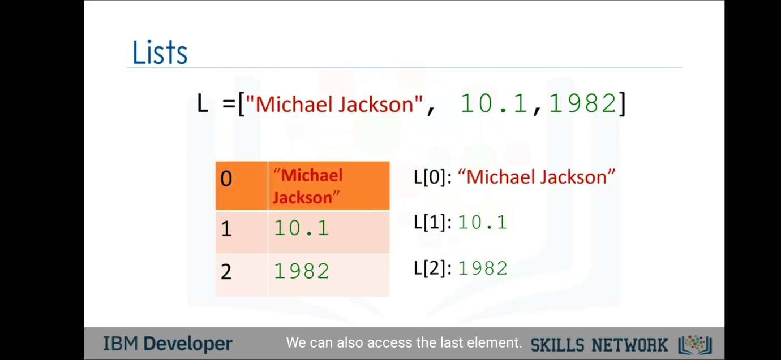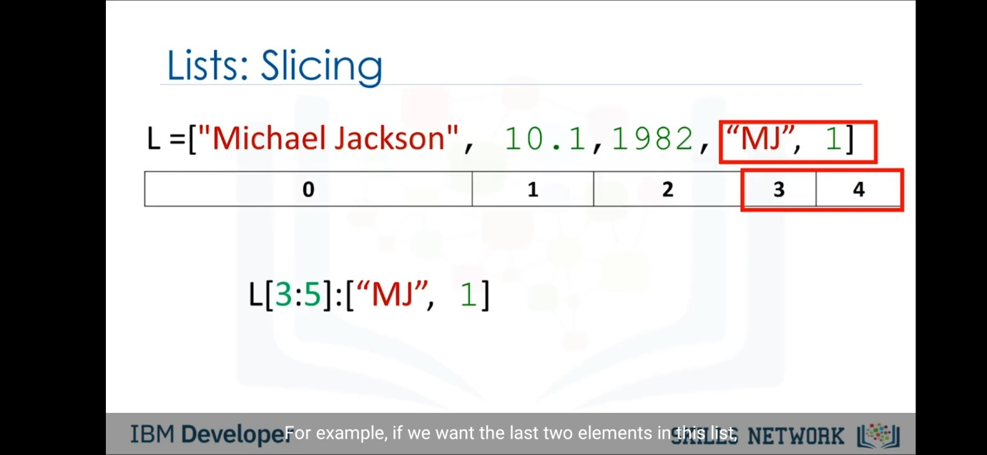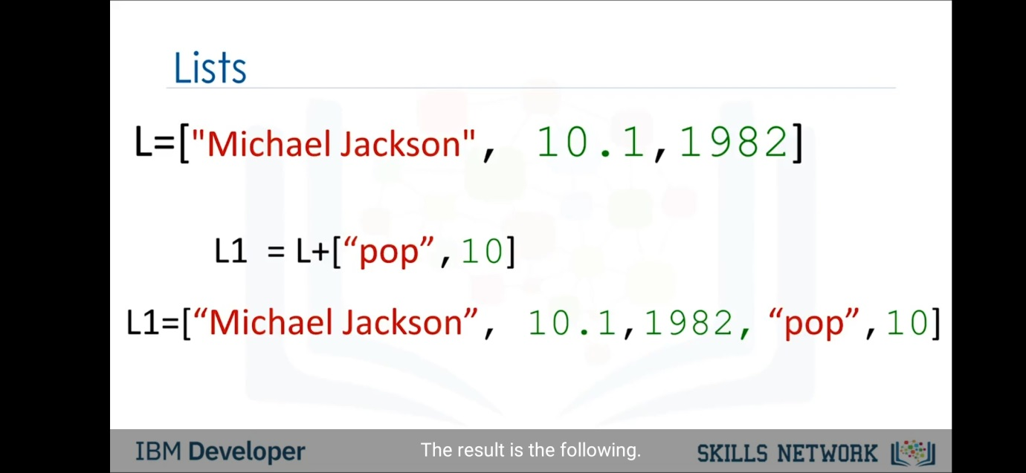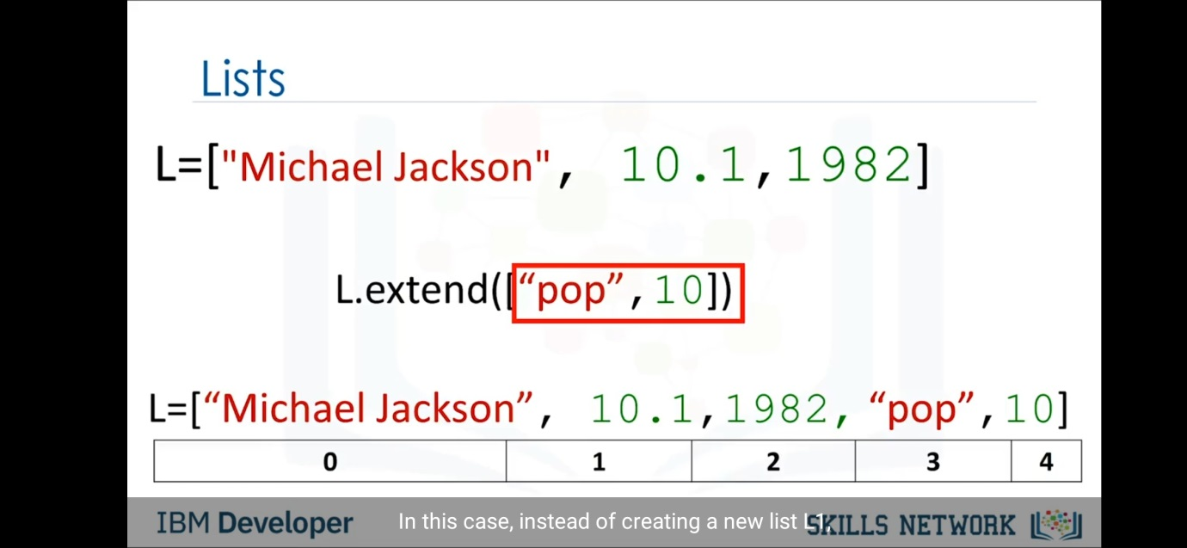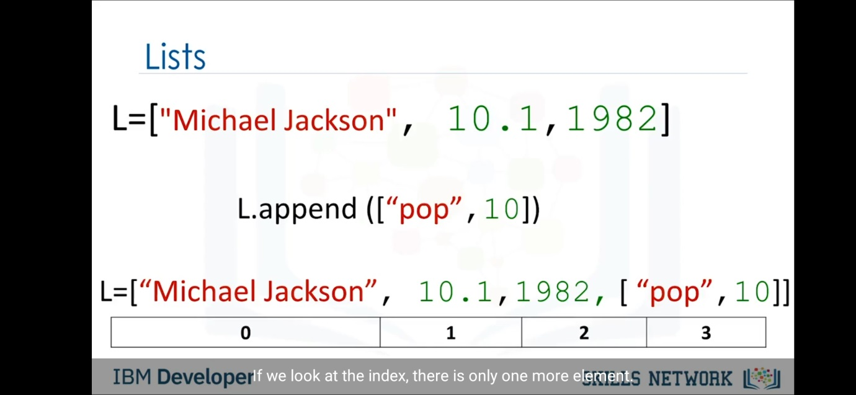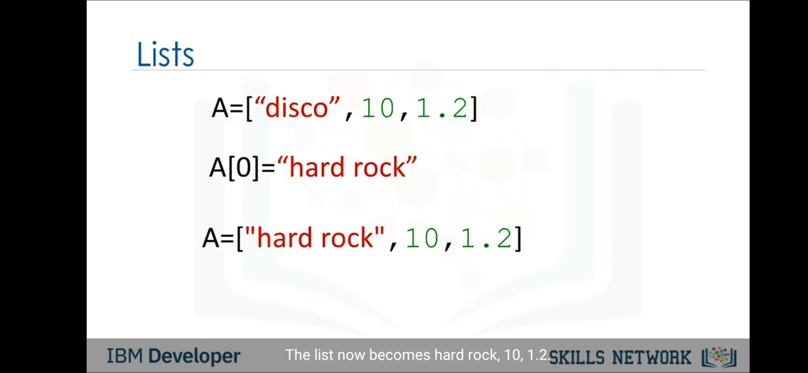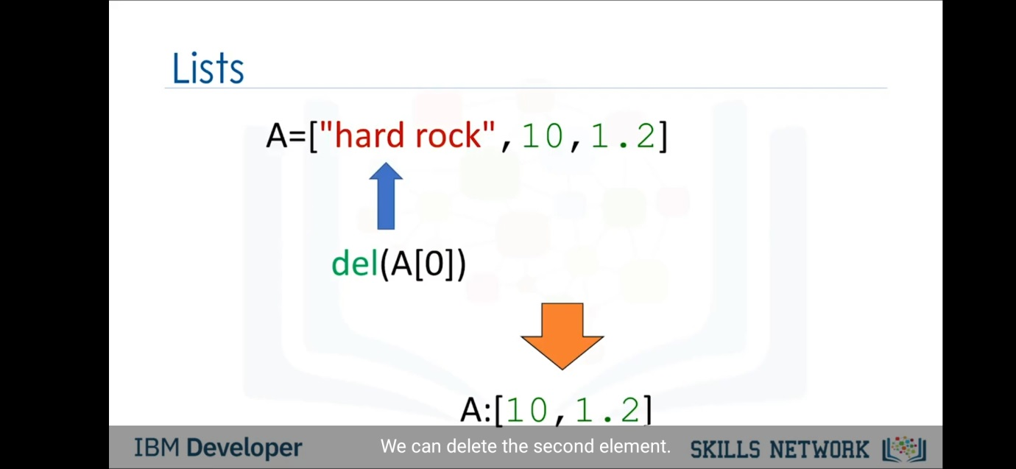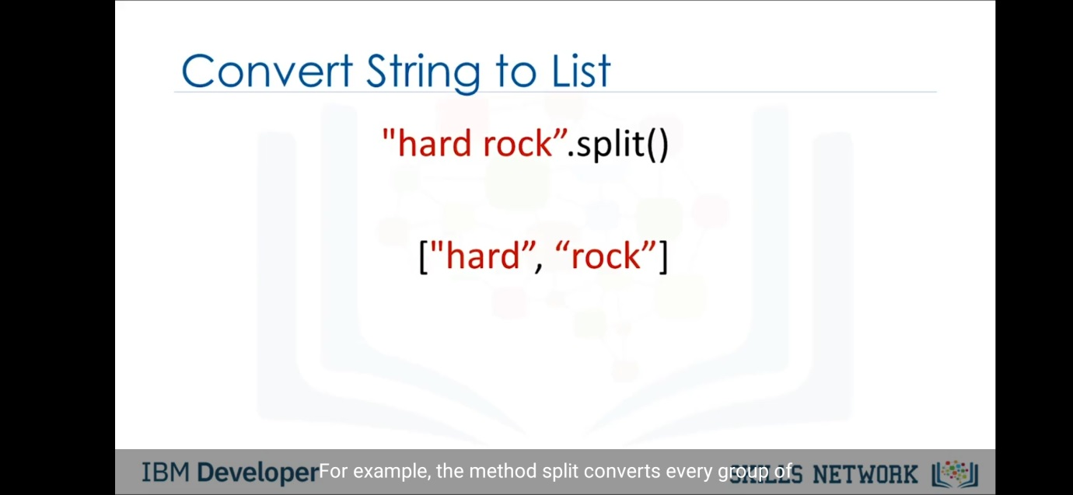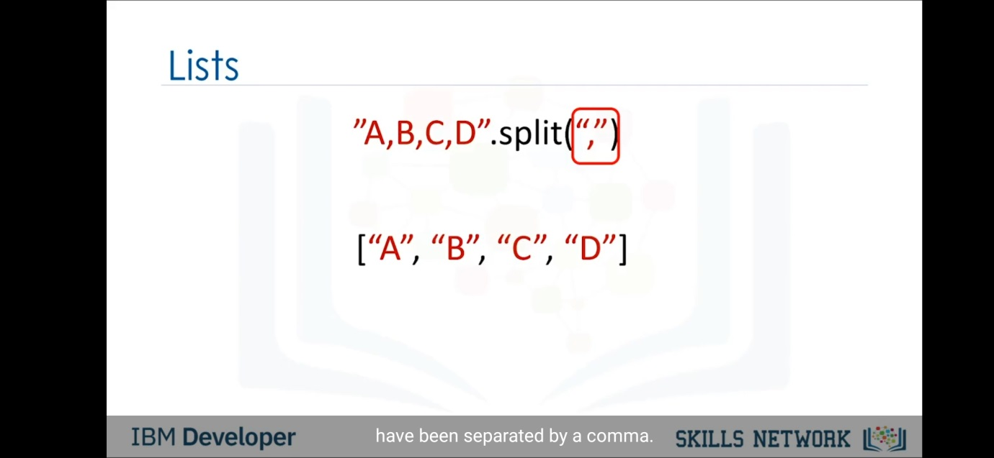

Clone independent list(i.e.,changes in one list would not affect other-

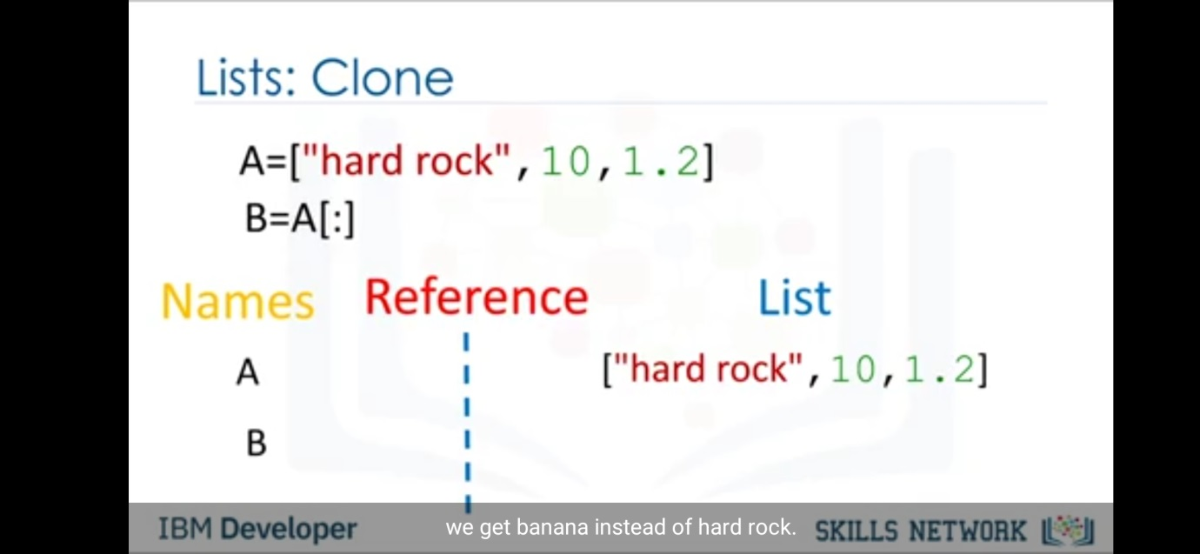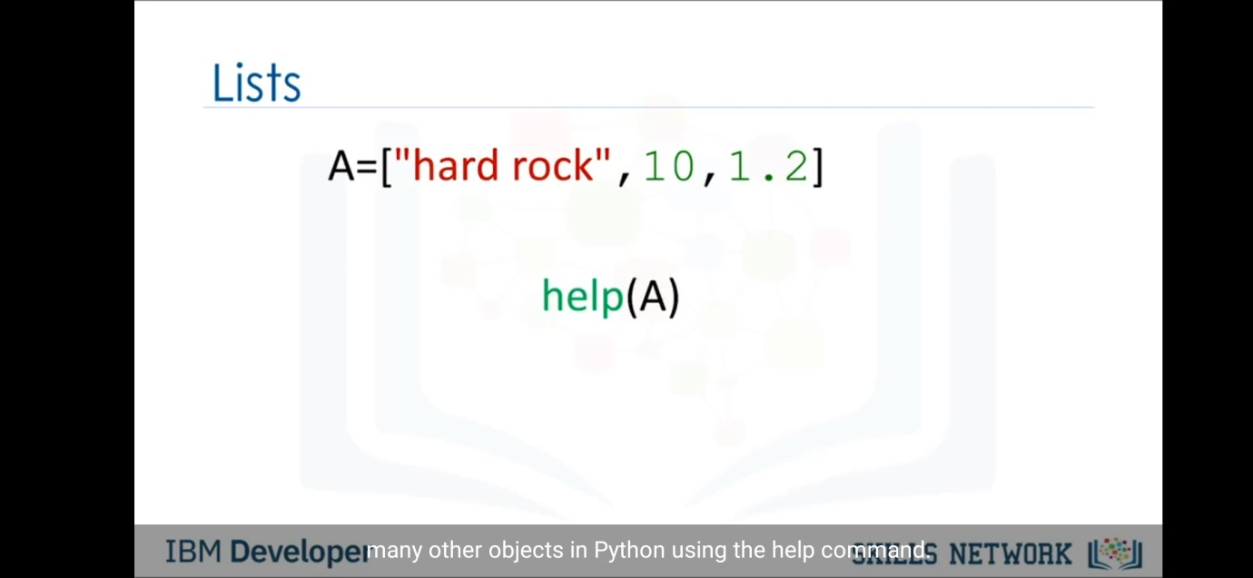

Dictionaries-

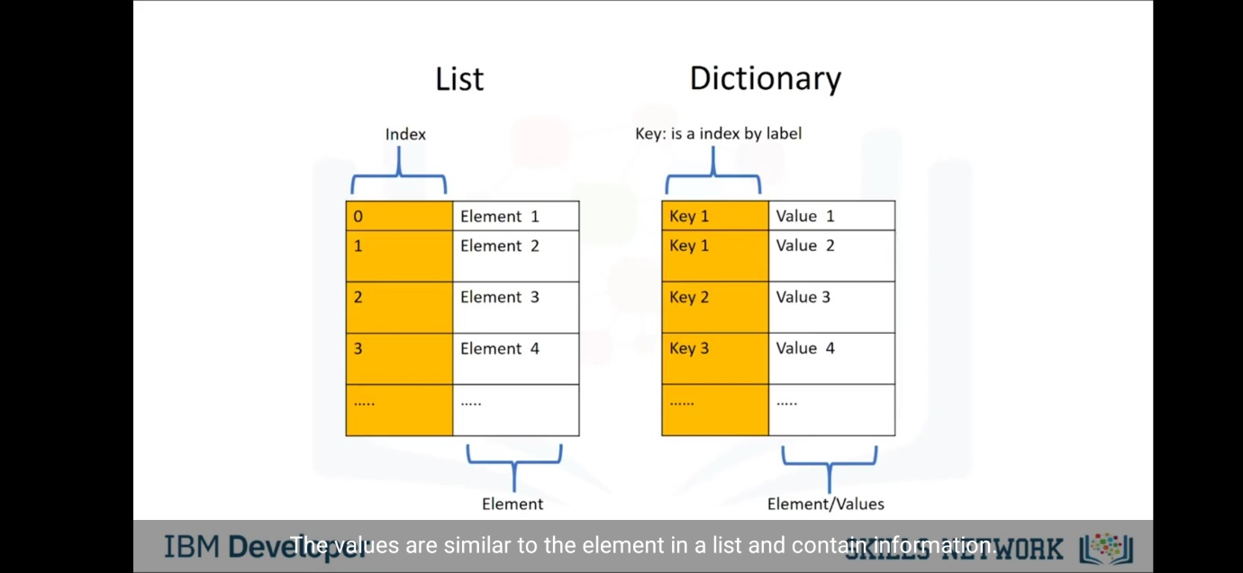

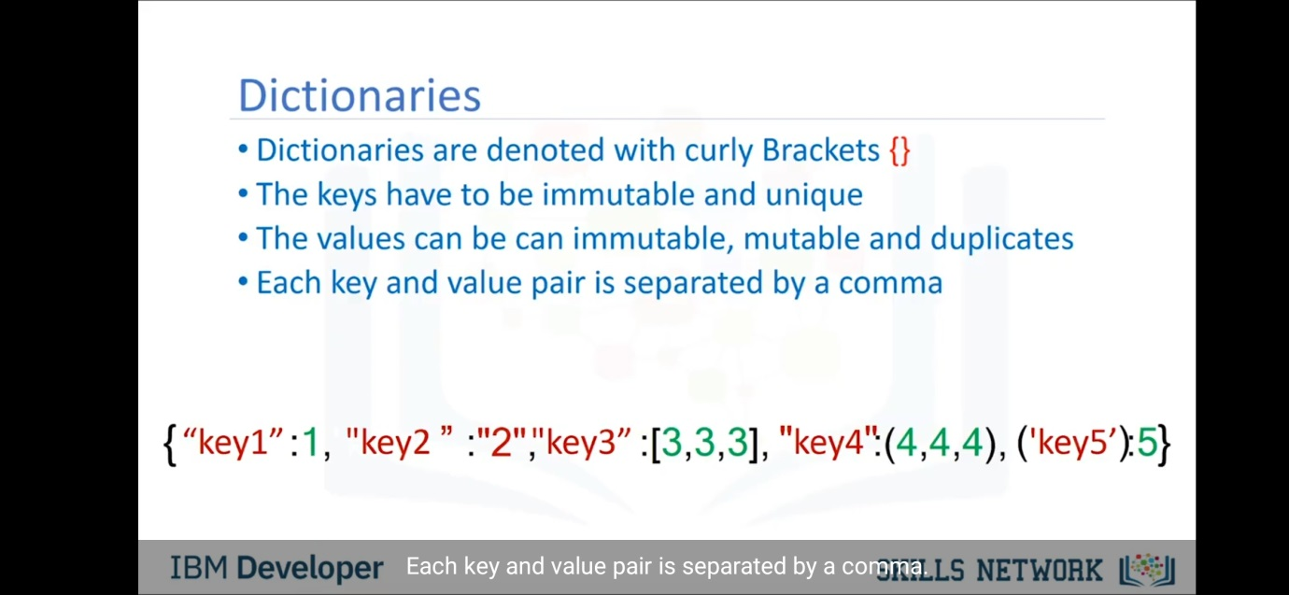

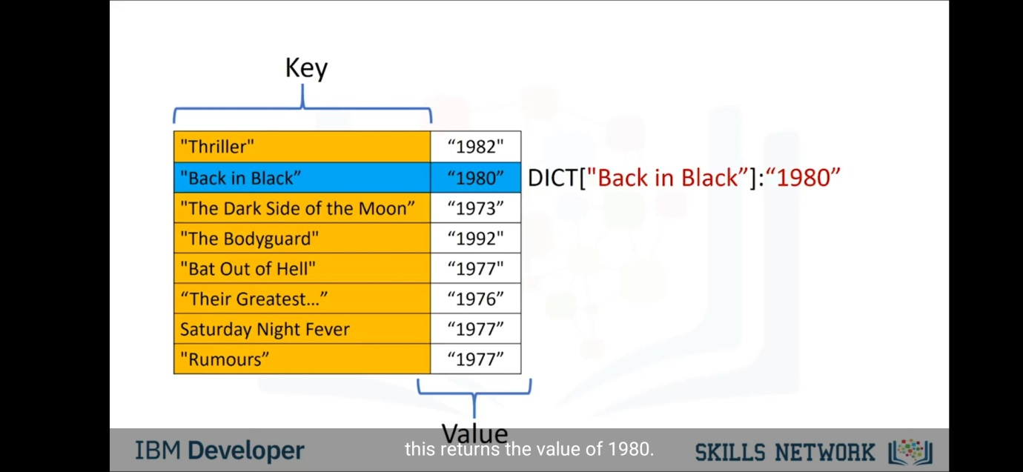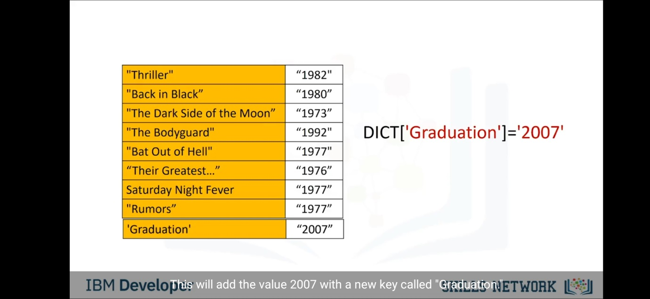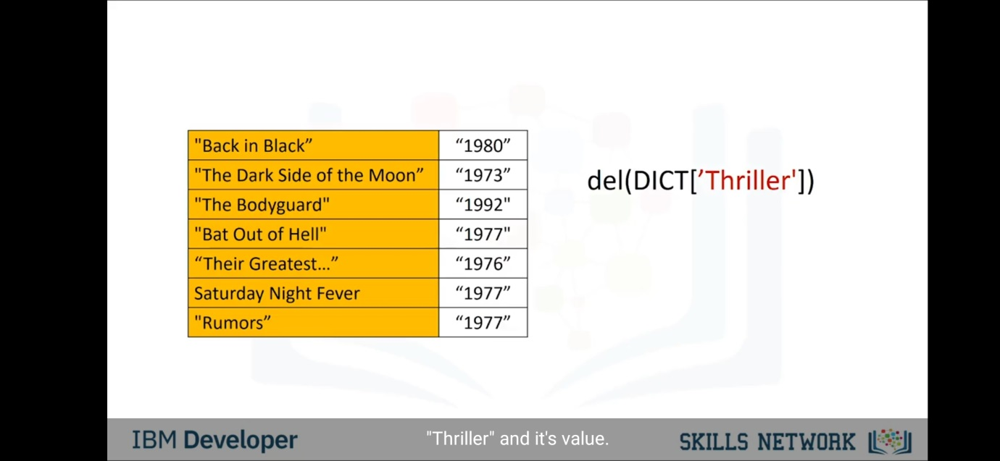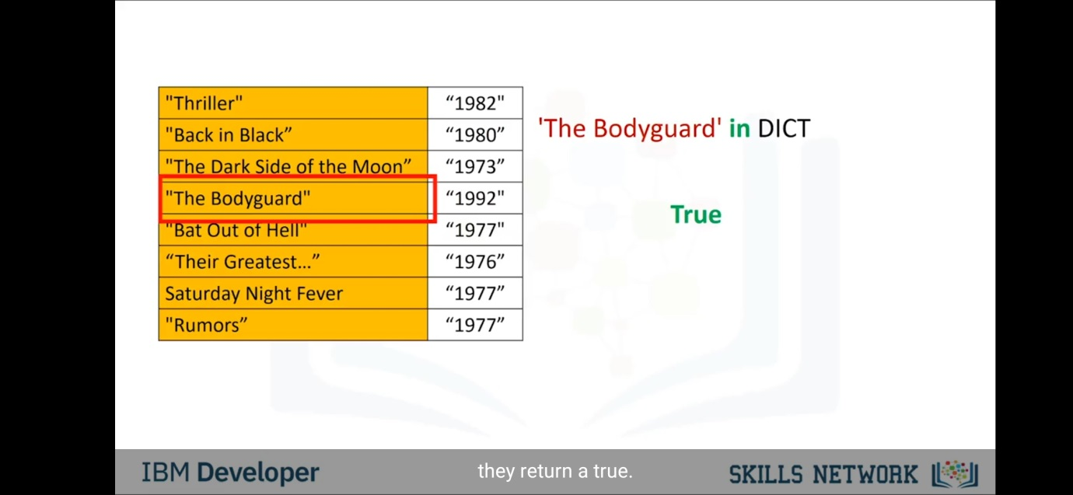0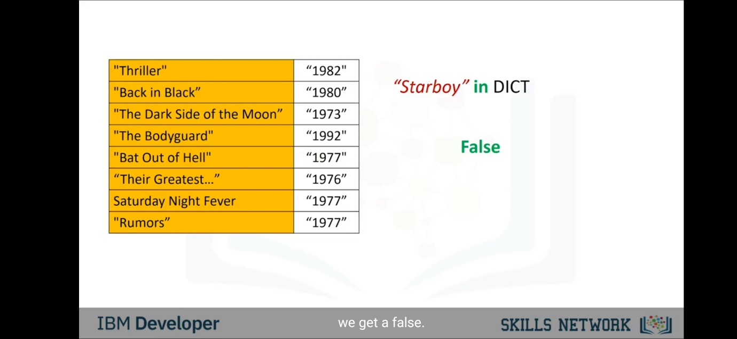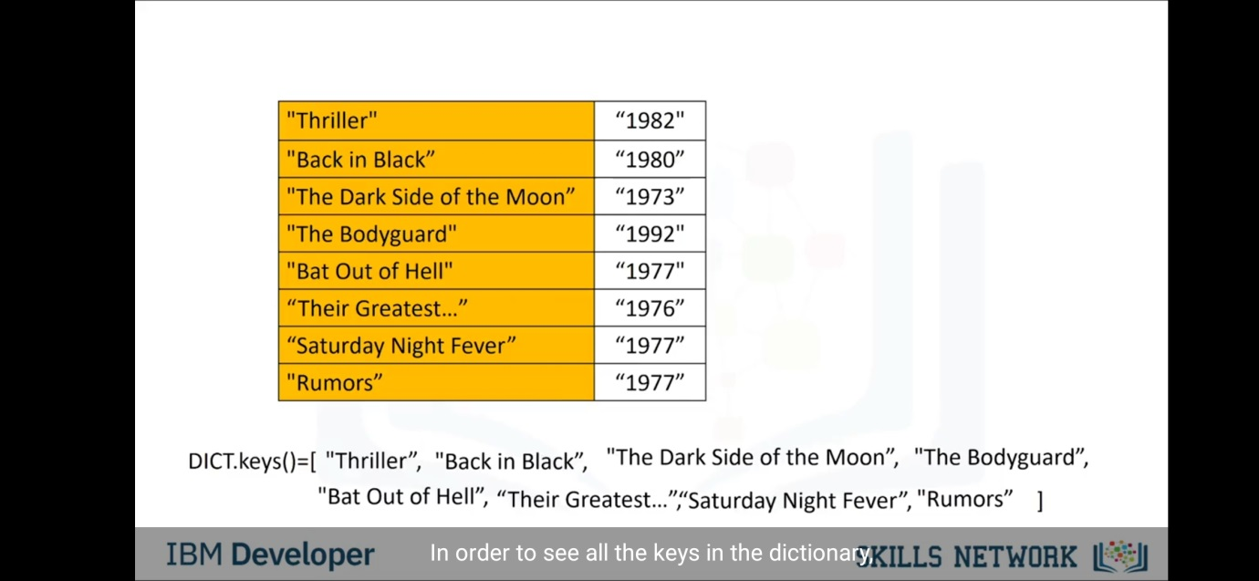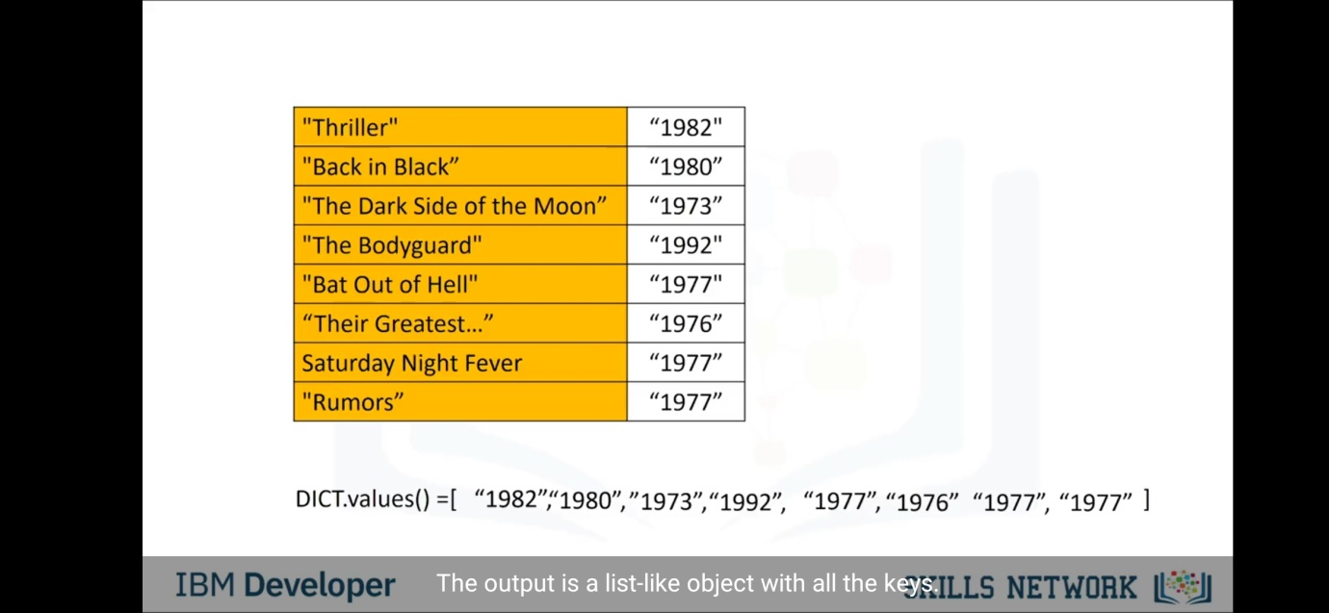

Sets-

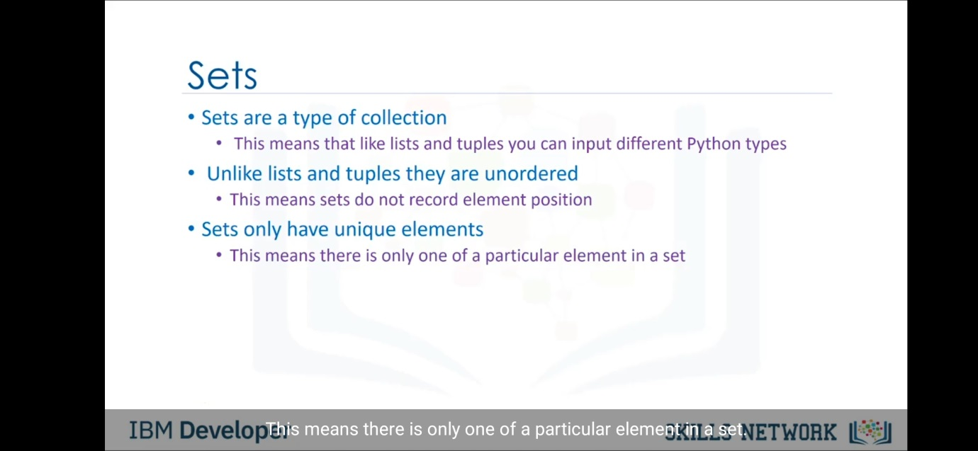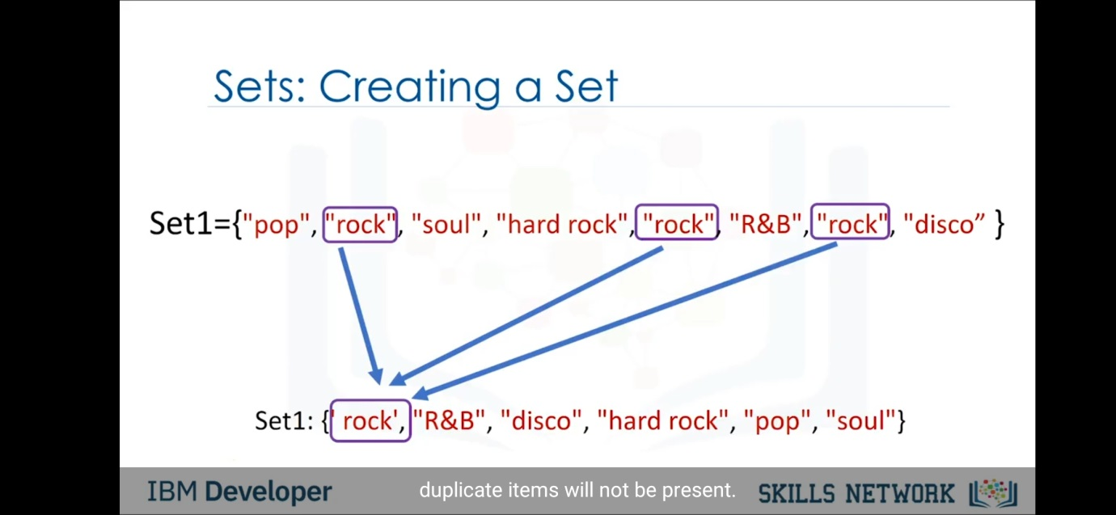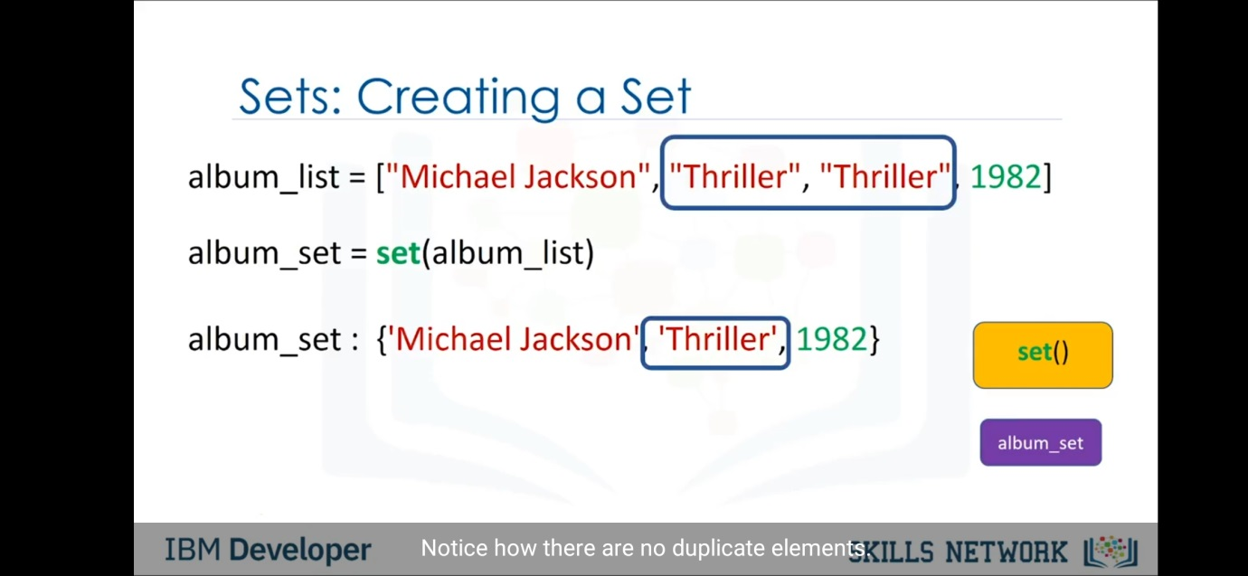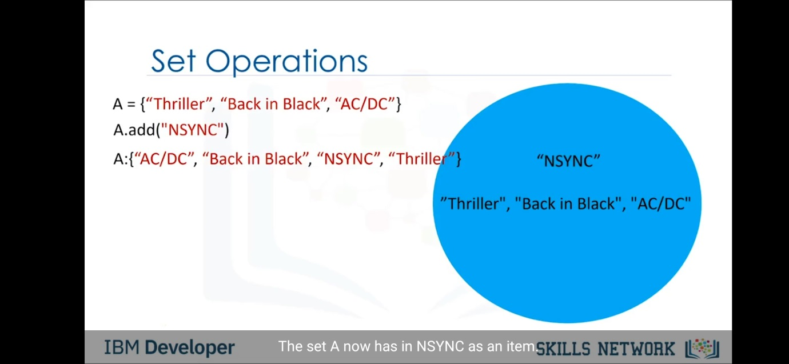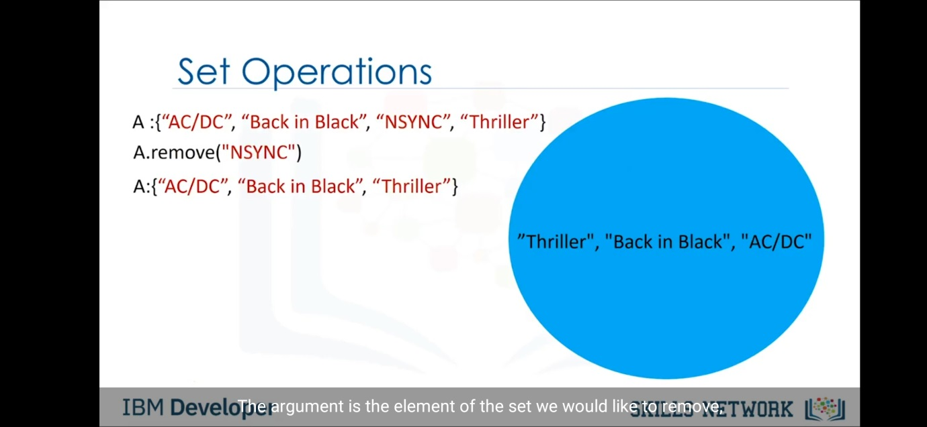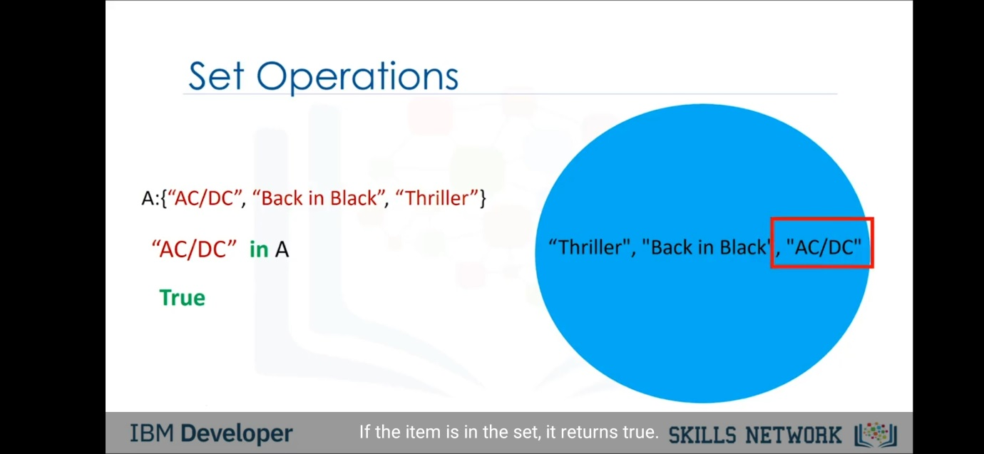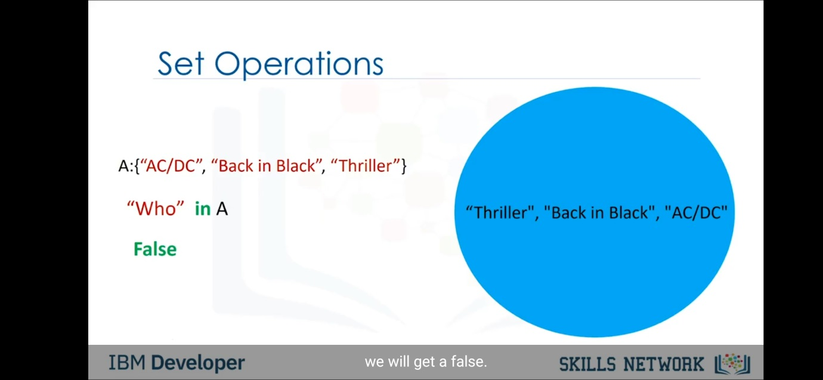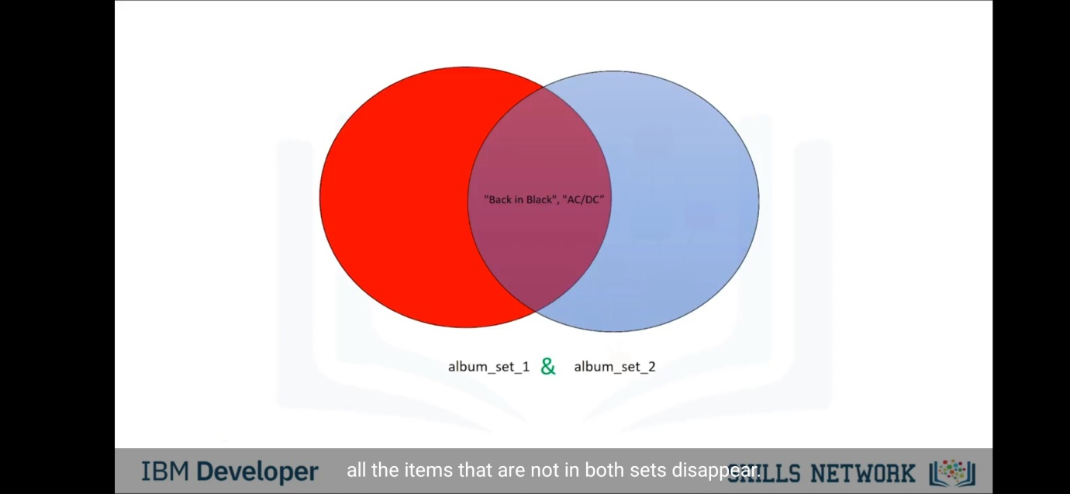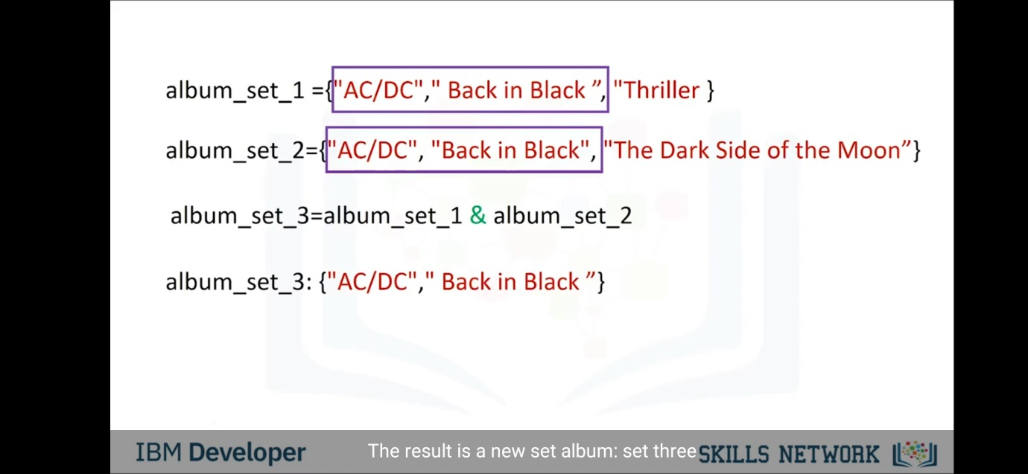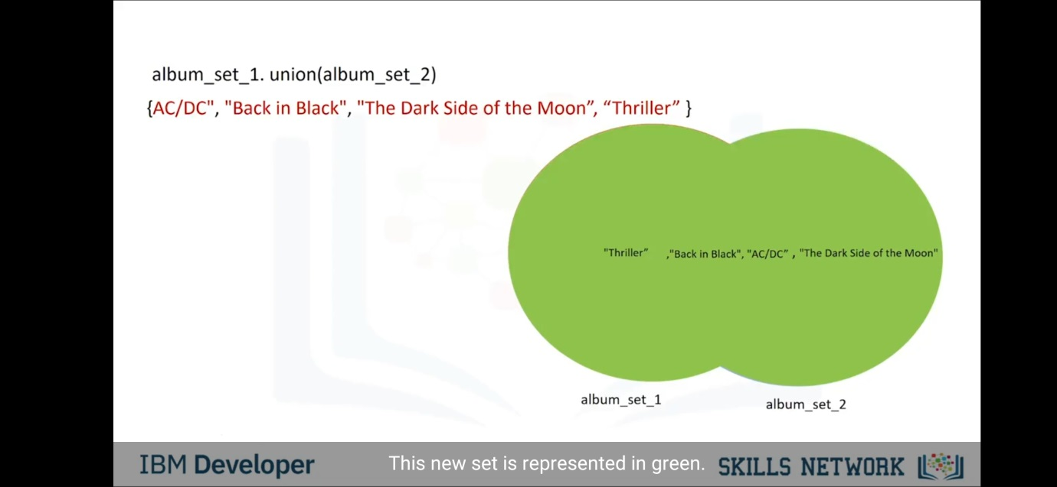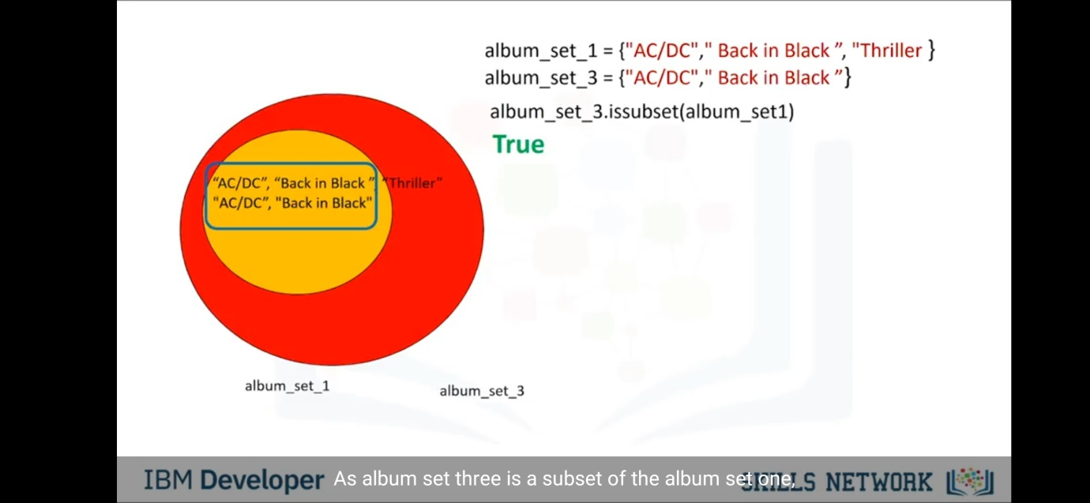

Comparison operators-

|  |  |  |
| --- | --- | --- |
| **Operator** | **Description** | **Example** |
| == | If the values of two operands are equal, then the condition becomes true. | (a == b) is not true. |
| != | If values of two operands are not equal, then condition becomes true. | (a != b) is true. |
| <> | If values of two operands are not equal, then condition becomes true. | (a <> b) is true. This is similar to != operator. |
| > | If the value of left operand is greater than the value of right operand, then condition becomes true. | (a > b) is not true. |
| < | If the value of left operand is less than the value of right operand, then condition becomes true. | (a < b) is true. |
| >= | If the value of left operand is greater than or equal to the value of right operand, then condition becomes true. | (a >= b) is not true. |
| <= | If the value of left operand is less than or equal to the value of right operand, then condition becomes true. | (a <= b) is true. |

Conditions and Branching-

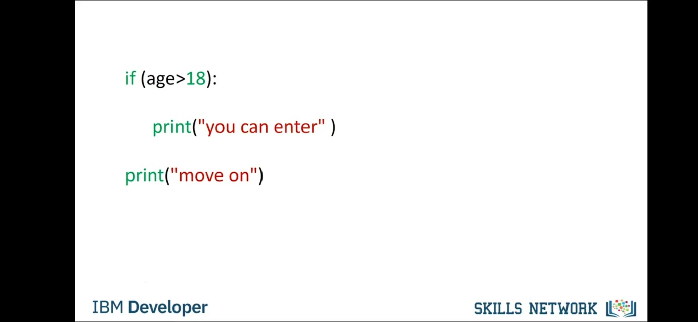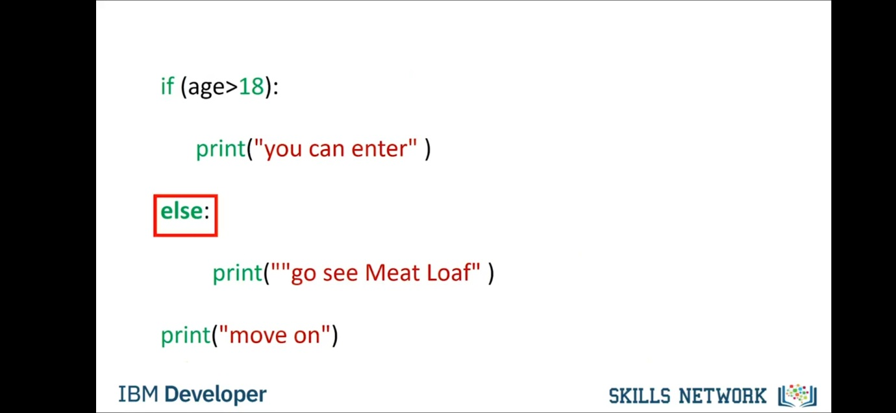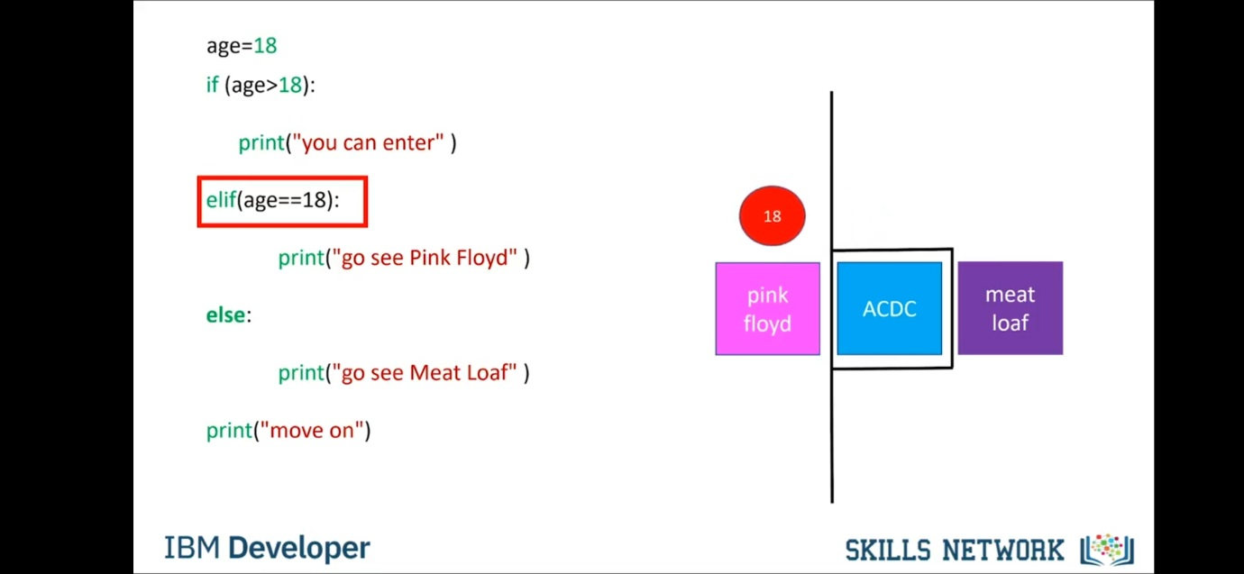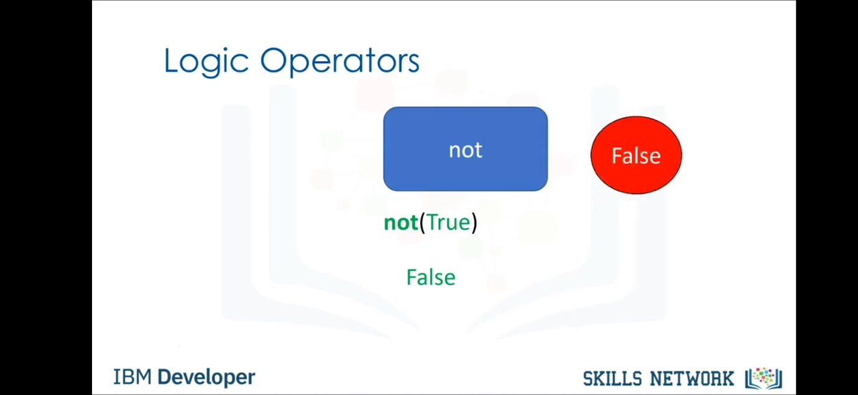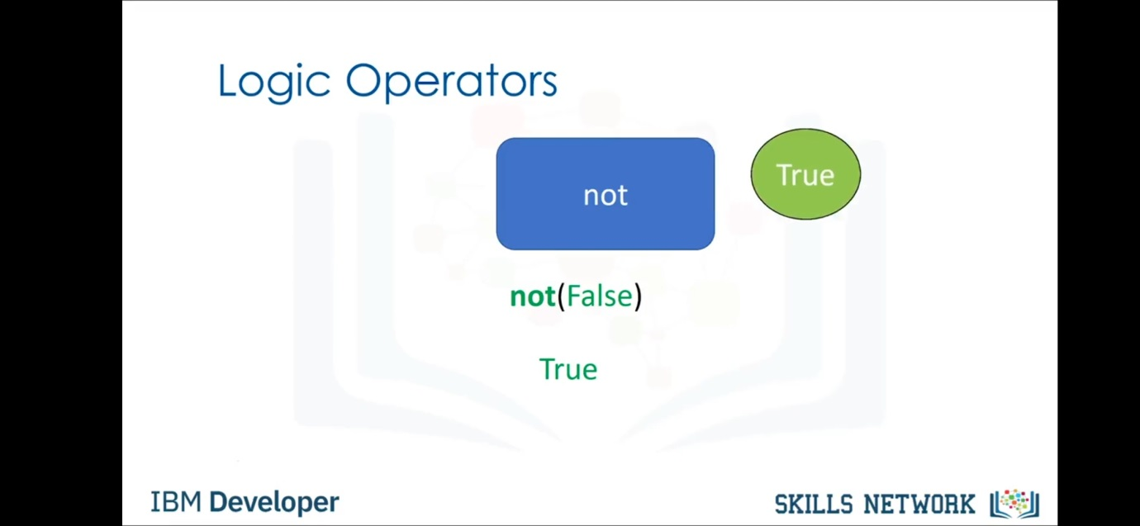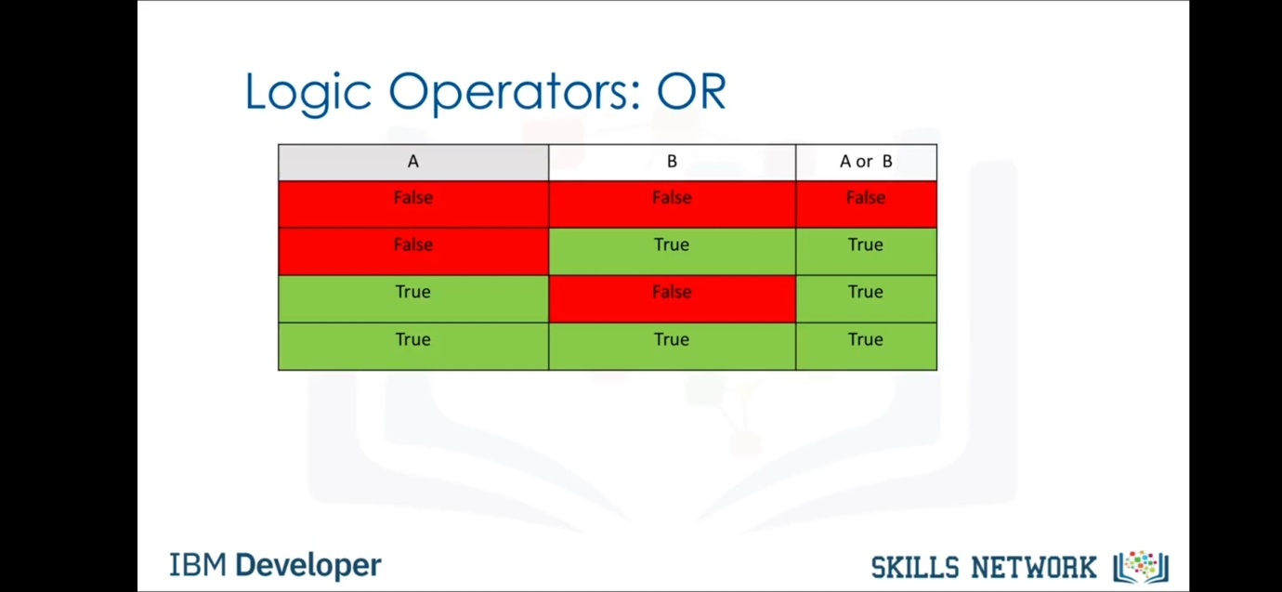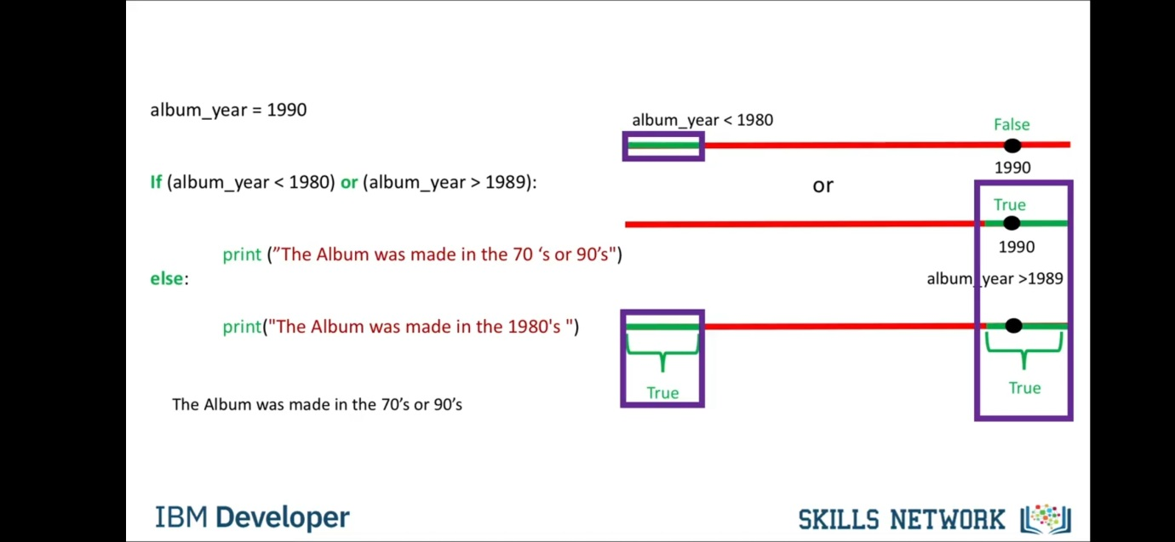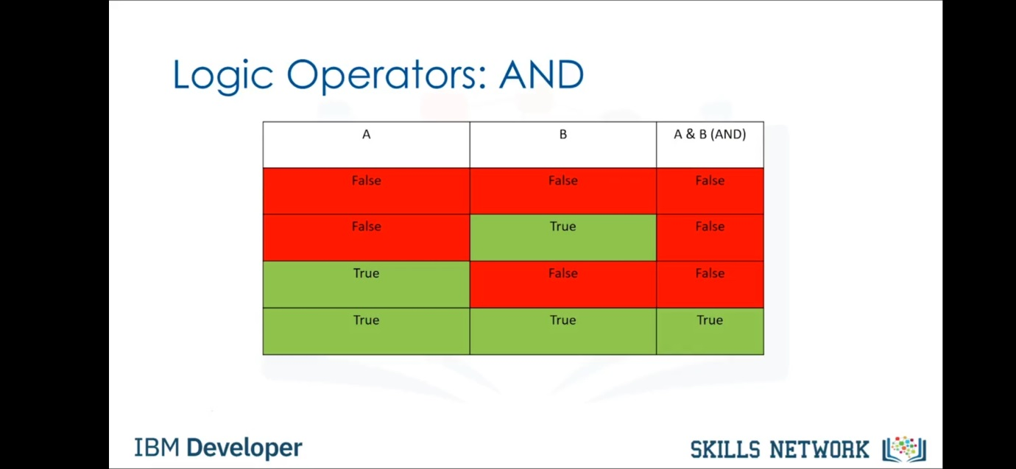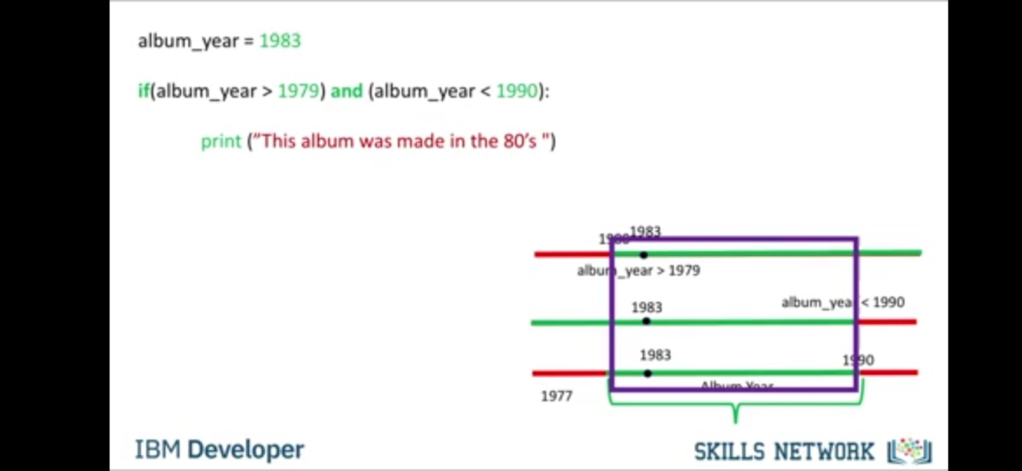

Loops-

For loop-

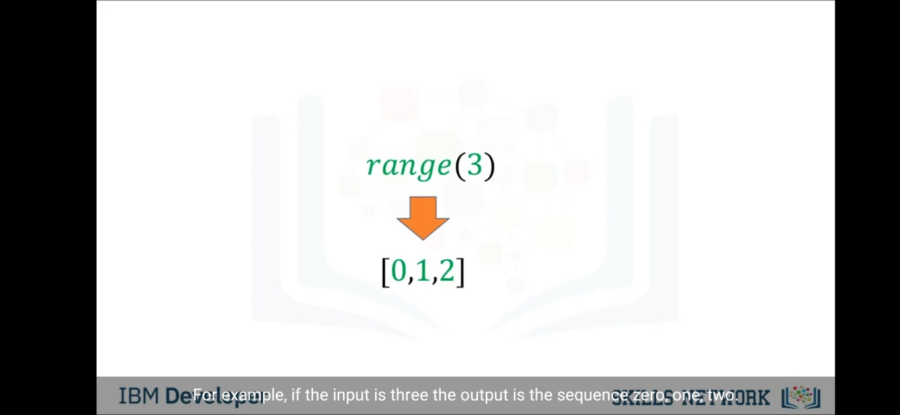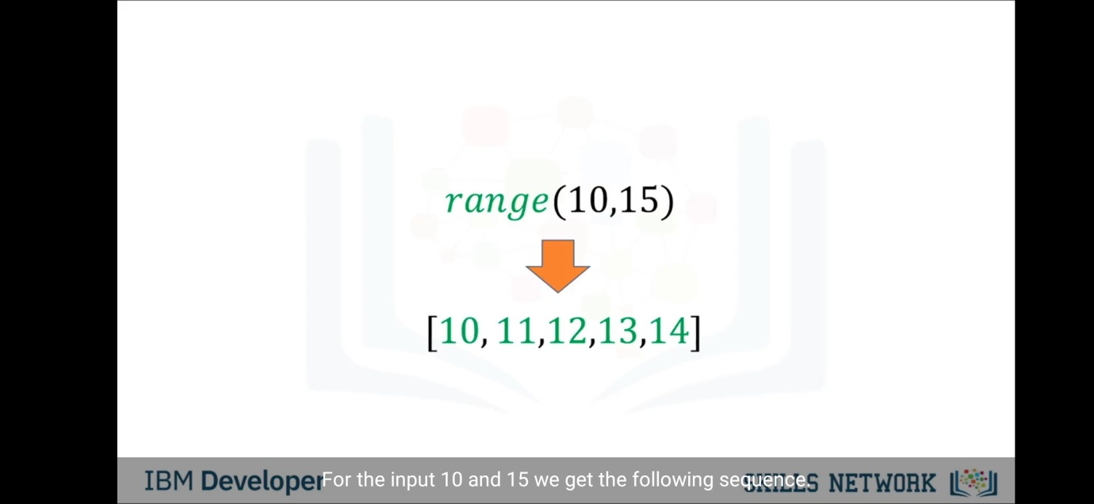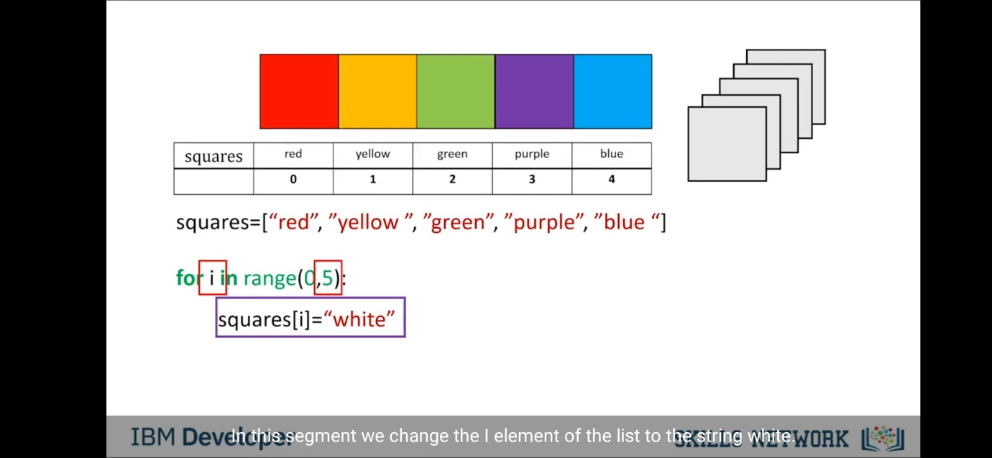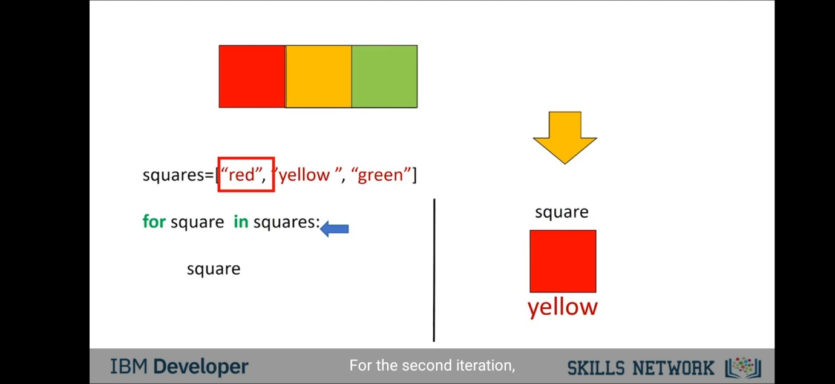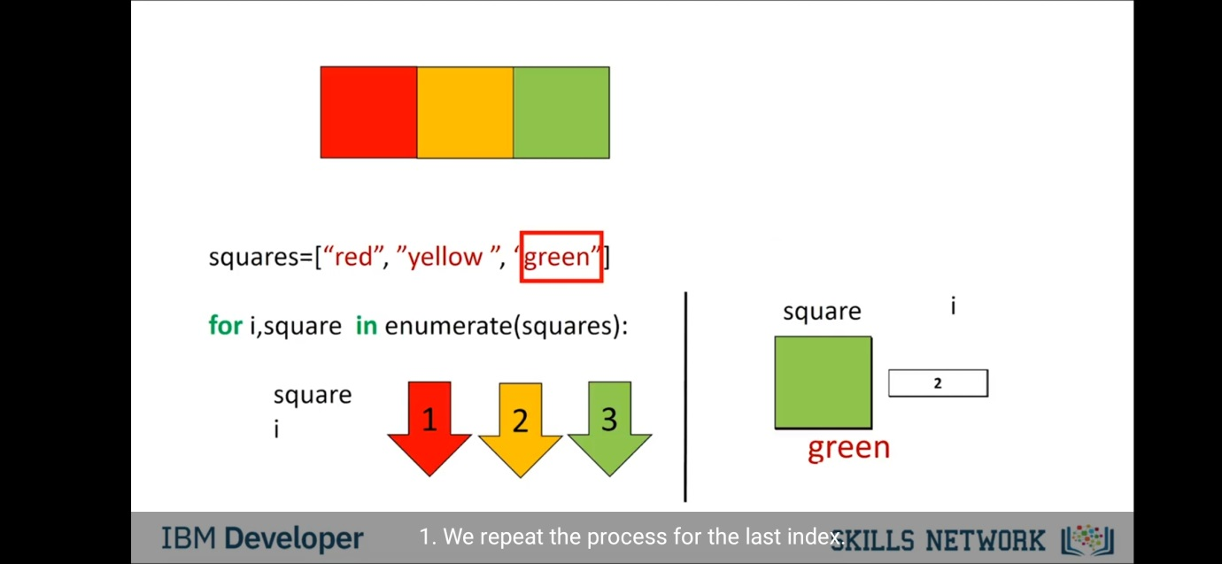

While loop-

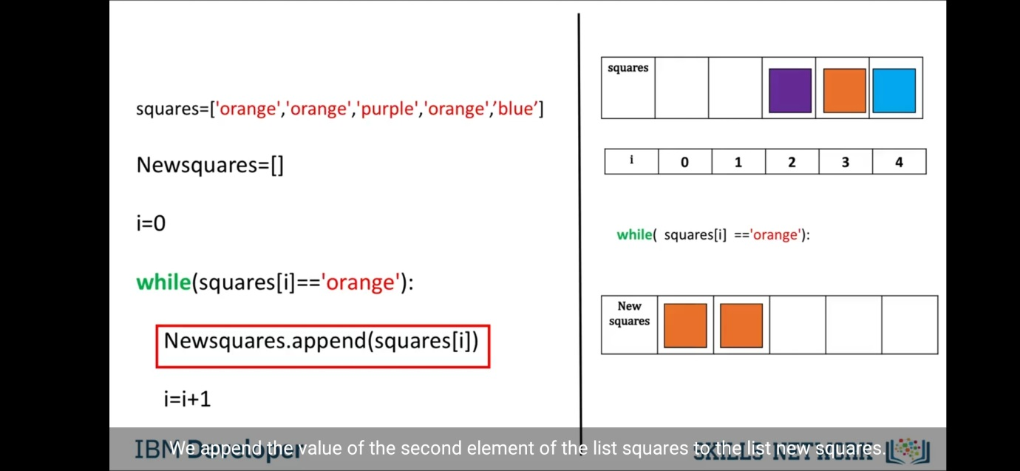

Functions-

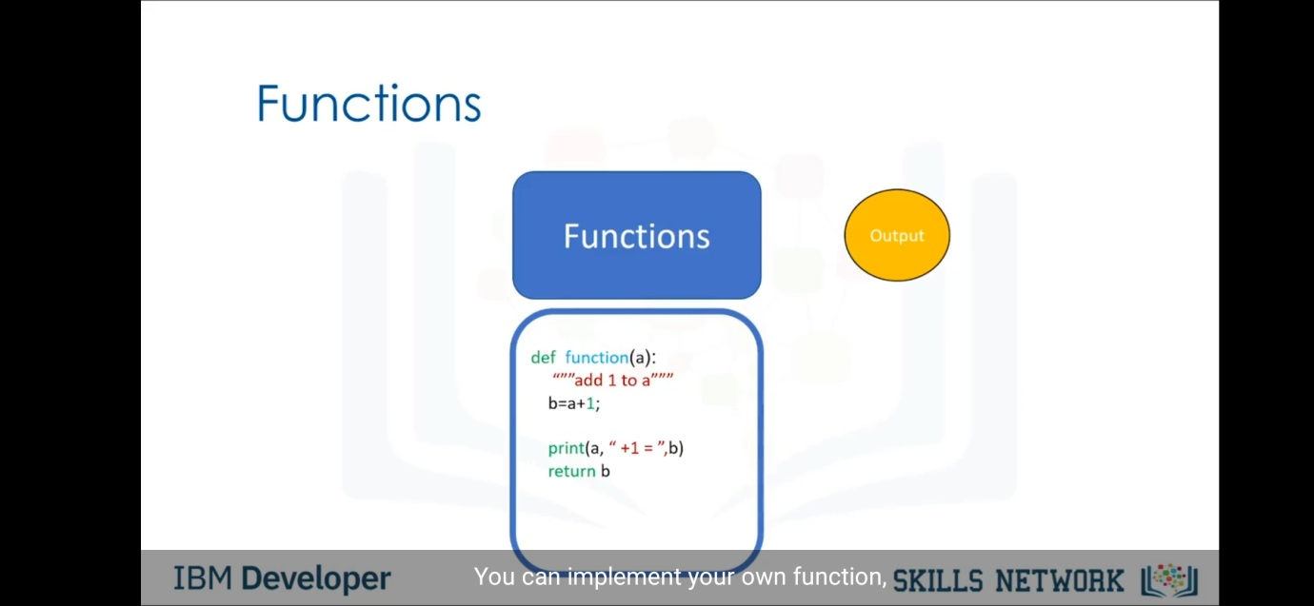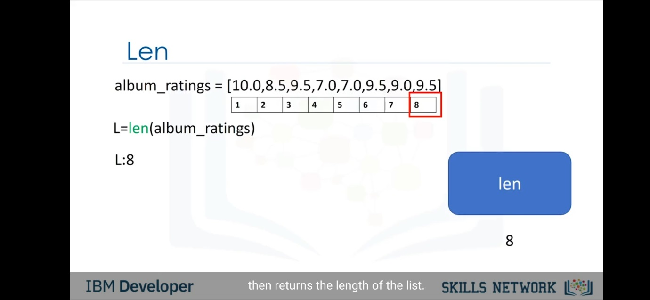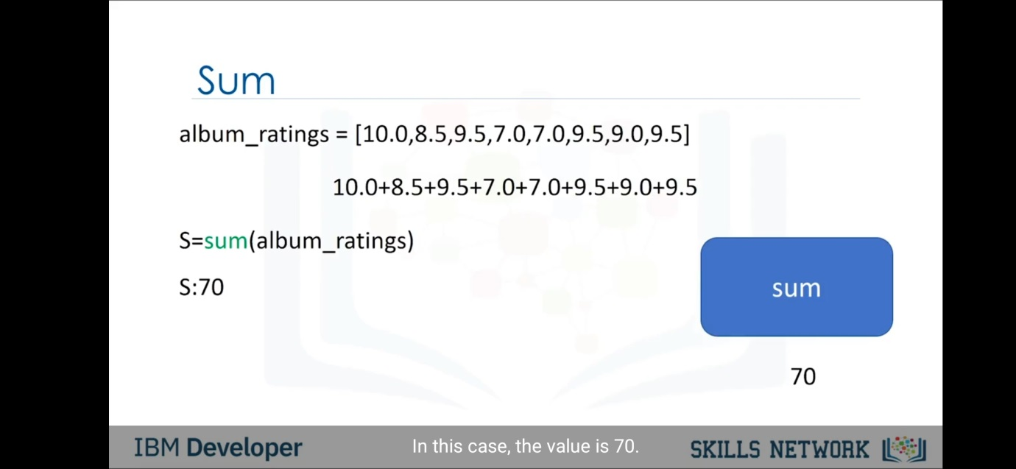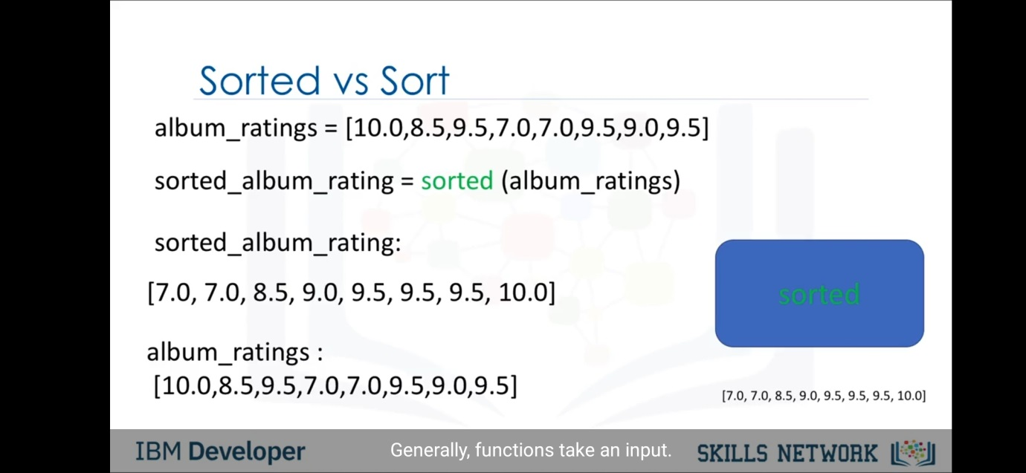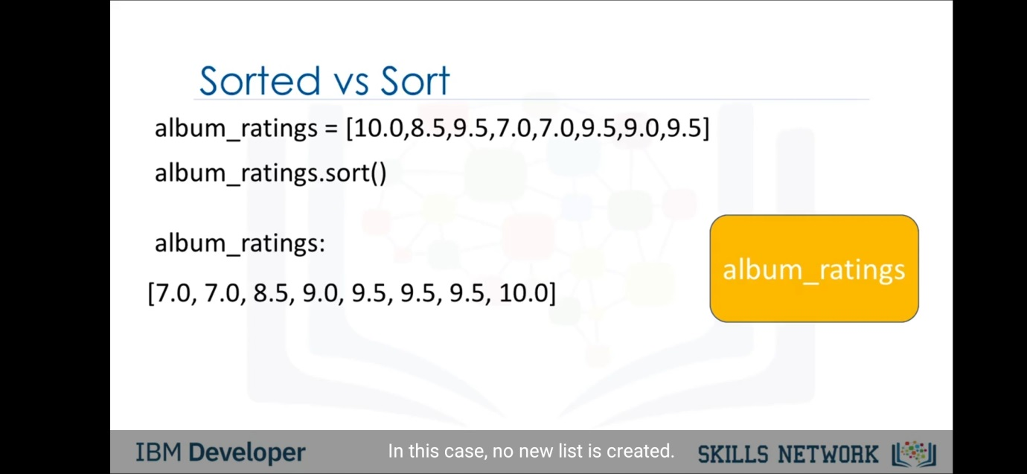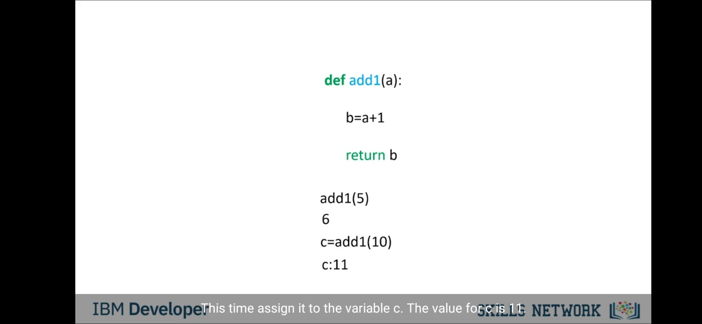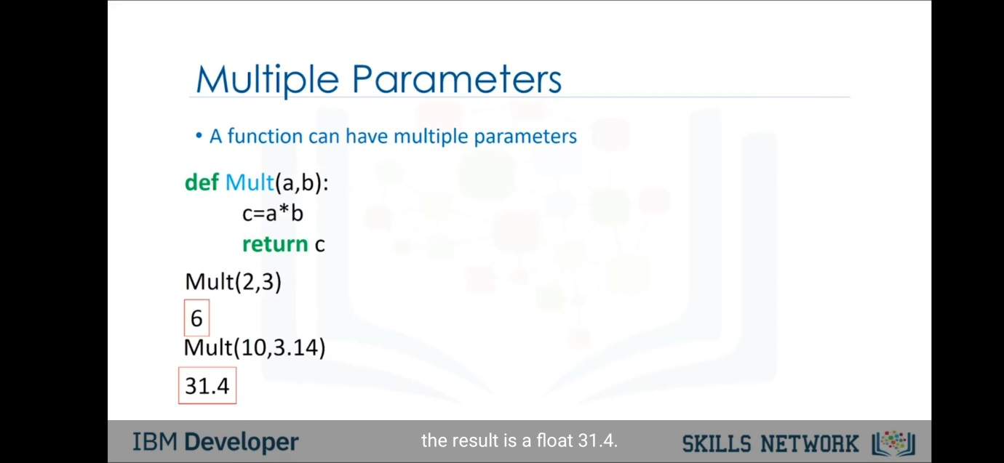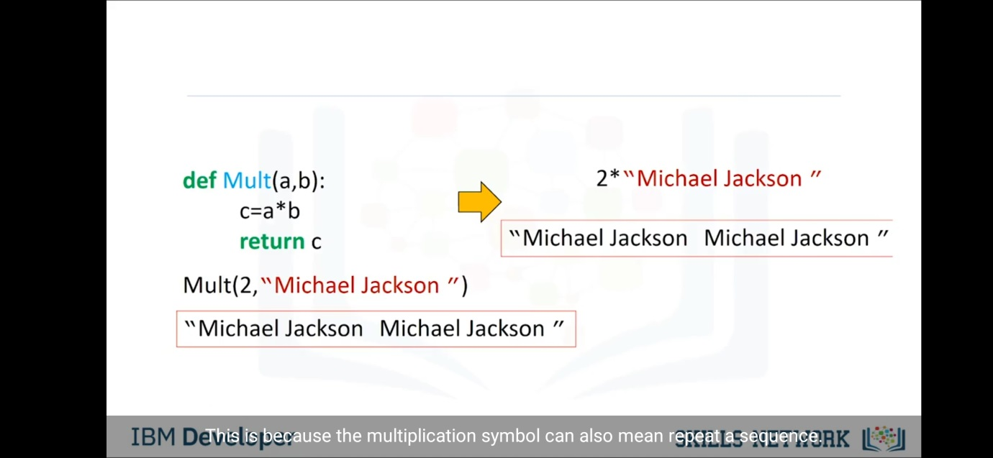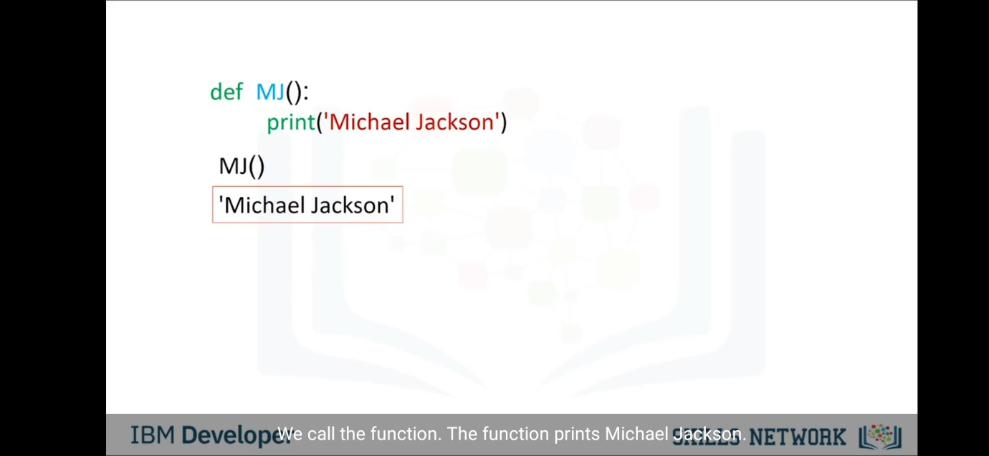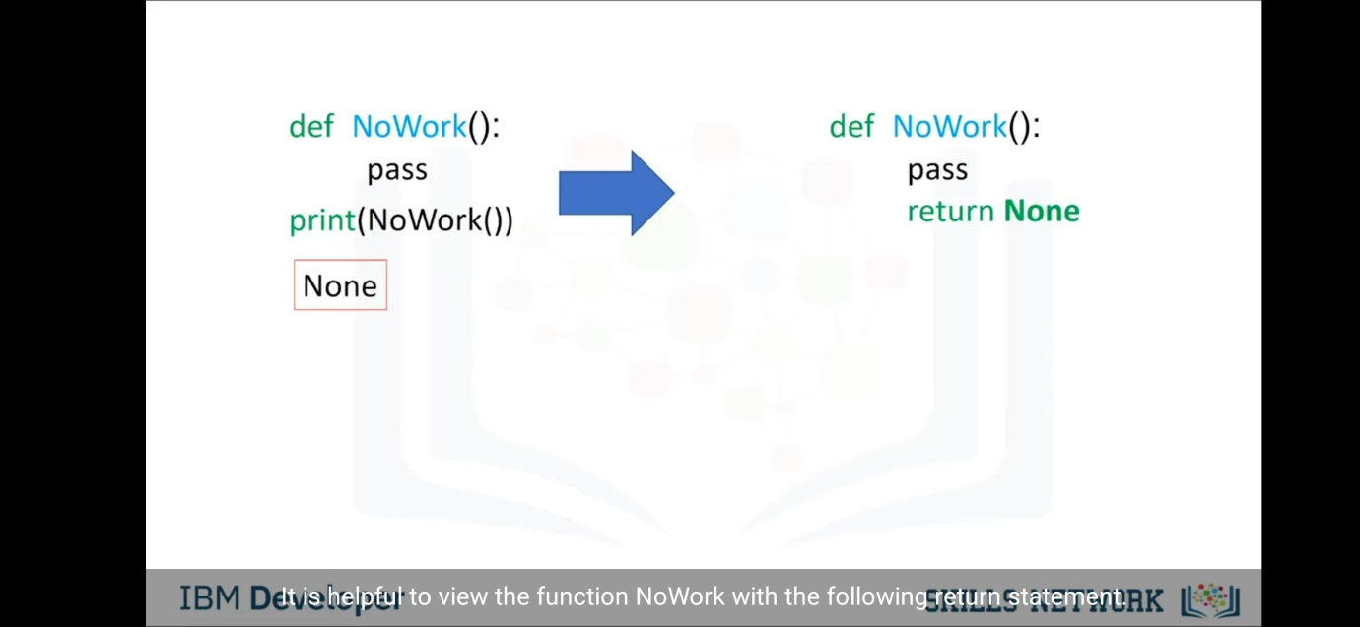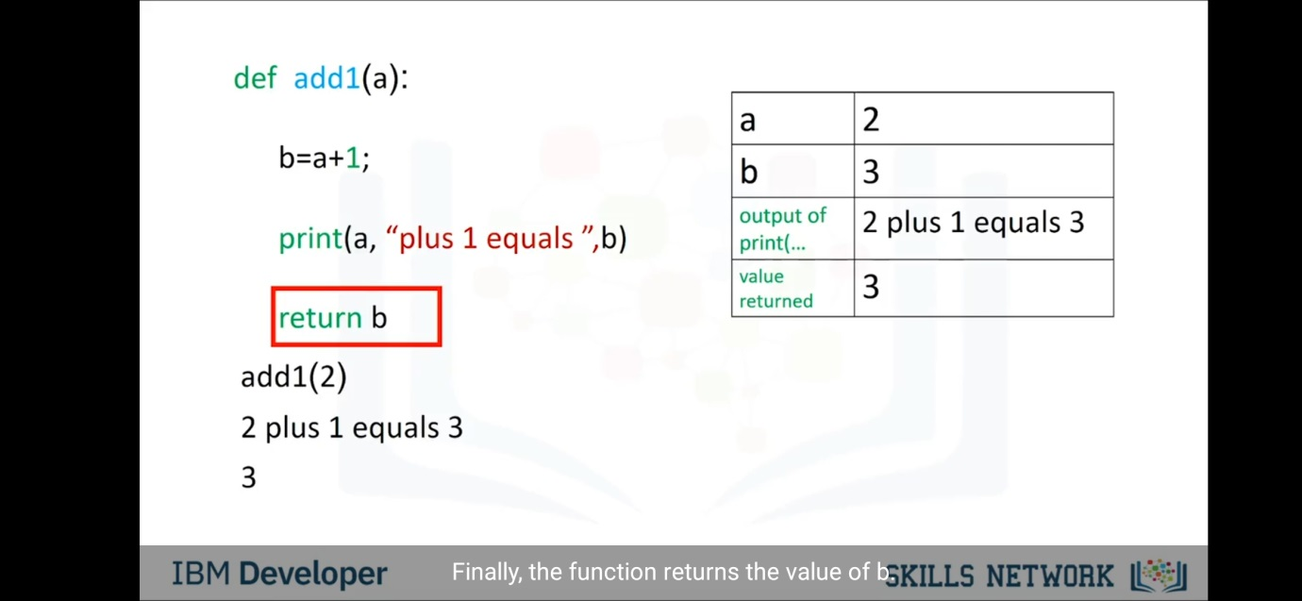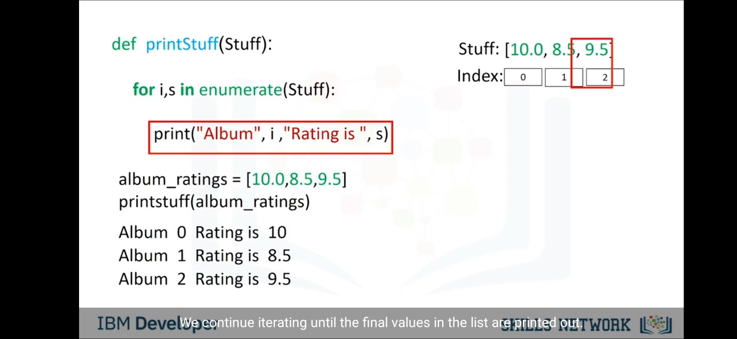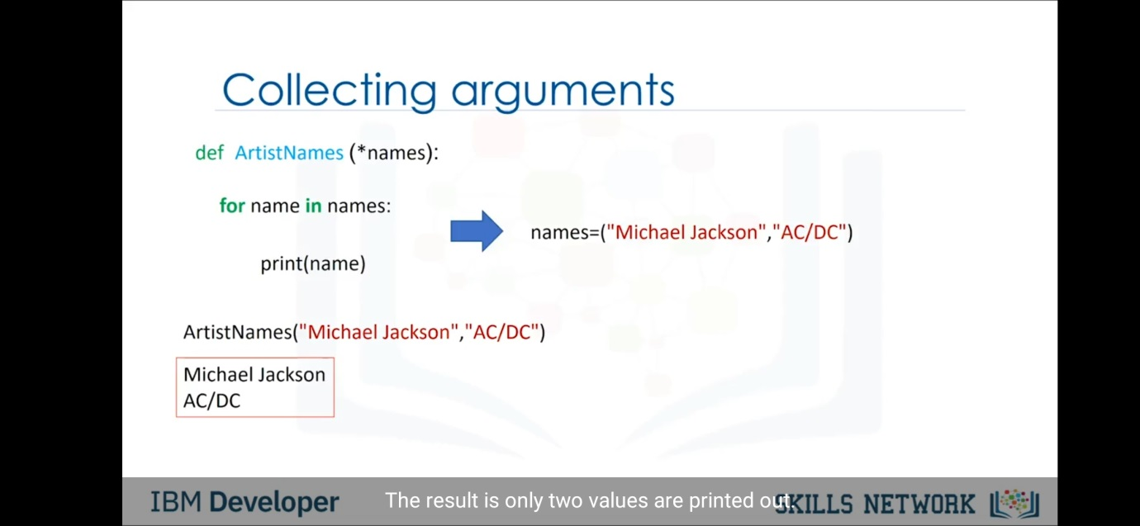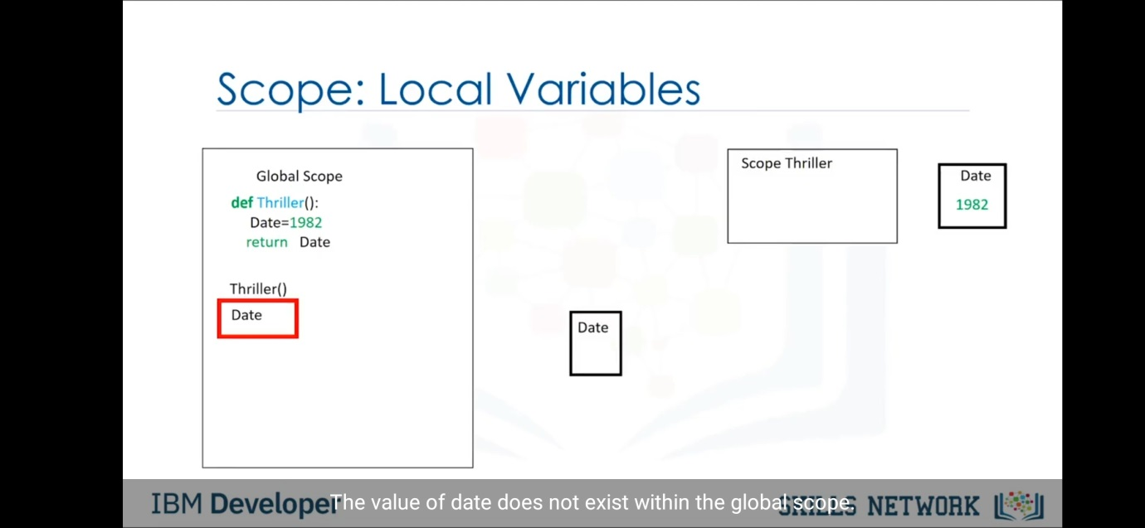 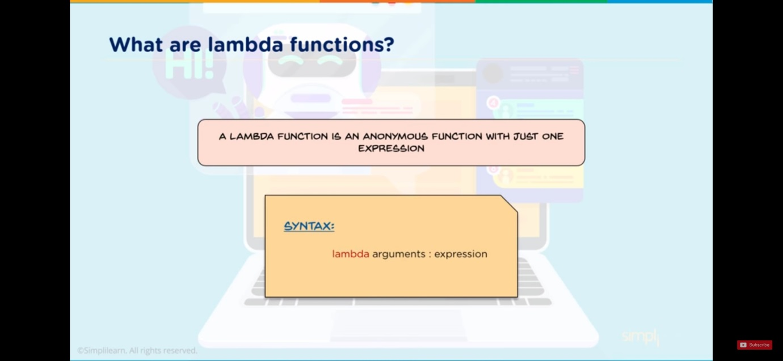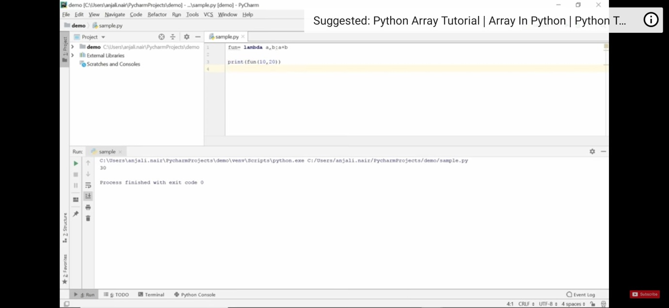

Class & Objects-

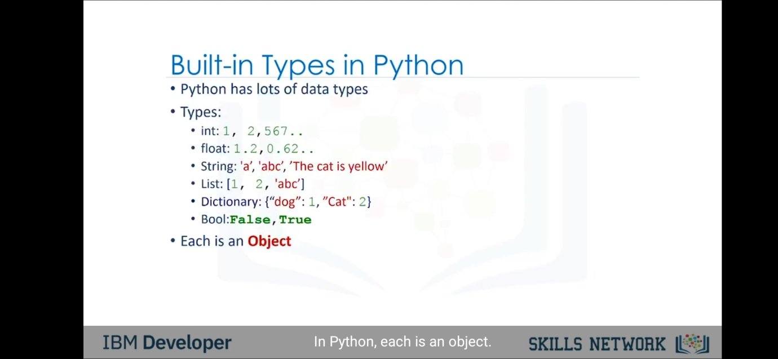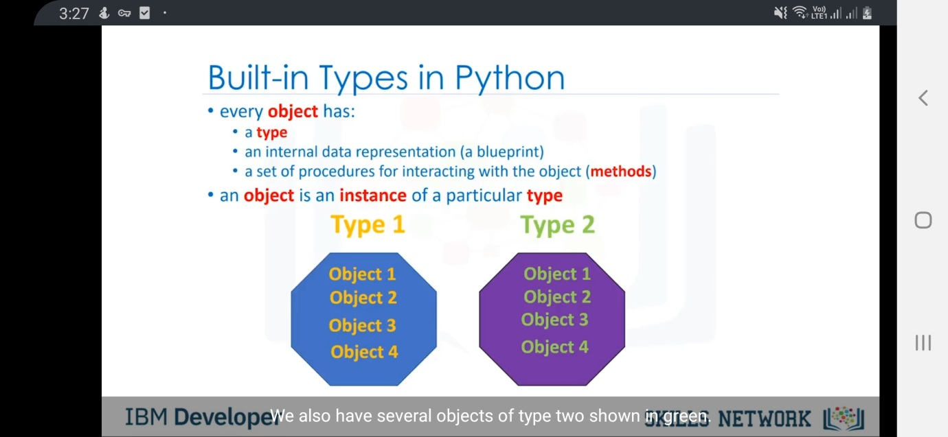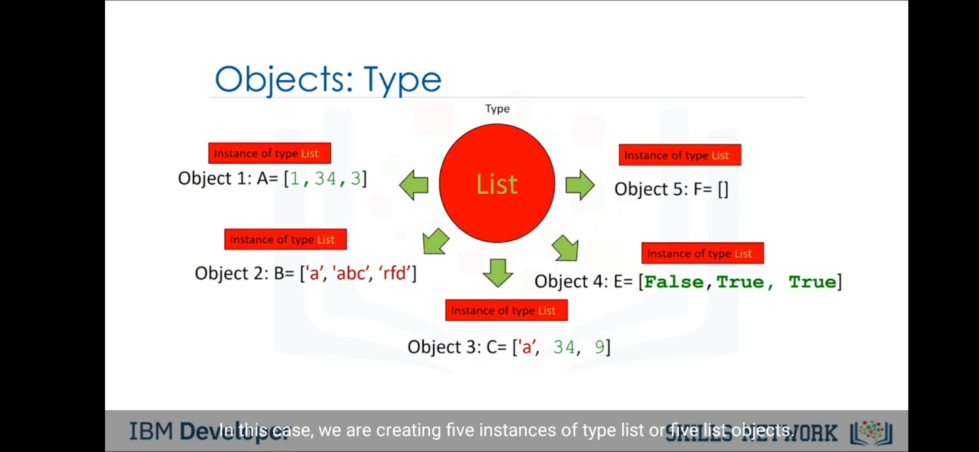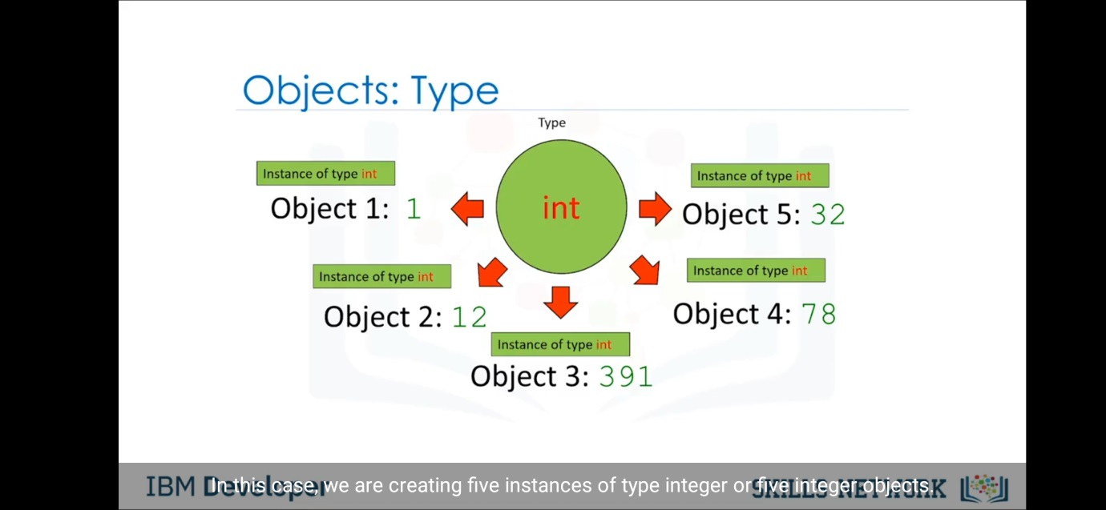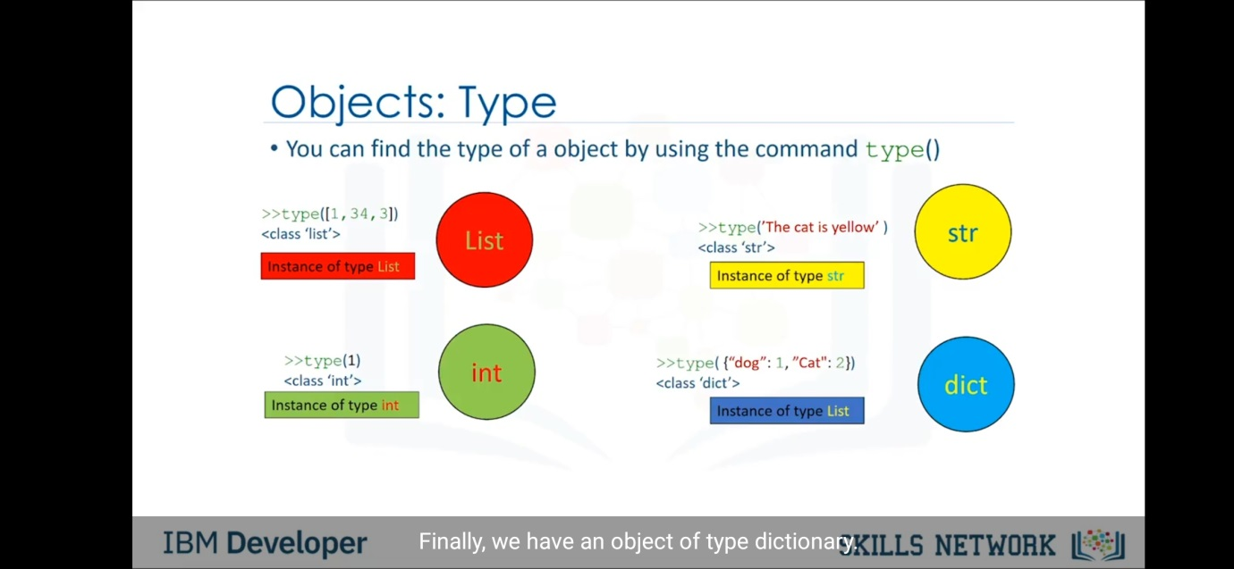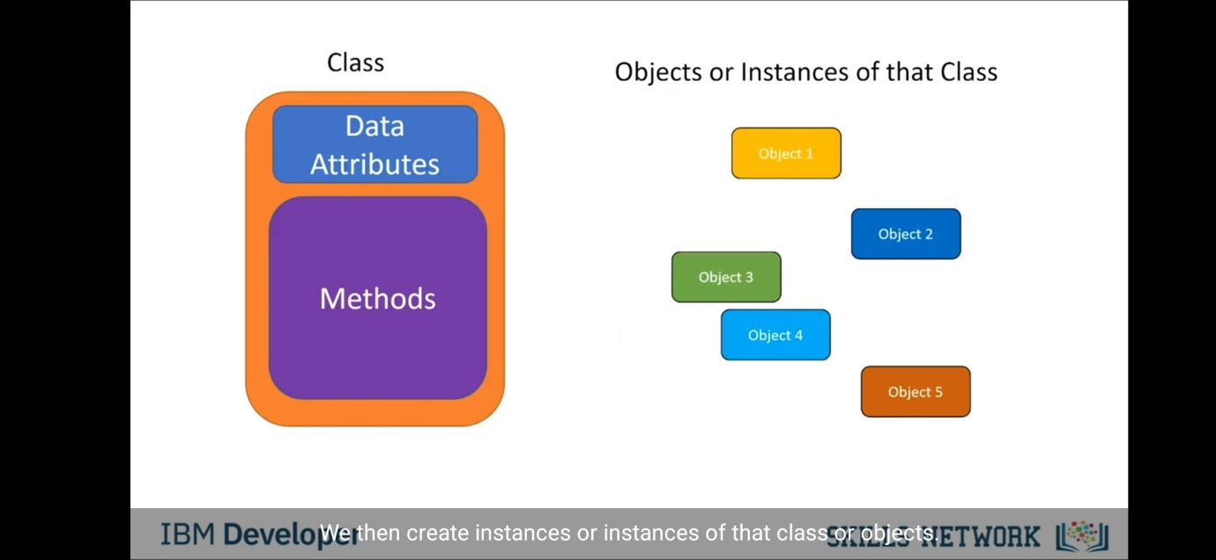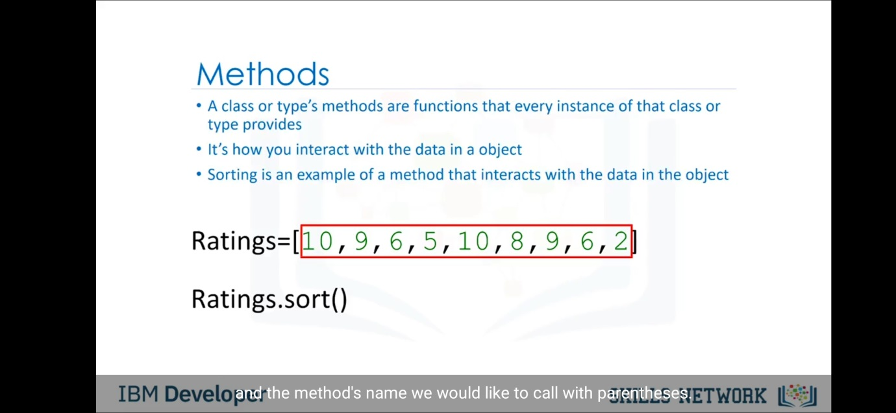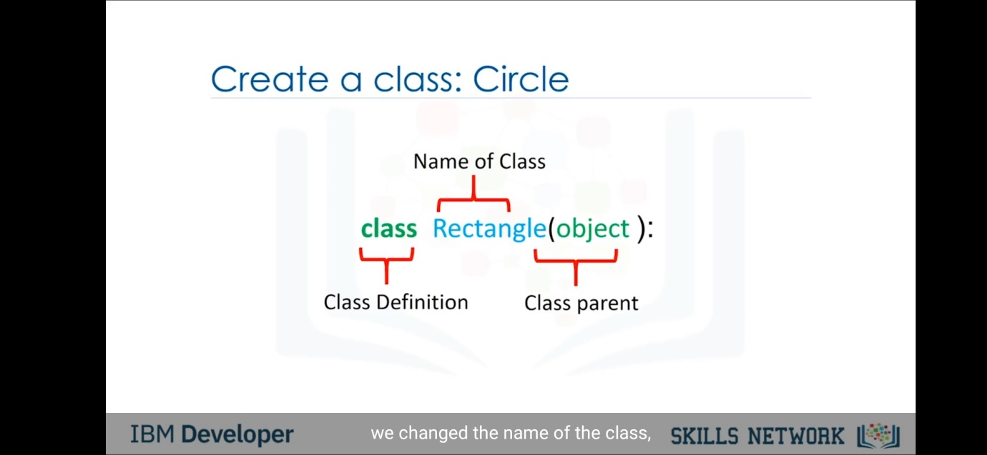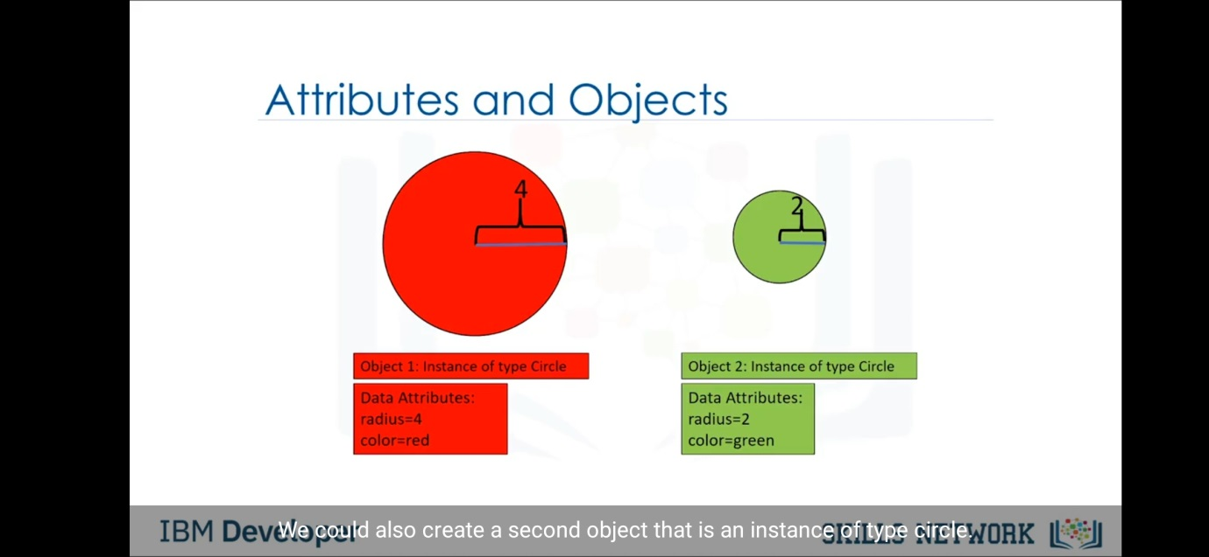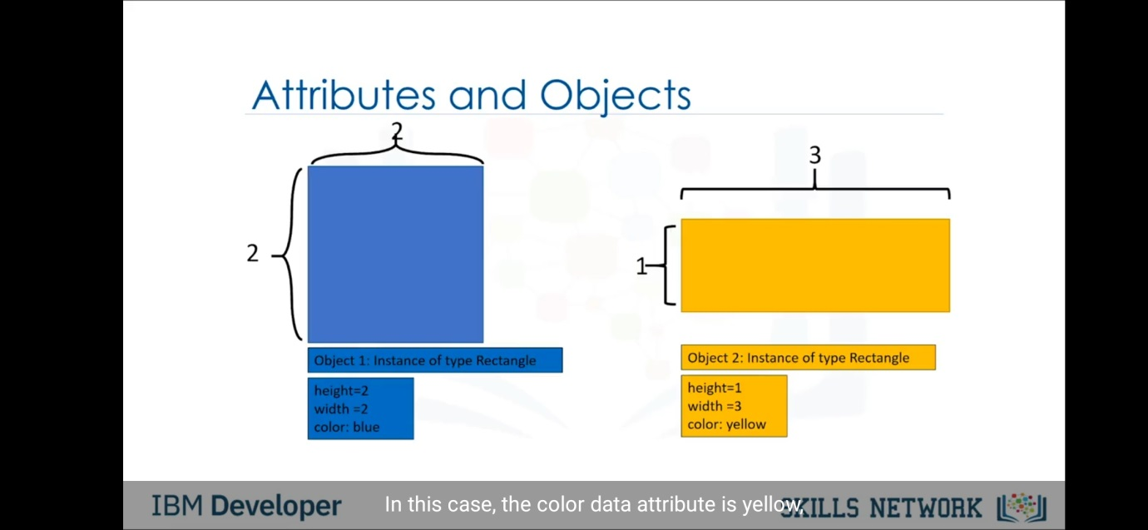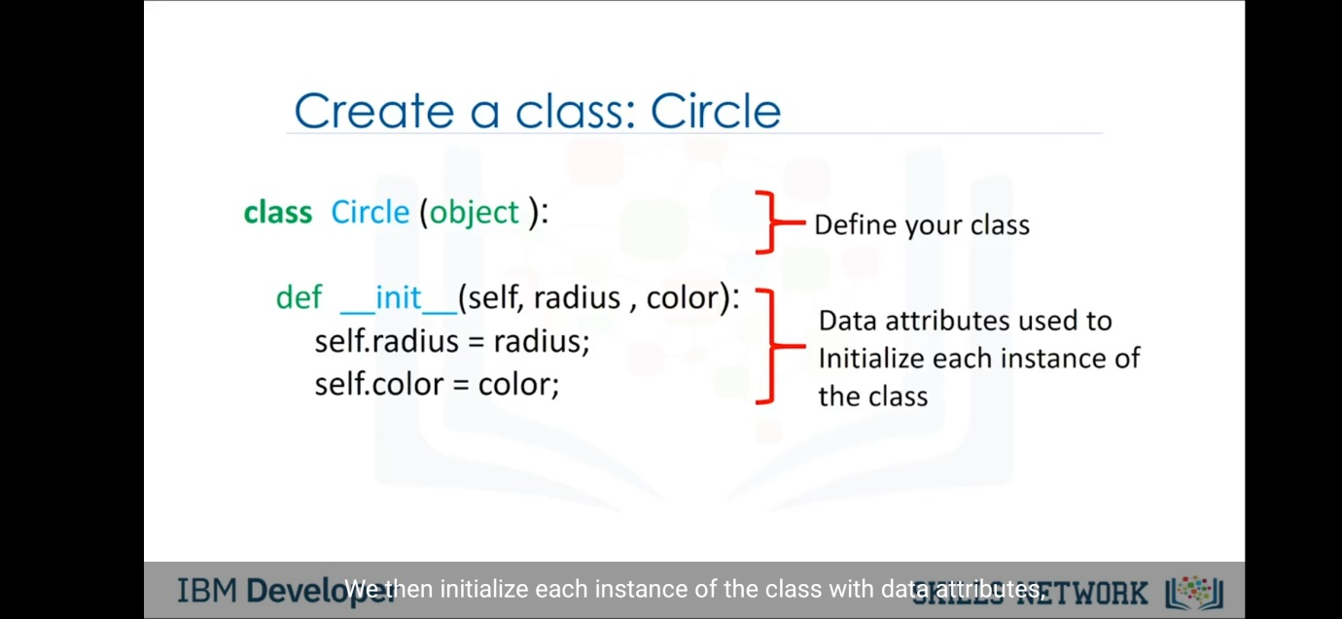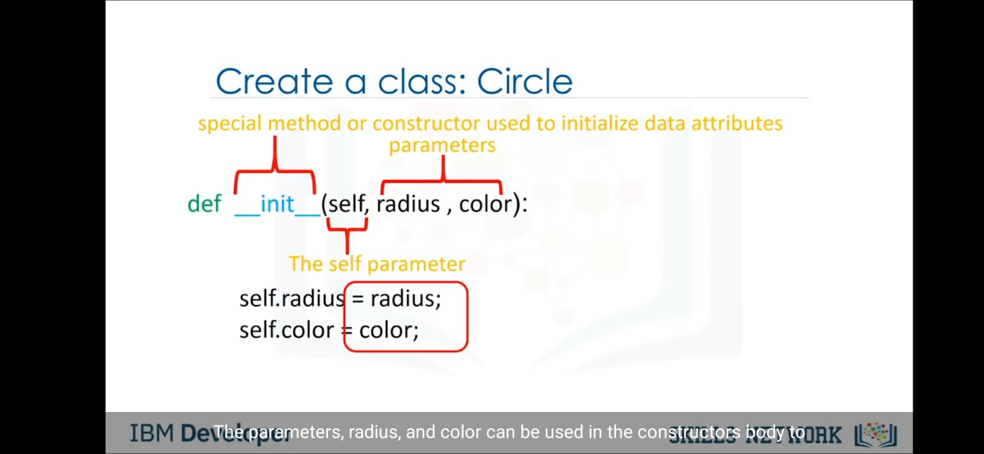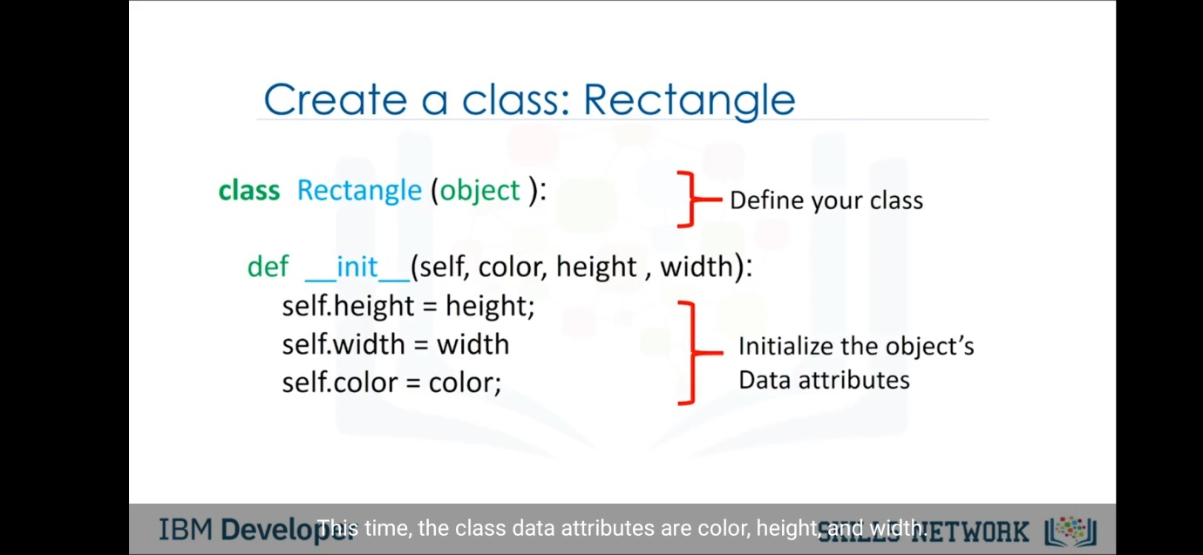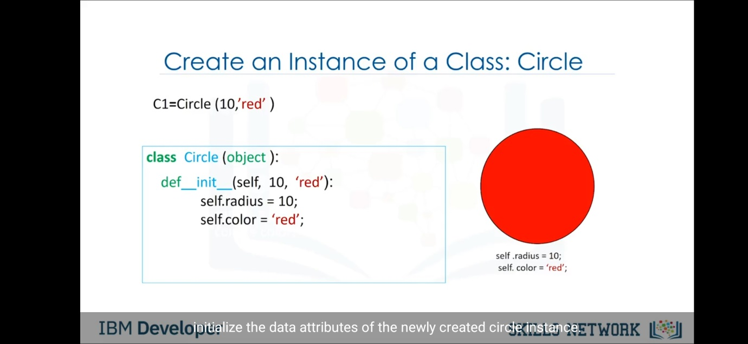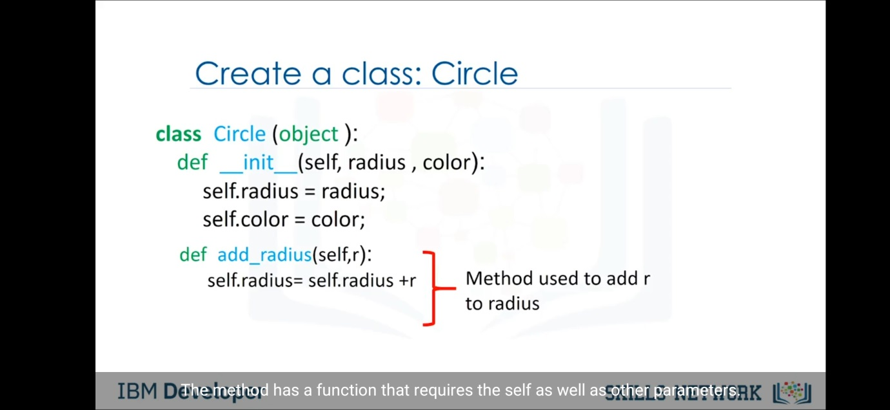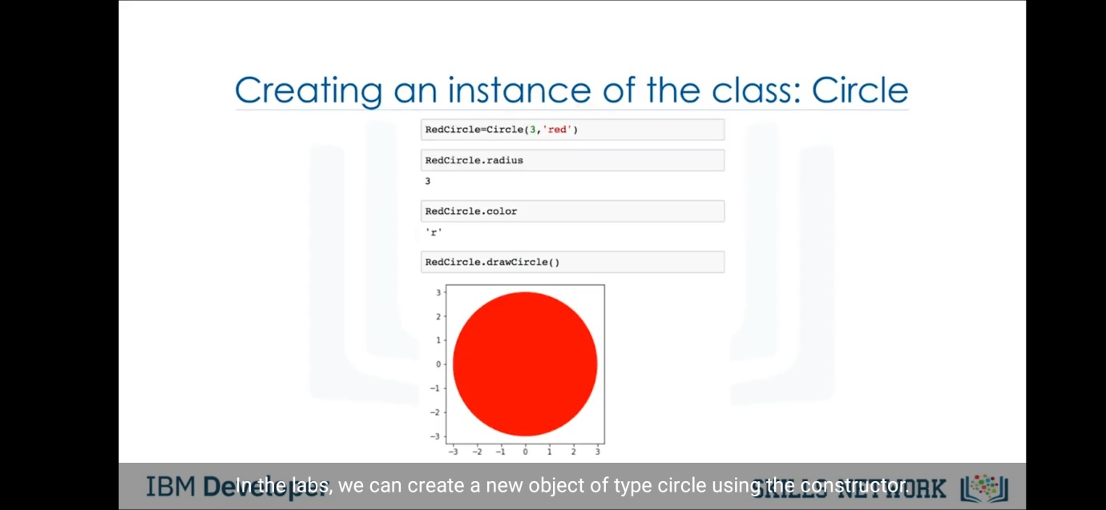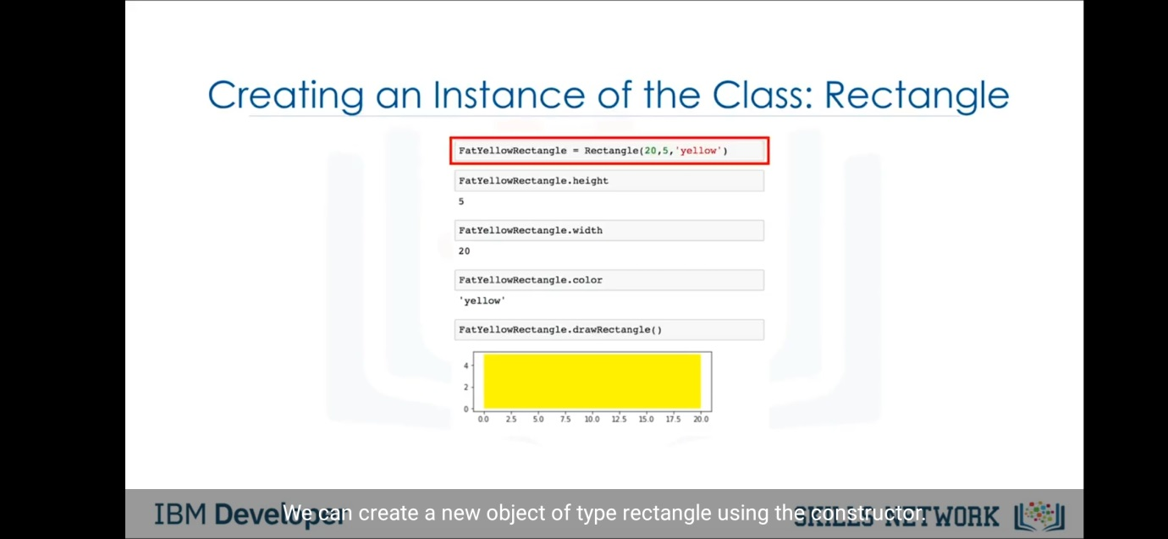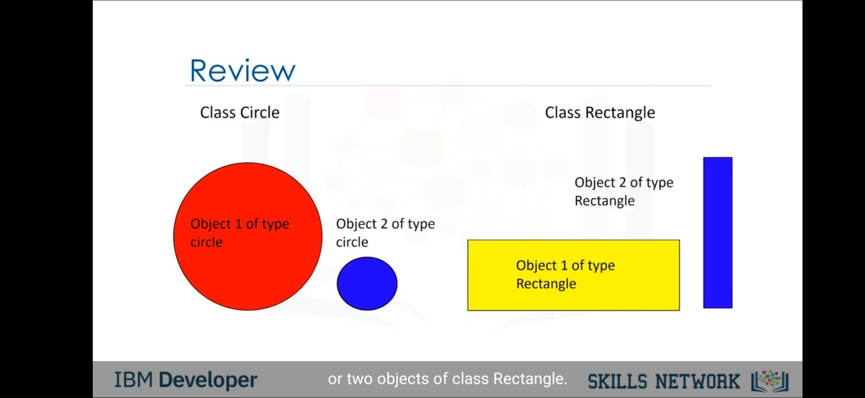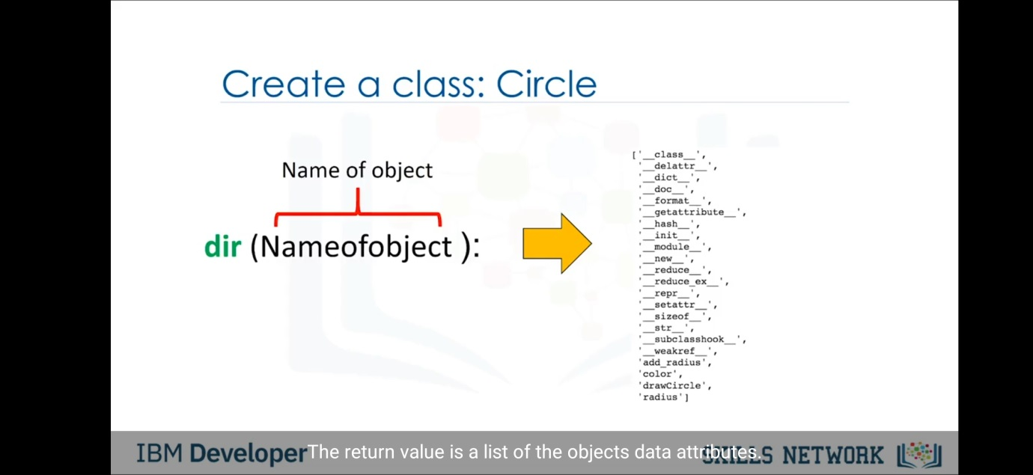

Open file in python-

"r" - Read - Default value. Opens a file for reading, error if the file does not exist

"a" - Append - Opens a file for appending, creates the file if it does not exist

"w" - Write - Opens a file for writing, creates the file if it does not exist

"x" - Create - Creates the specified file, returns an error if the file exists

"t" - Text - Default value. Text mode

"b" - Binary - Binary mode (e.g. images)

e.g.,

f = open("demofile.txt", "rt")

print(f.read())

Here "r" for read, and "t" for text are the default values, you do not need to specify them.

Read one line of the file:

f = open("demofile.txt", "r")  
print(f.readline())

Read two lines of the file:

f = open("demofile.txt", "r")  
print(f.readline())  
print(f.readline())

Close the file when you are finish with it:

f = open("demofile.txt", "r")  
print(f.readline())  
f.close()

Open the file "demofile2.txt" and append content to the file:

f = open("demofile2.txt", "a")  
f.write("Now the file has more content!")  
f.close()  
  
#open and read the file after the appending:  
f = open("demofile2.txt", "r")  
print(f.read())

Open the file "demofile3.txt" and overwrite the content:

f = open("demofile3.txt", "w")  
f.write("Woops! I have deleted the content!")  
f.close()  
  
#open and read the file after the appending:  
f = open("demofile3.txt", "r")  
print(f.read())

Create a file called "myfile.txt":

f = open("myfile.txt", "x")

Remove the file "demofile.txt":

import os  
os.remove("demofile.txt")

Check if file exists, then delete it:

import os  
if os.path.exists("demofile.txt"):  
  os.remove("demofile.txt")  
else:  
  print("The file does not exist")

Remove the folder "myfolder":

import os  
os.rmdir("myfolder")

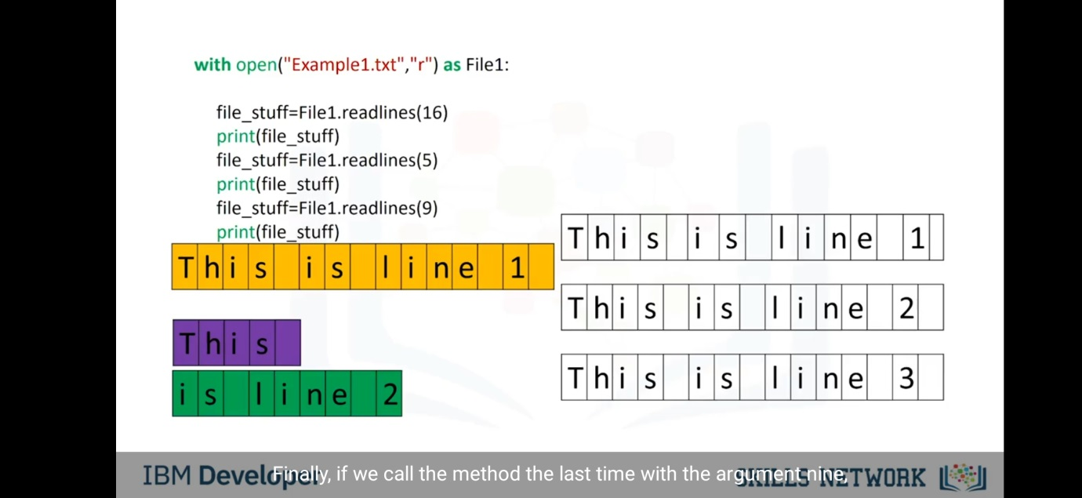

When we use with we no need to close file(it automatically closes).

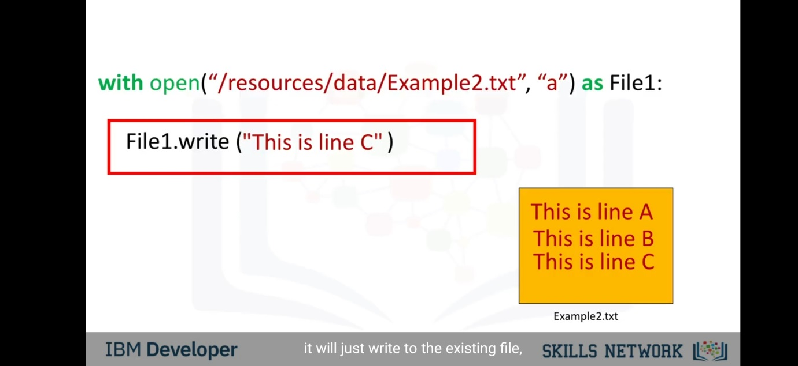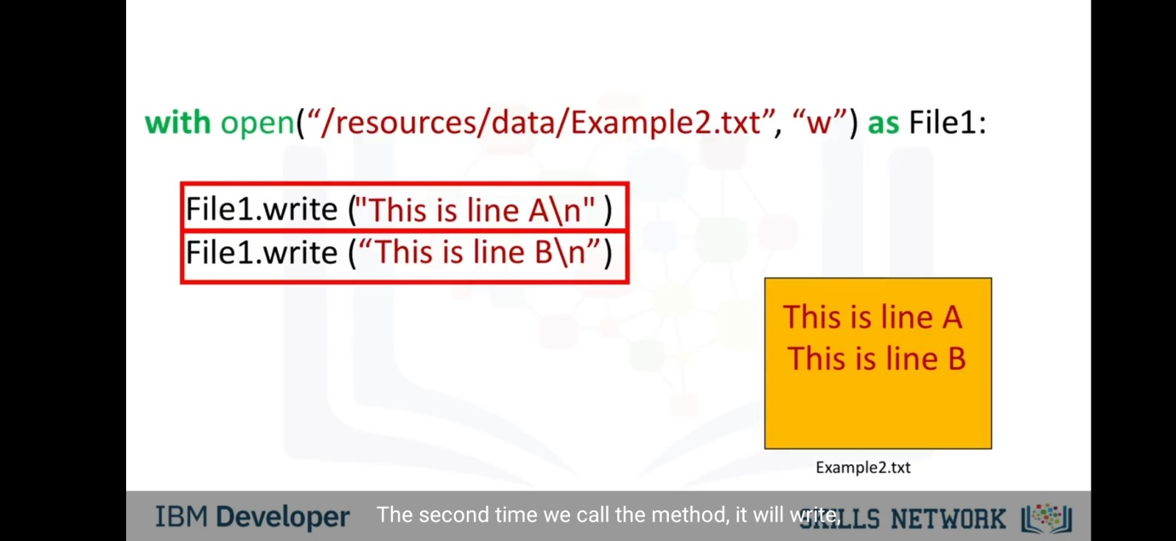 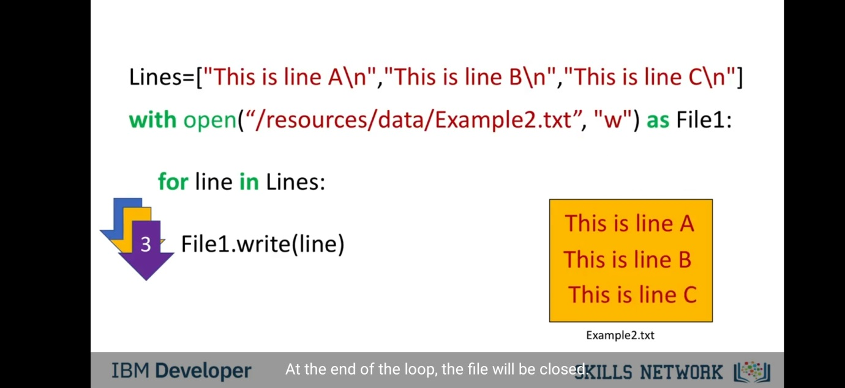 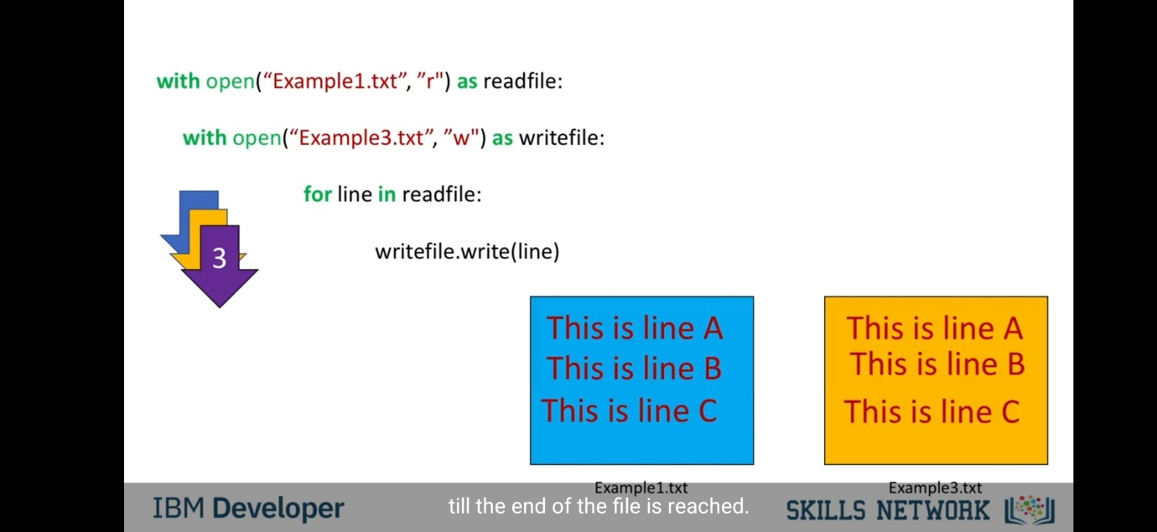

Loading data with Pandas-

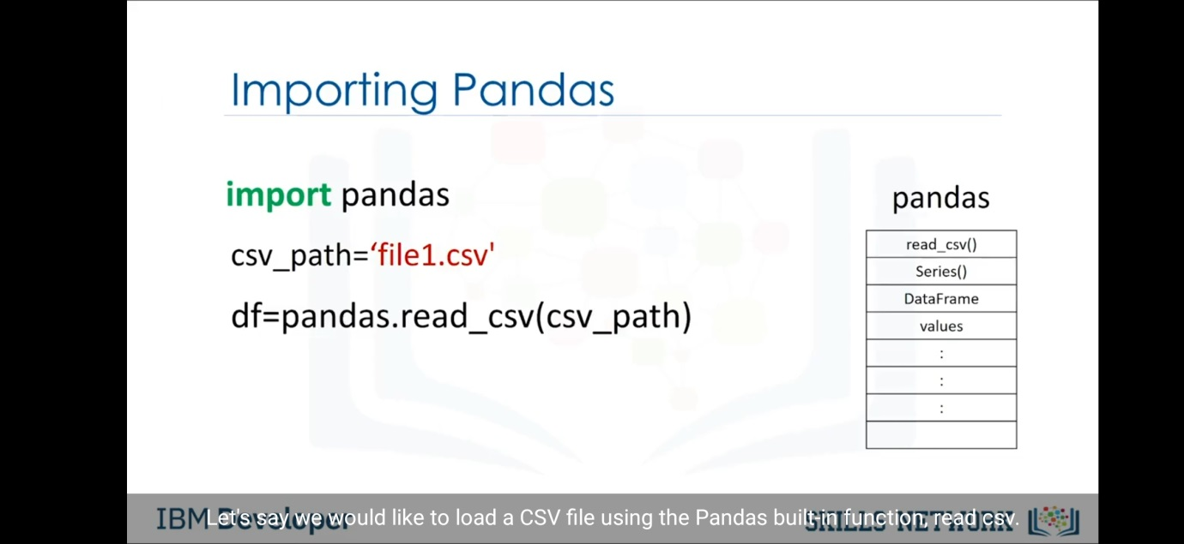 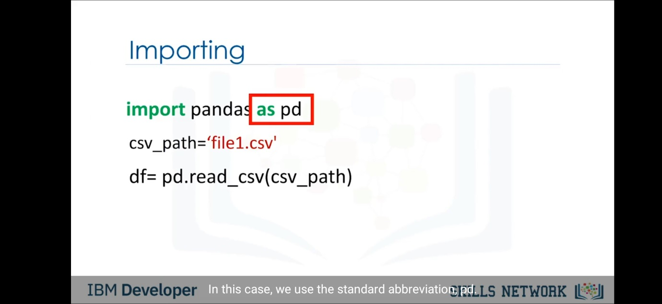 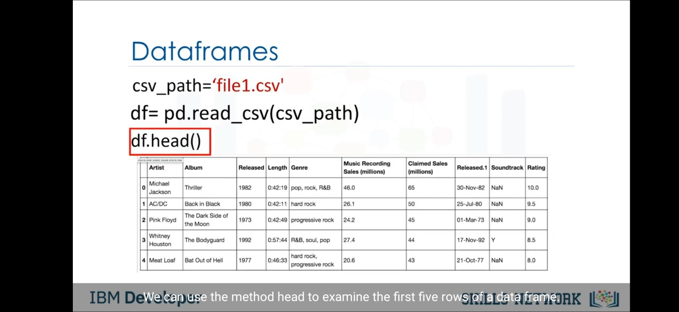 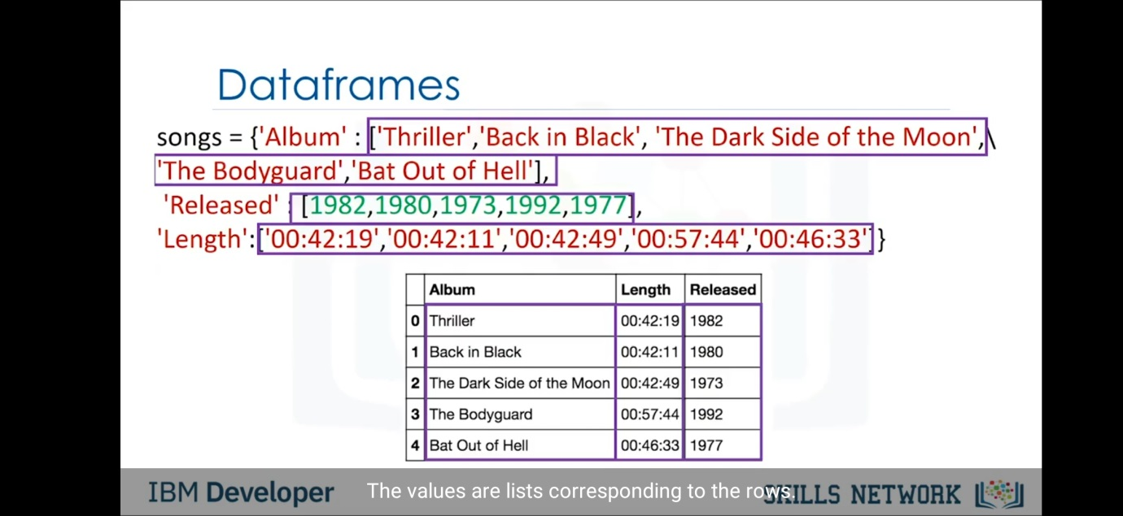 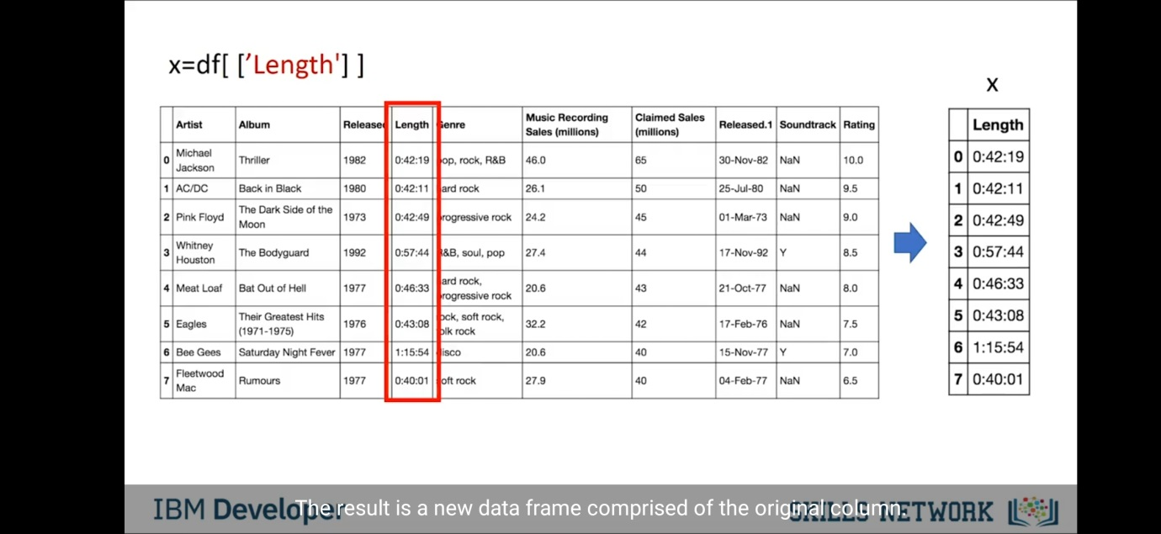 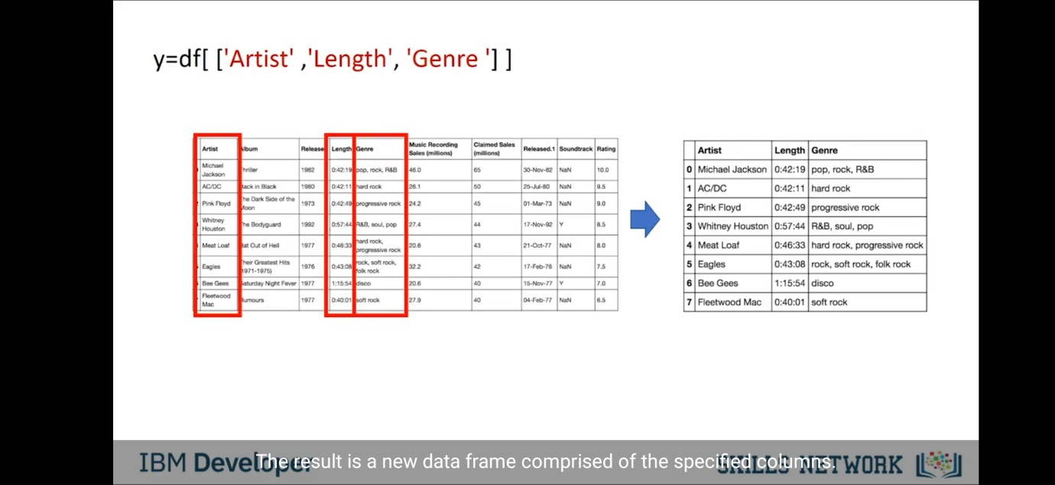

# Using loc, iloc and ix

There are three ways to select data from a data frame in Pandas: loc, iloc, and ix.

## loc

loc is primarily label based; when two arguments are used, you use column headers and row indexes to select the data you want. loc can also take an integer as a row or column number.

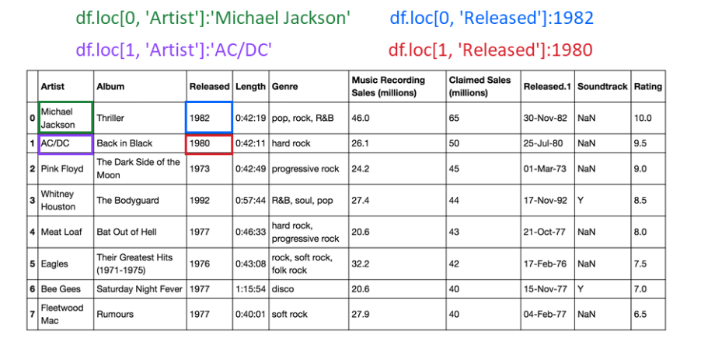

## iloc

iloc is integer-based. You use column numbers and row numbers to get rows or columns at particular positions in the data frame.

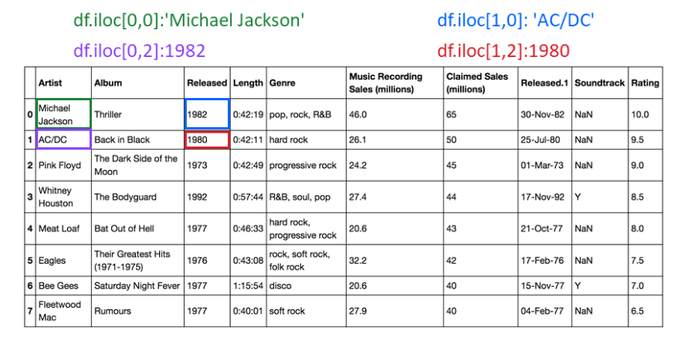

## ix

By default, ix looks for a label. If ix doesn't find a label, it will use an integer. This means you can select data by using either column numbers and row numbers or column headers and row names using ix.

In Pandas version 0.20.0 and later, ix is deprecated.

Slicing-

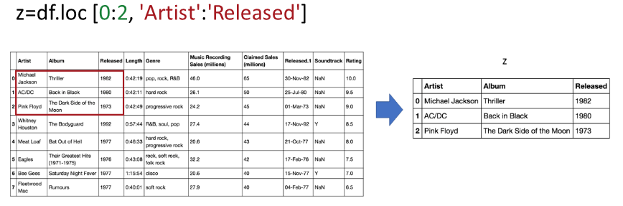 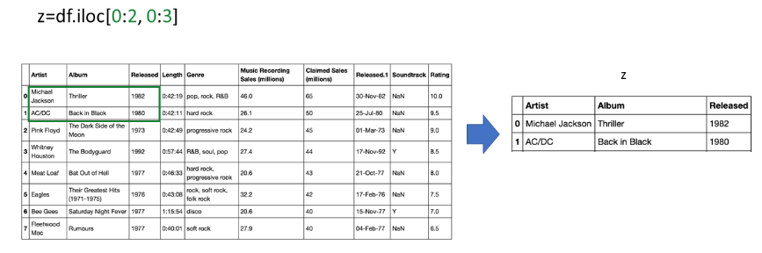

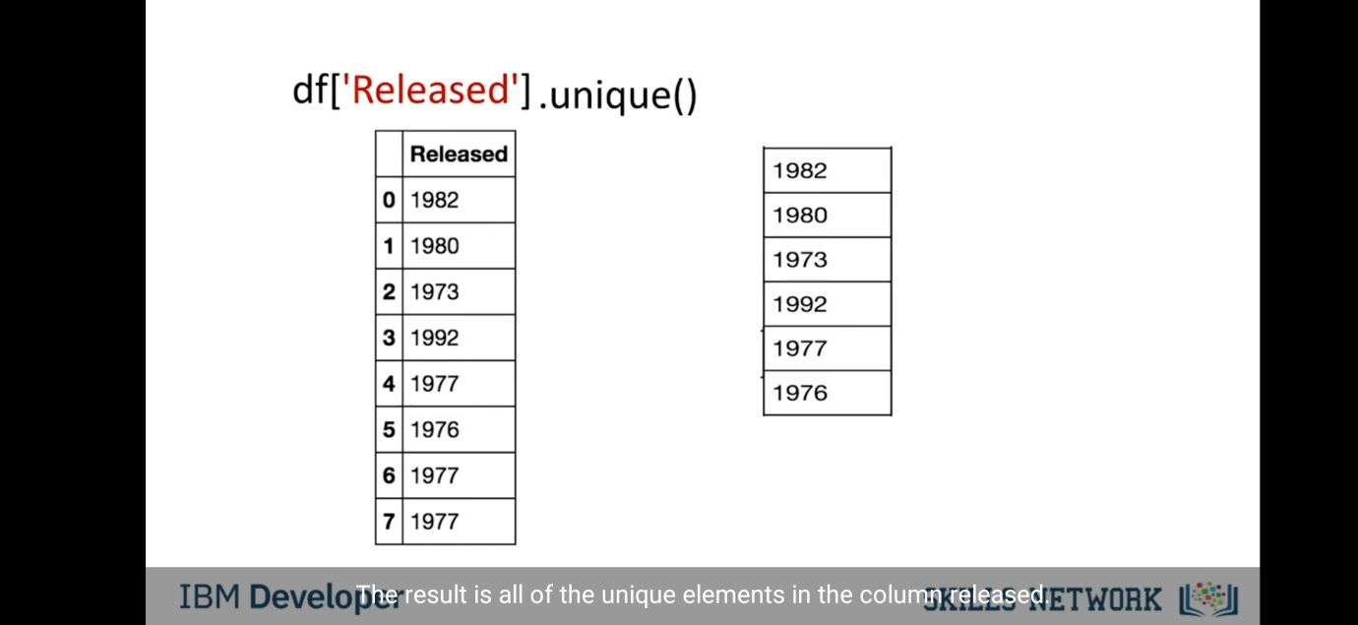

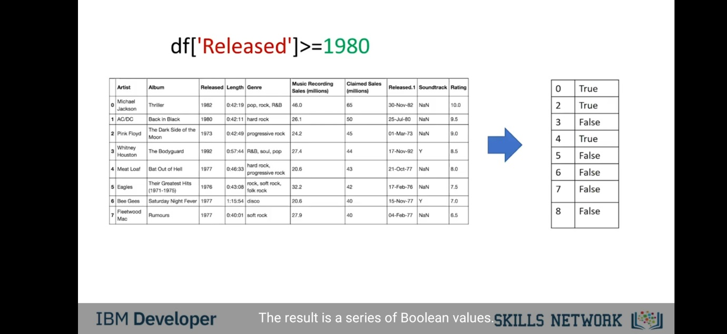 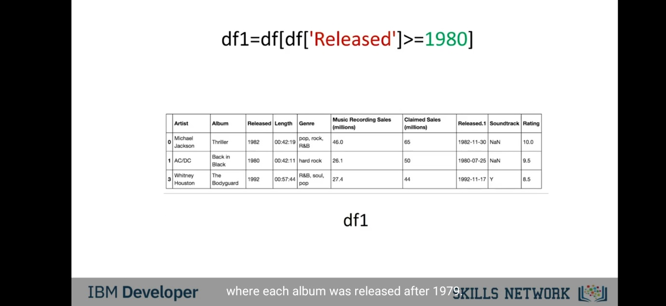 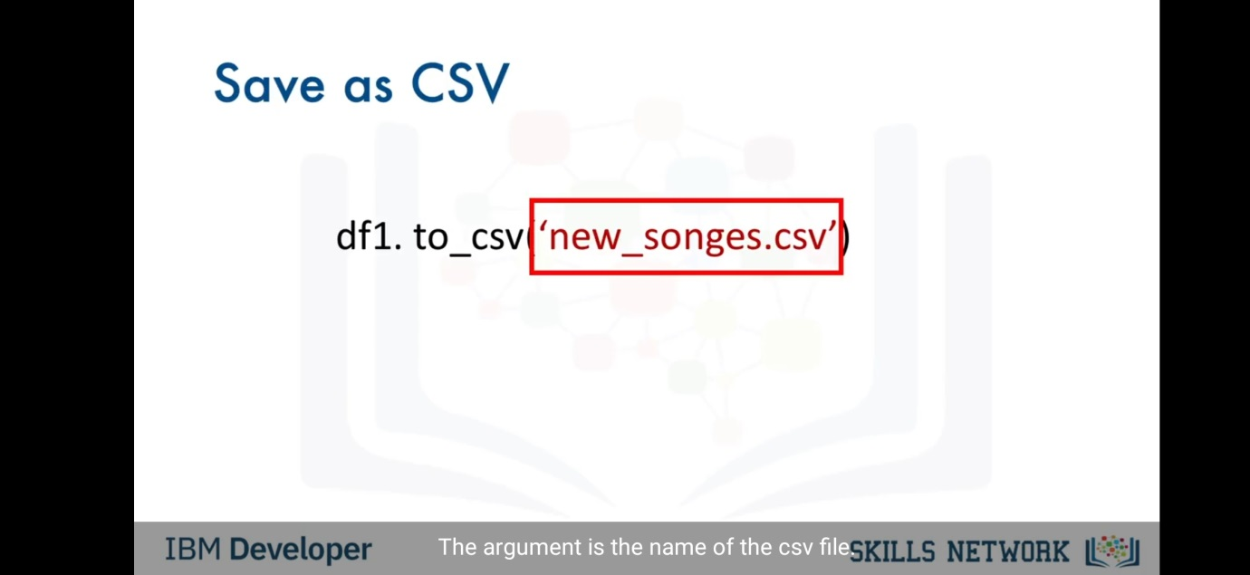

One dimensional Numpy –

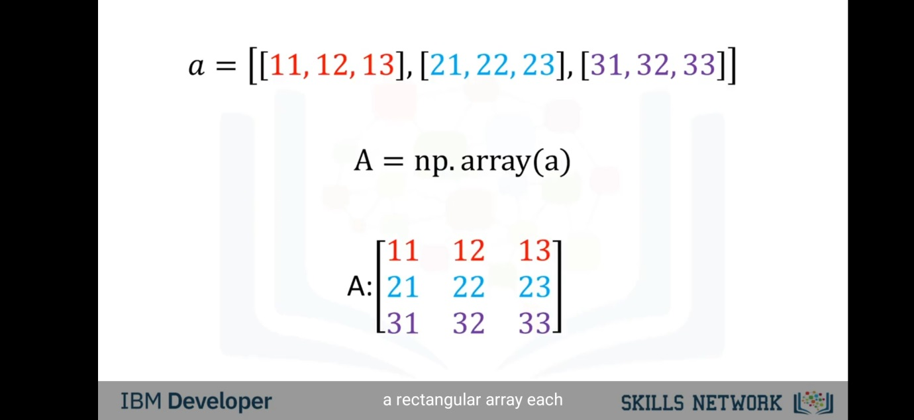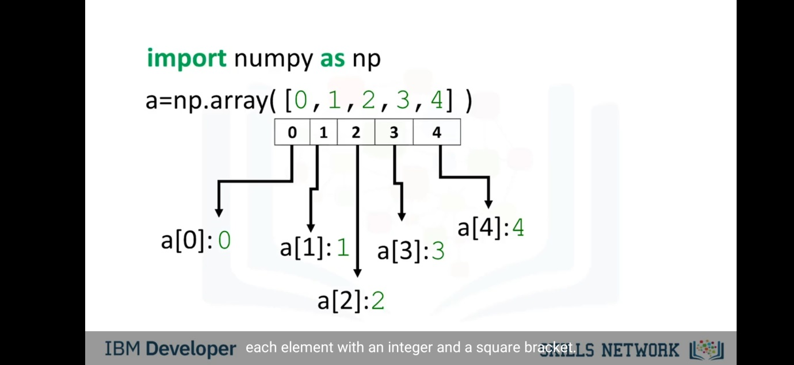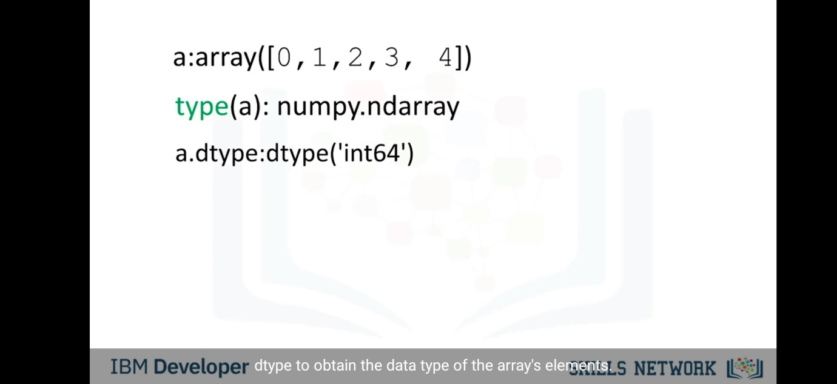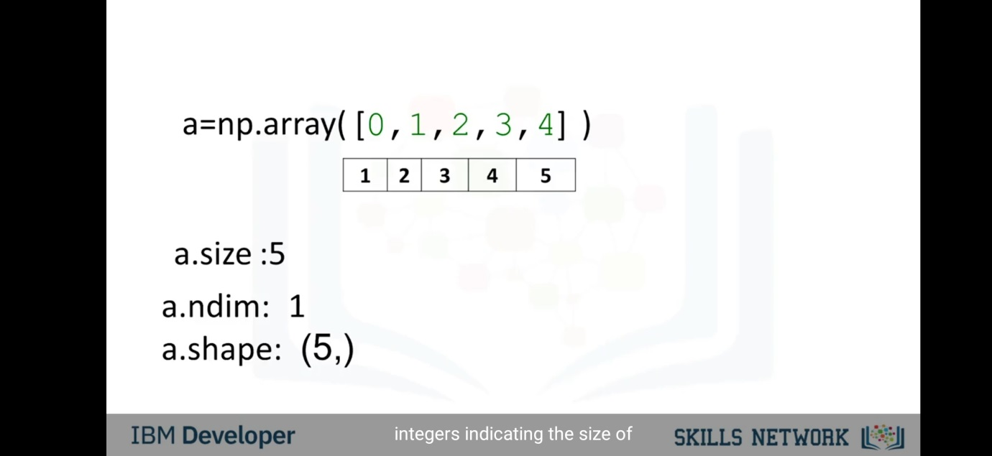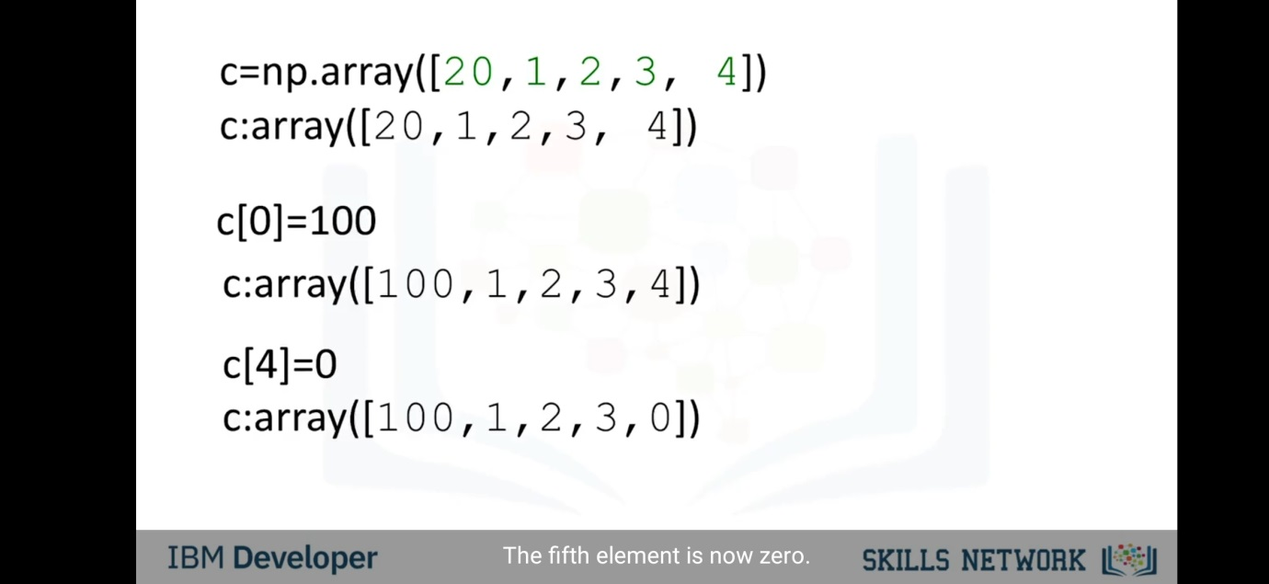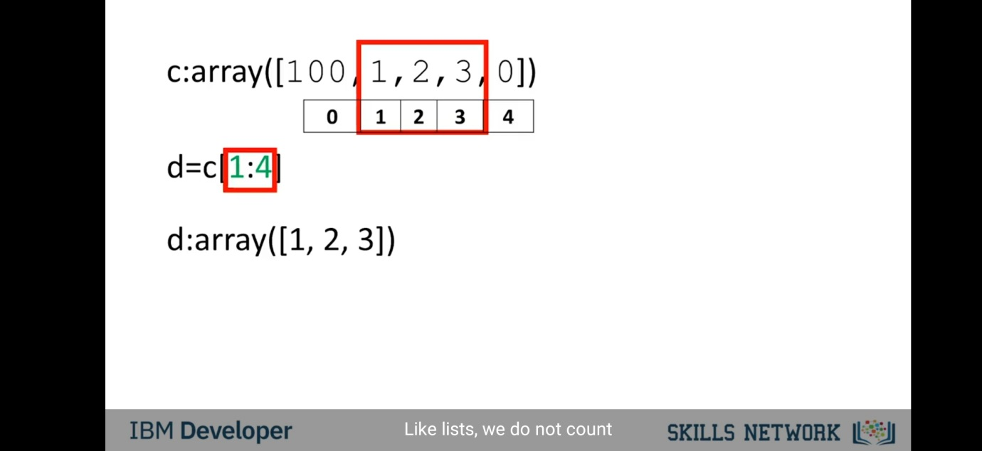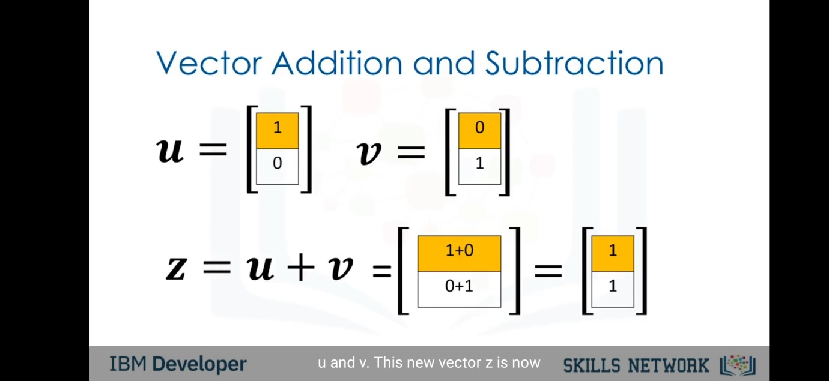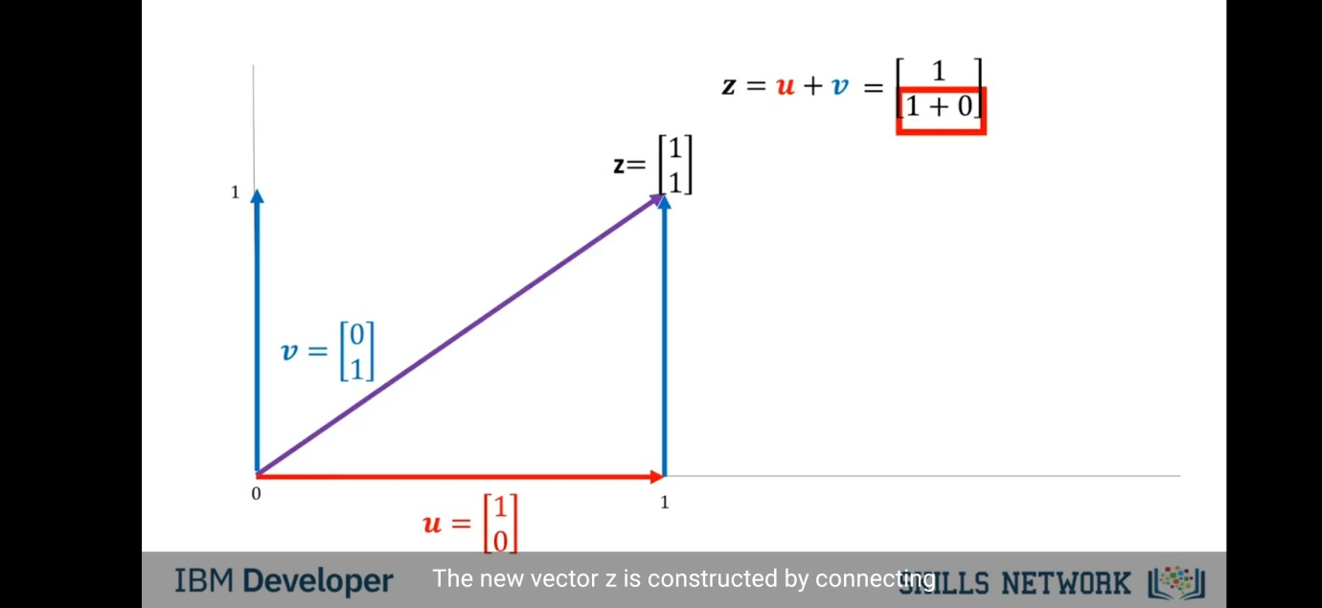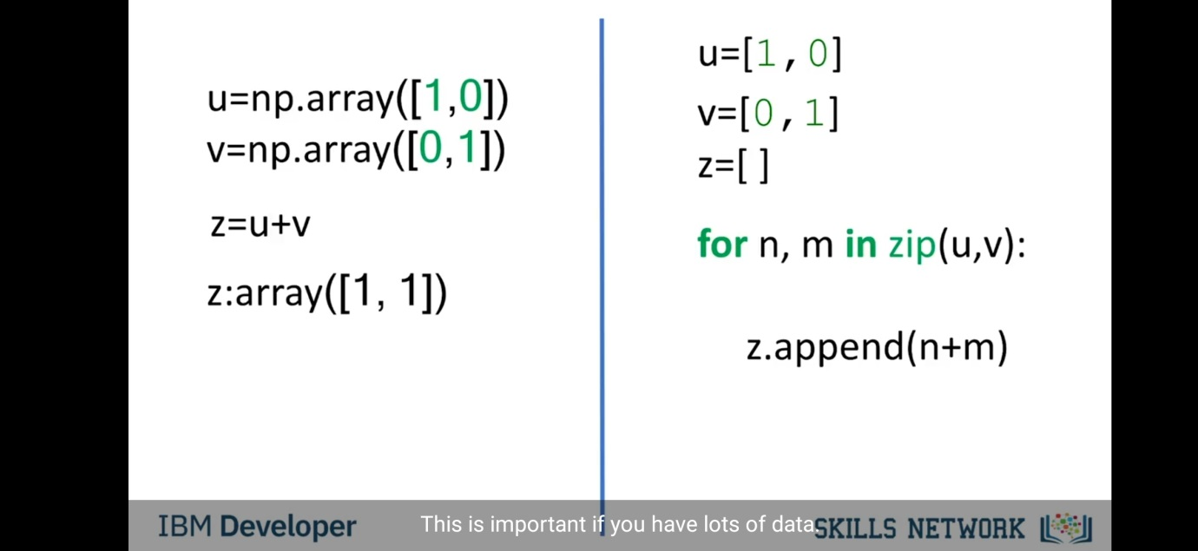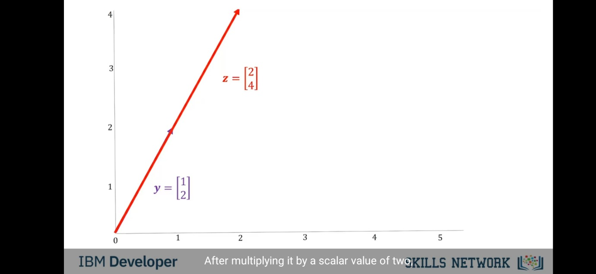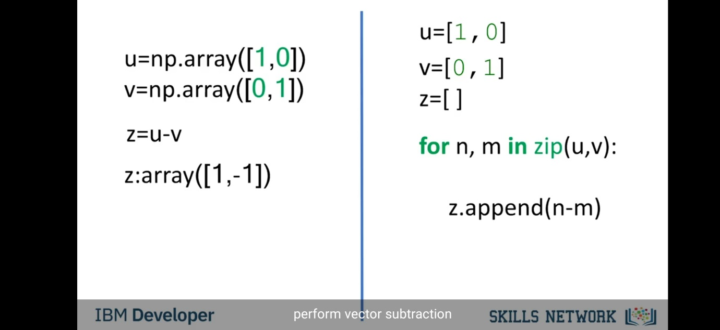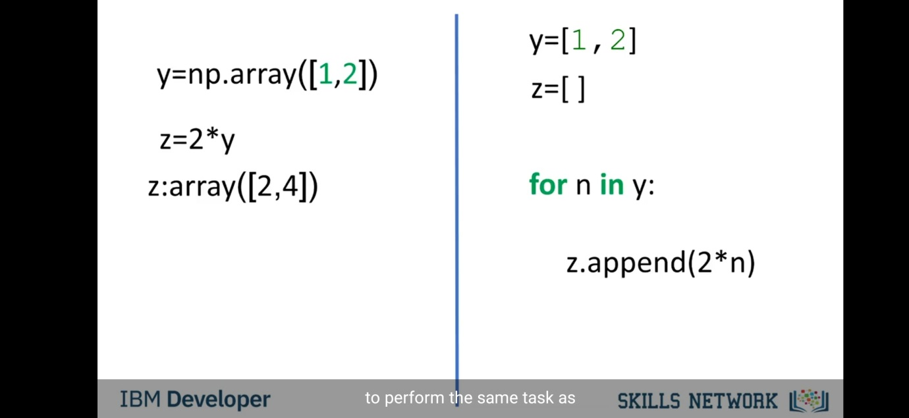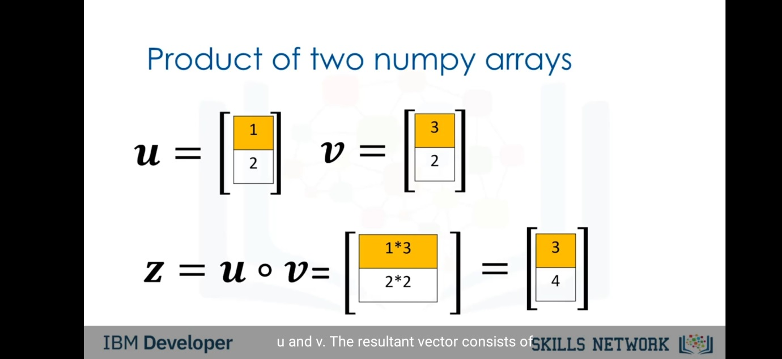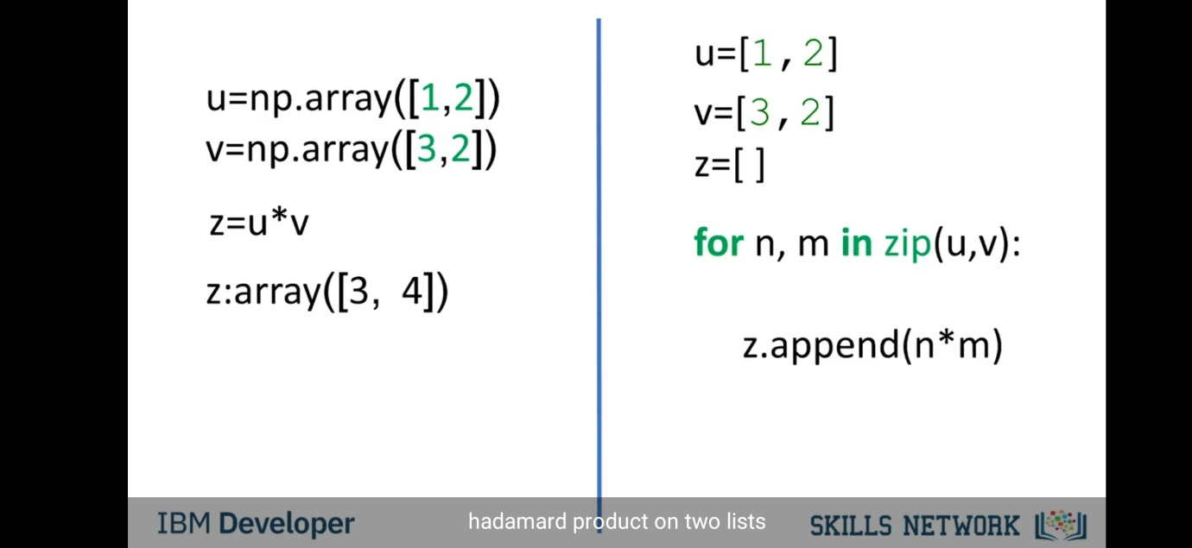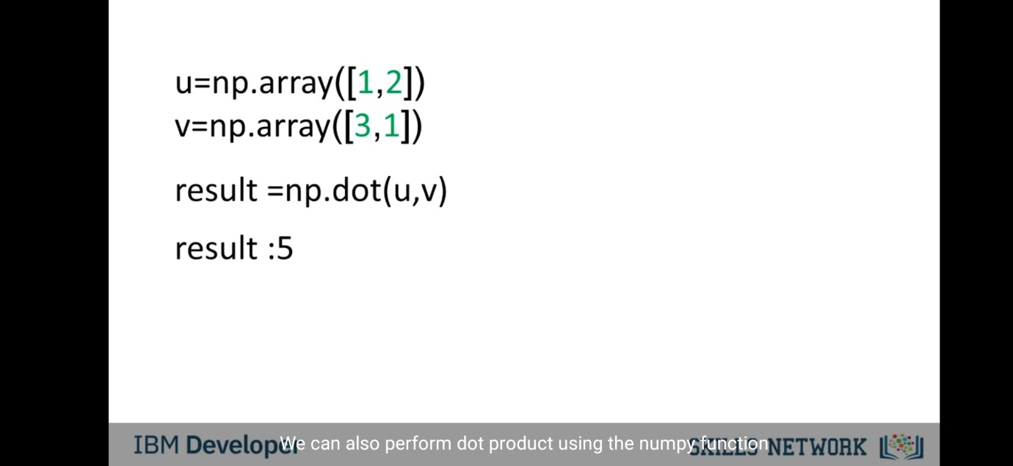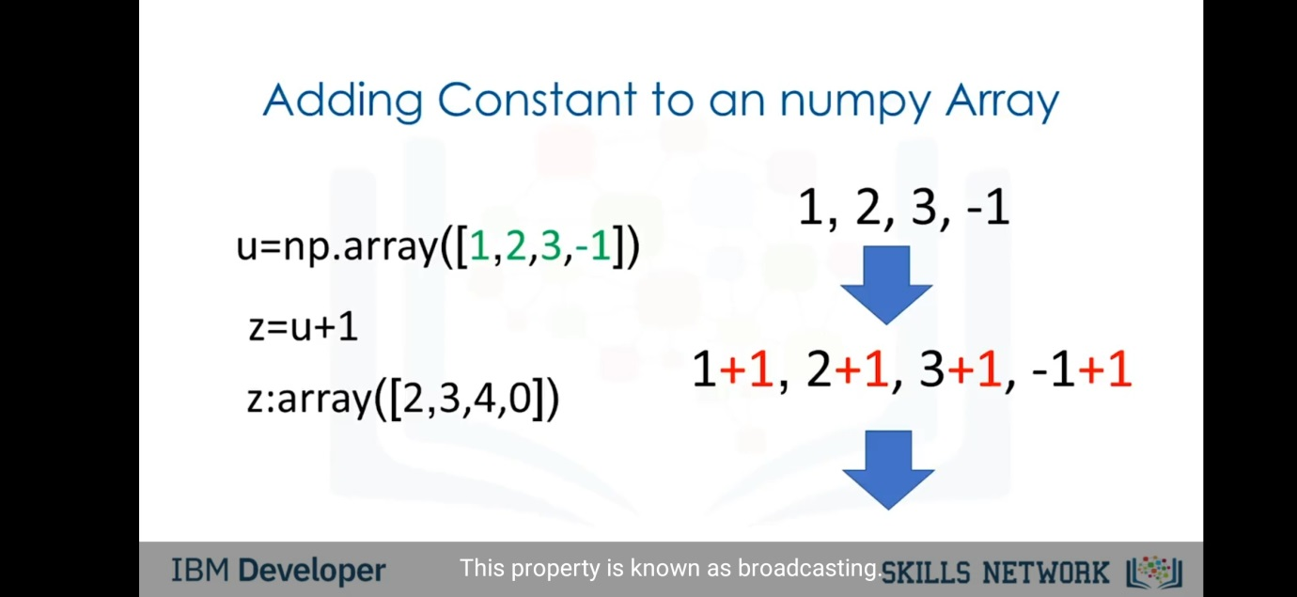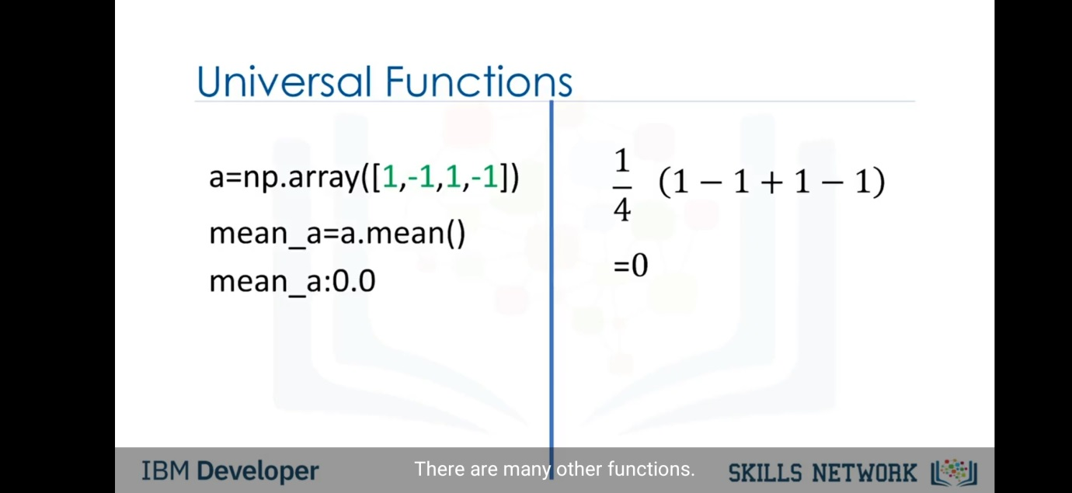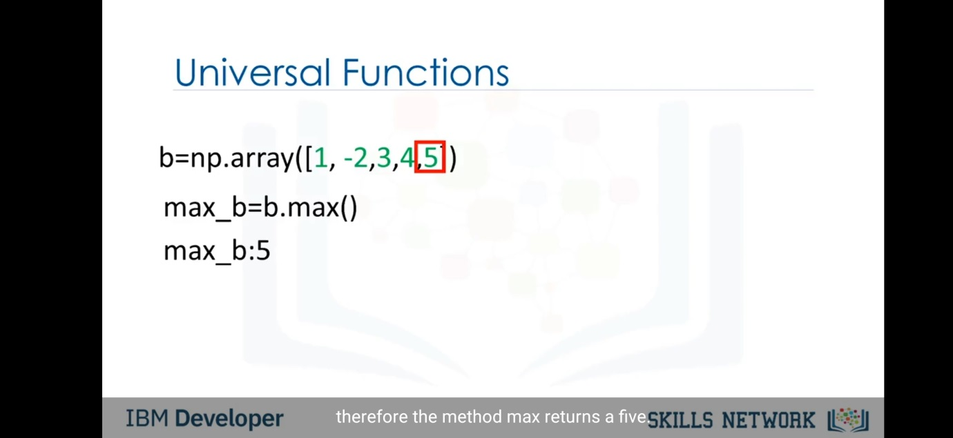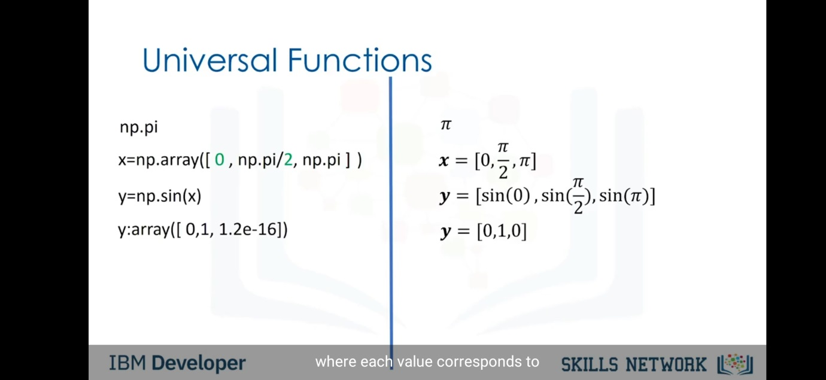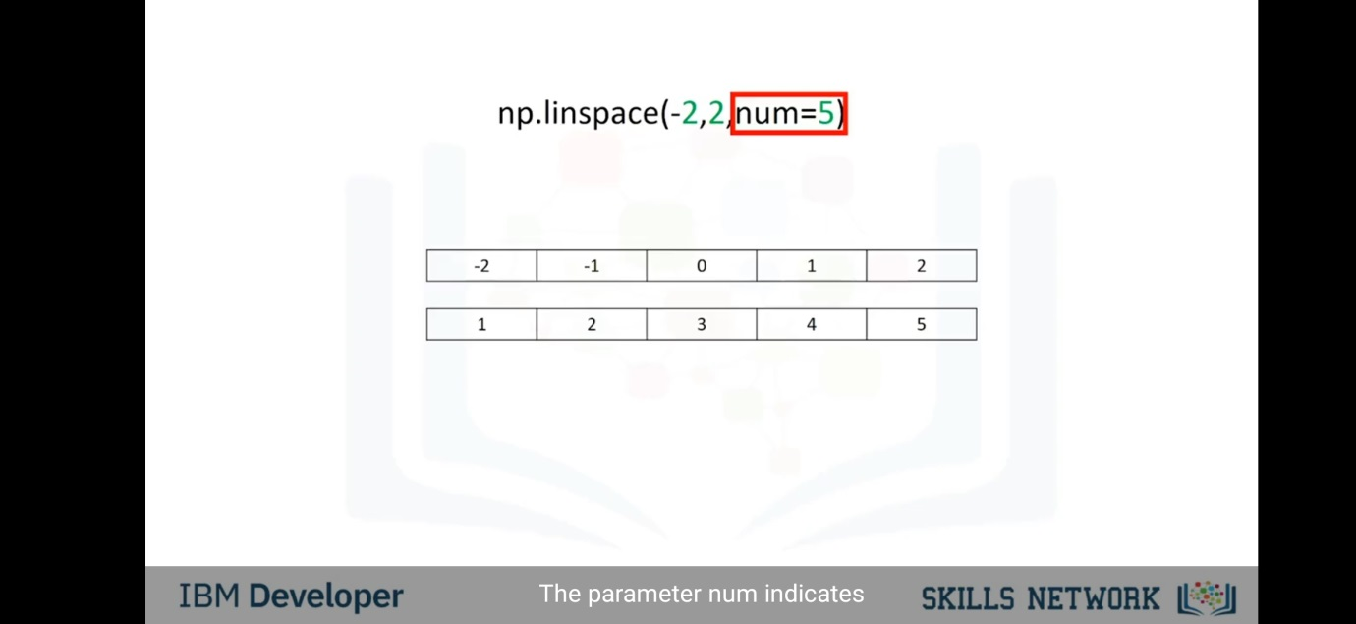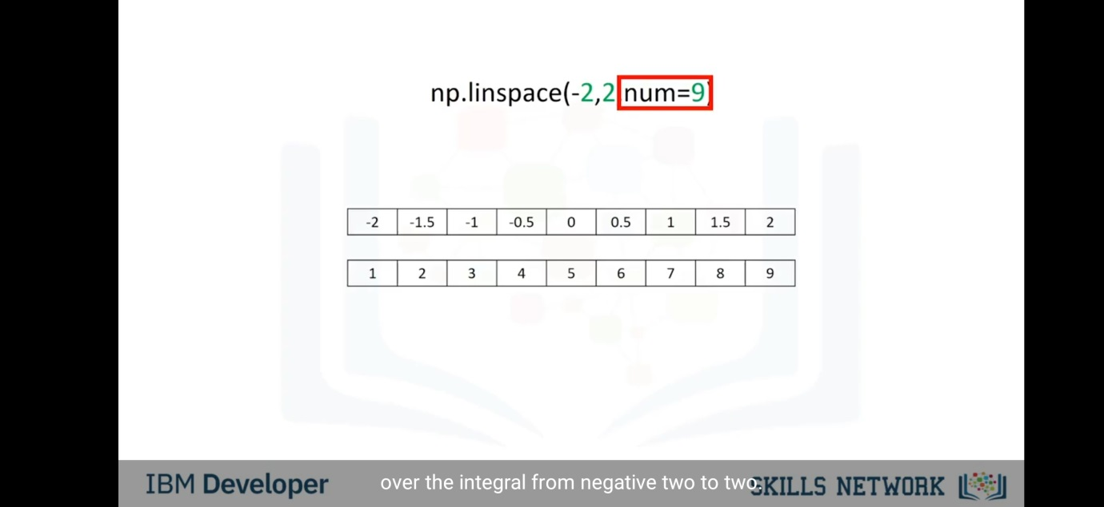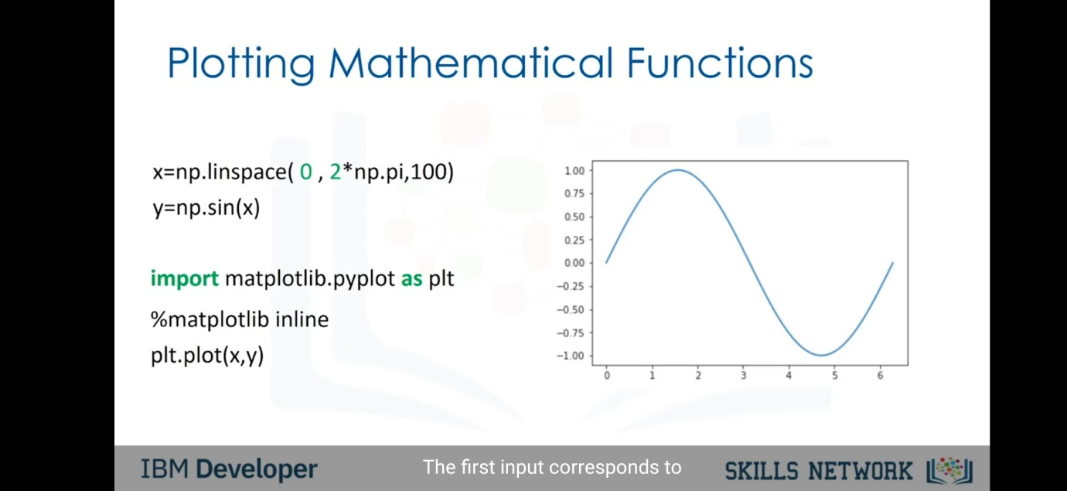

Two Dimensional Numpy-

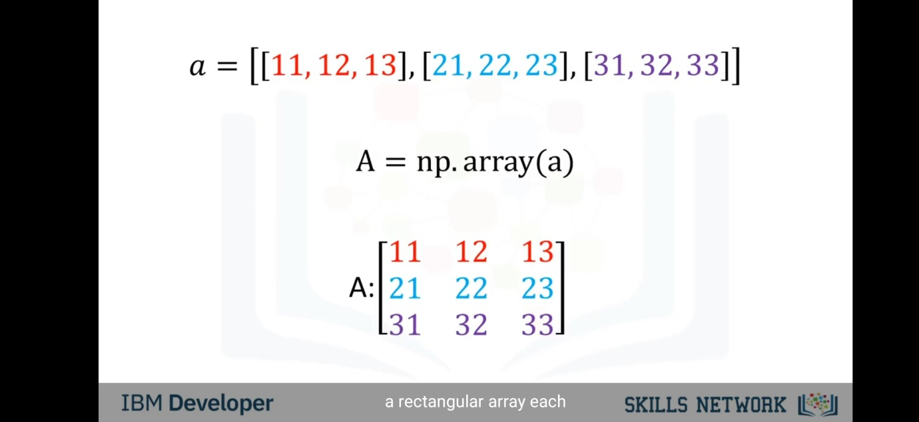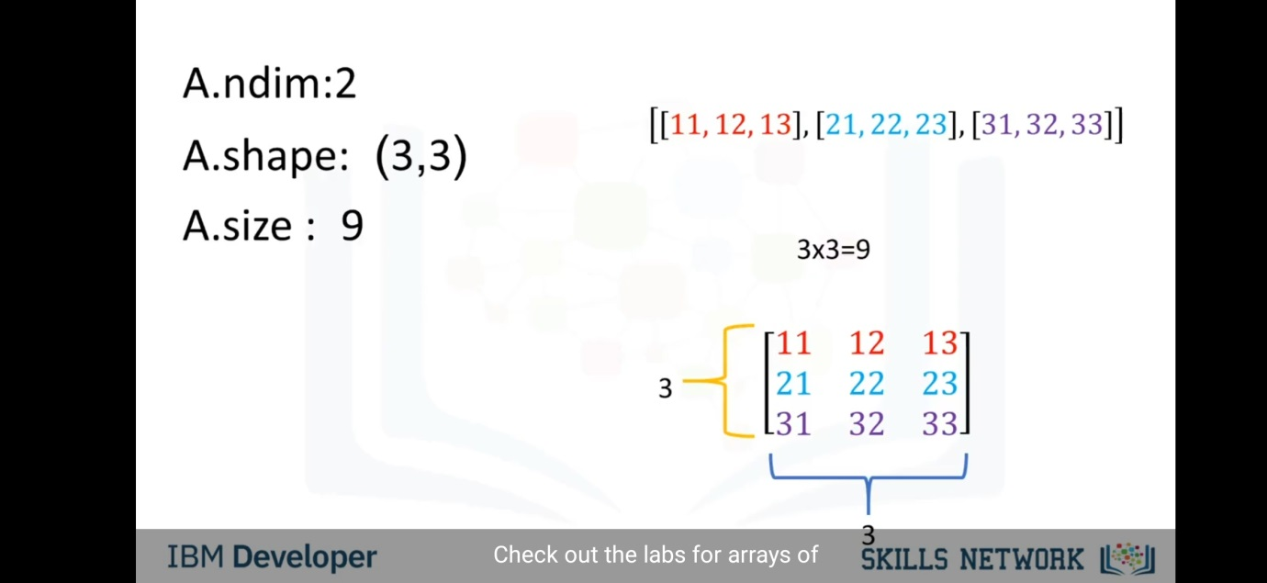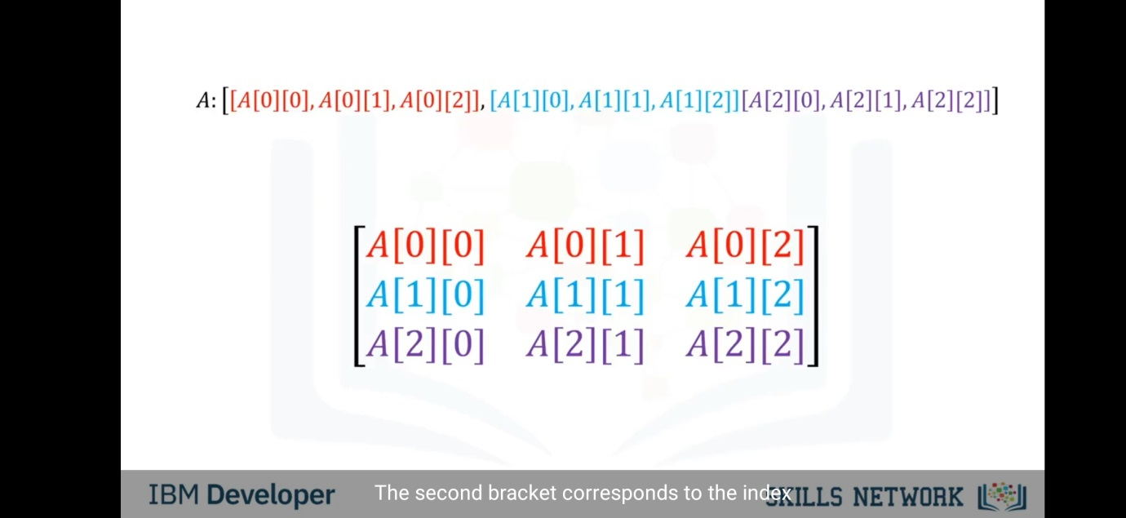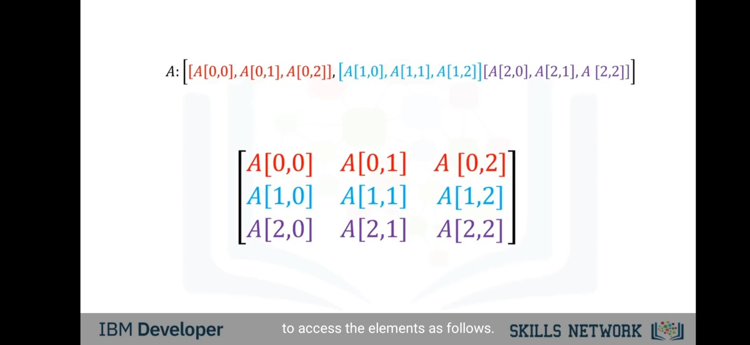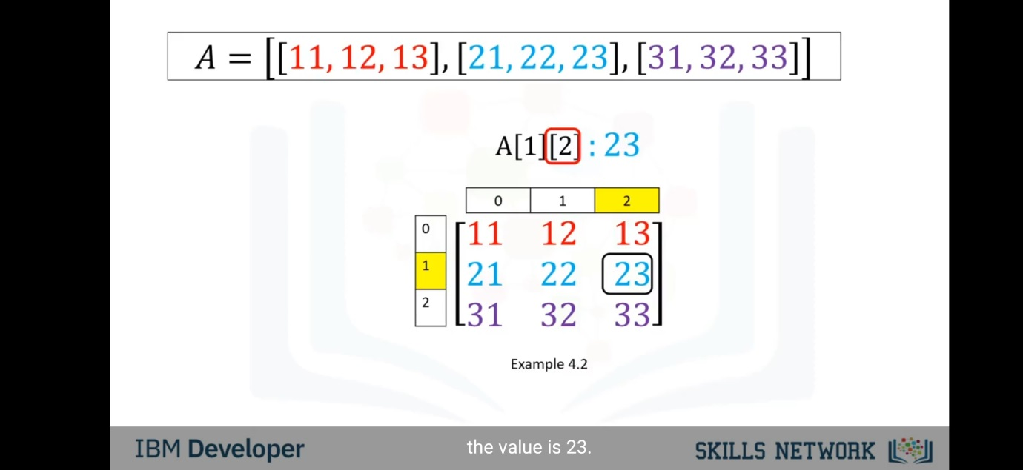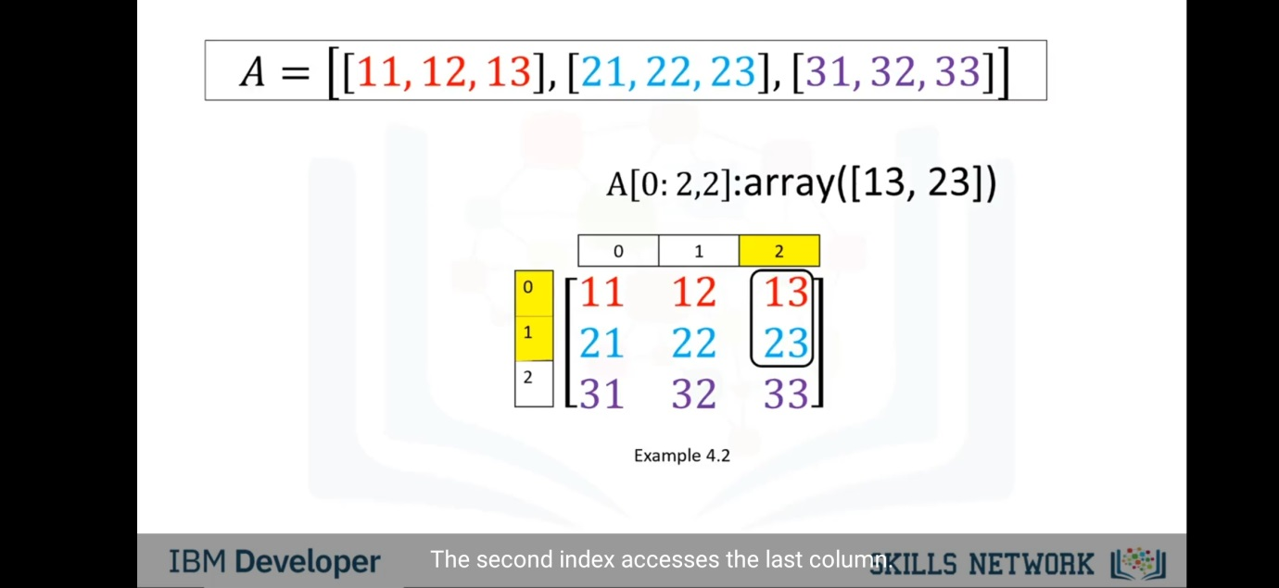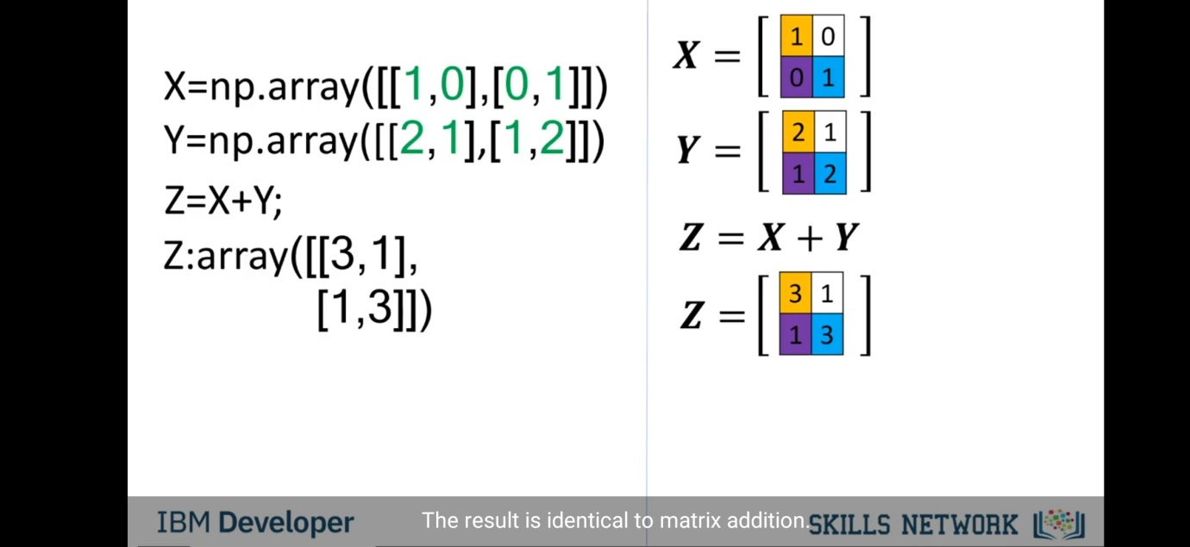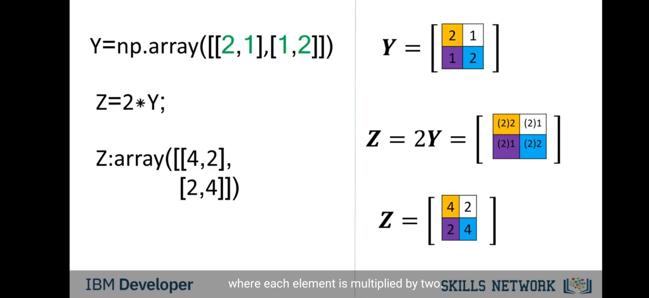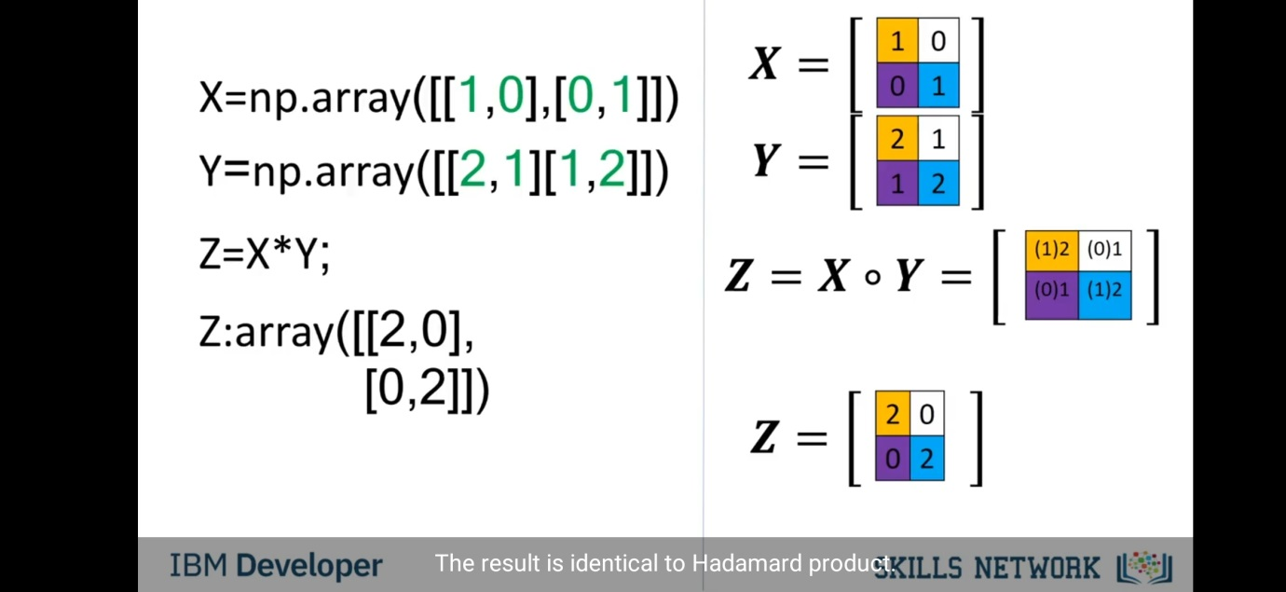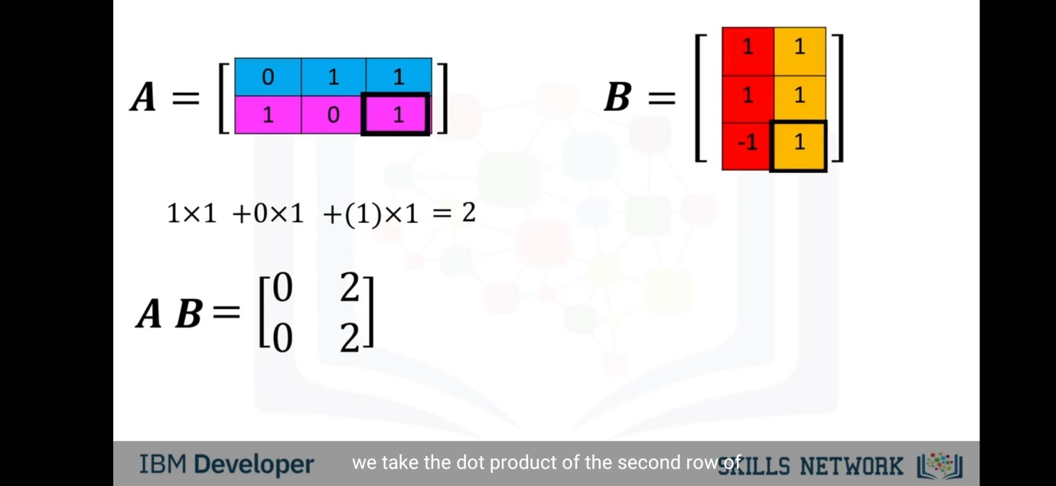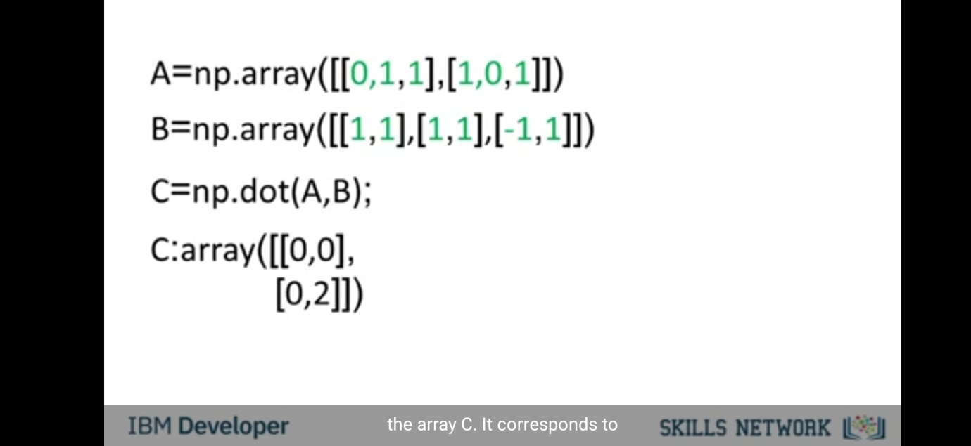

Simple APIs-

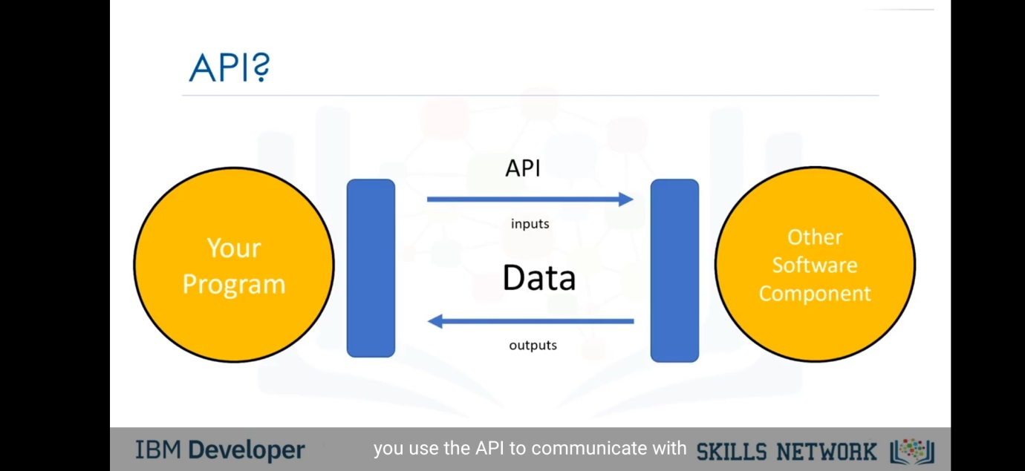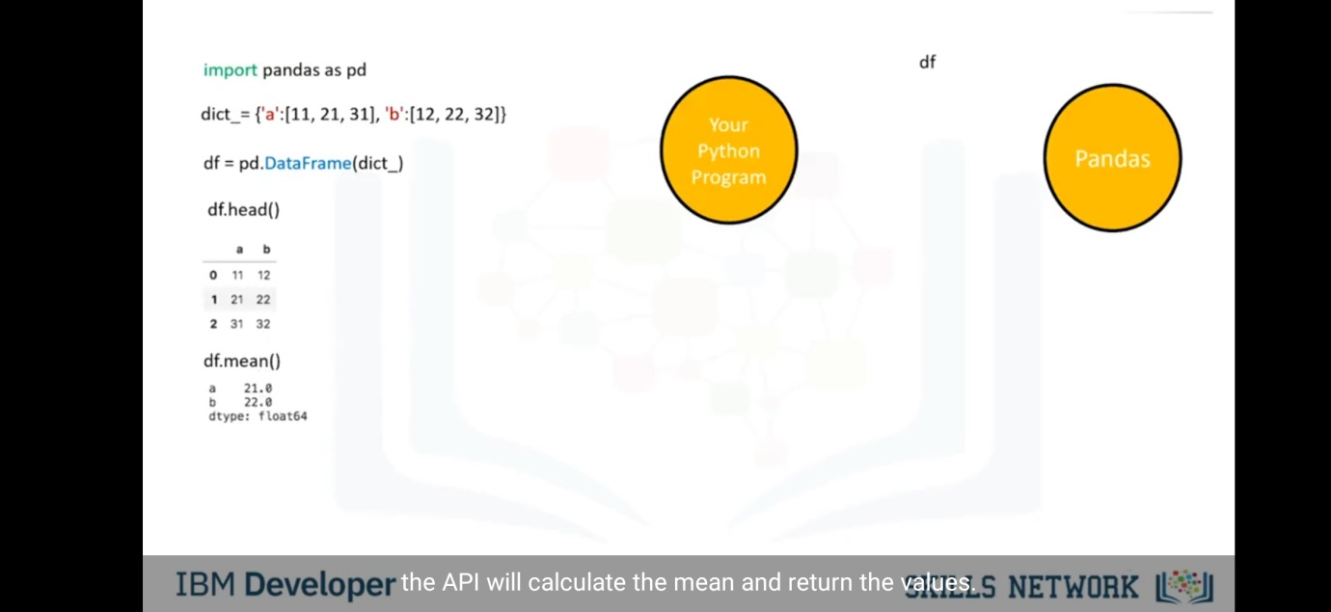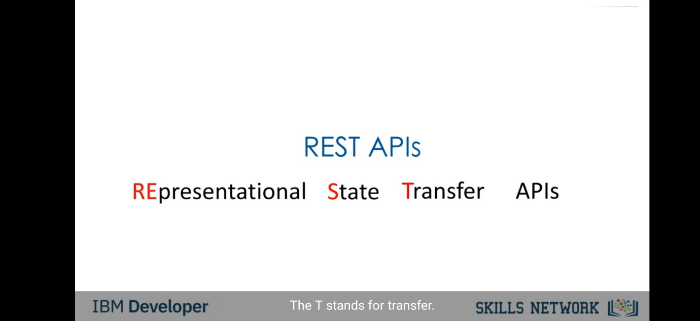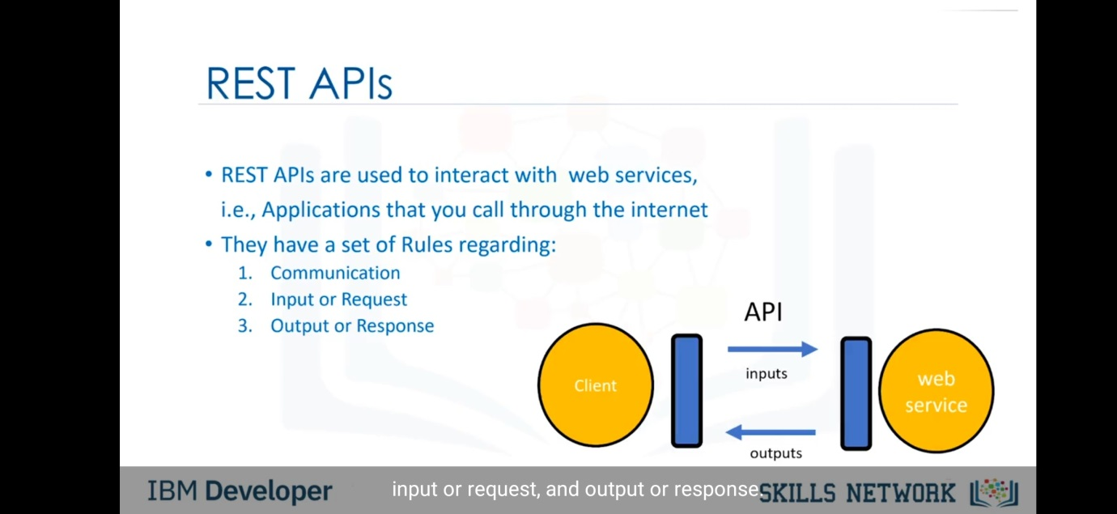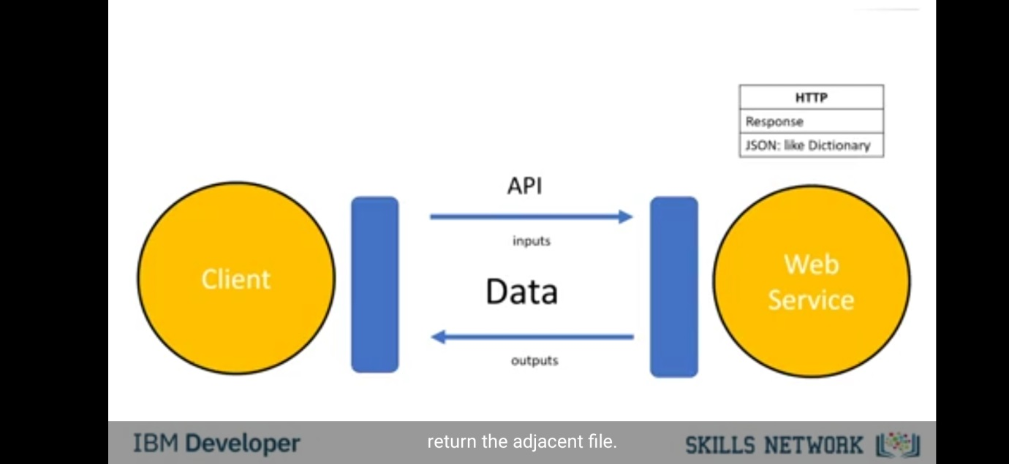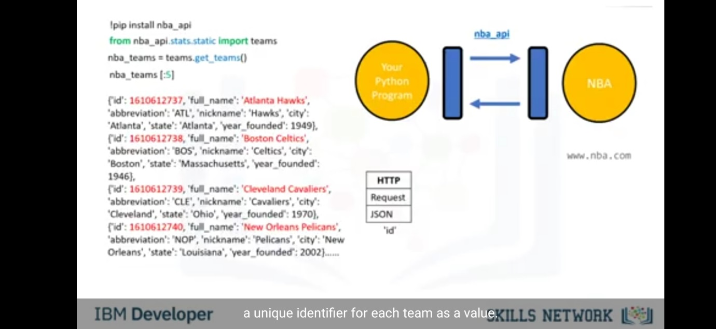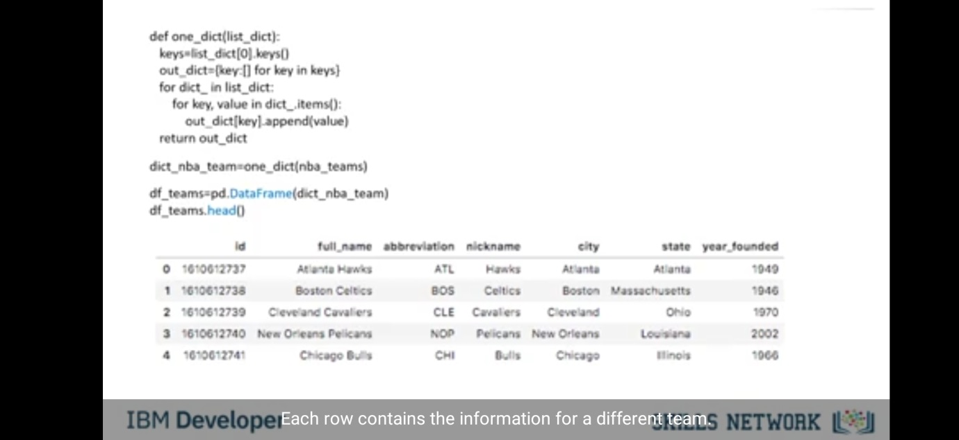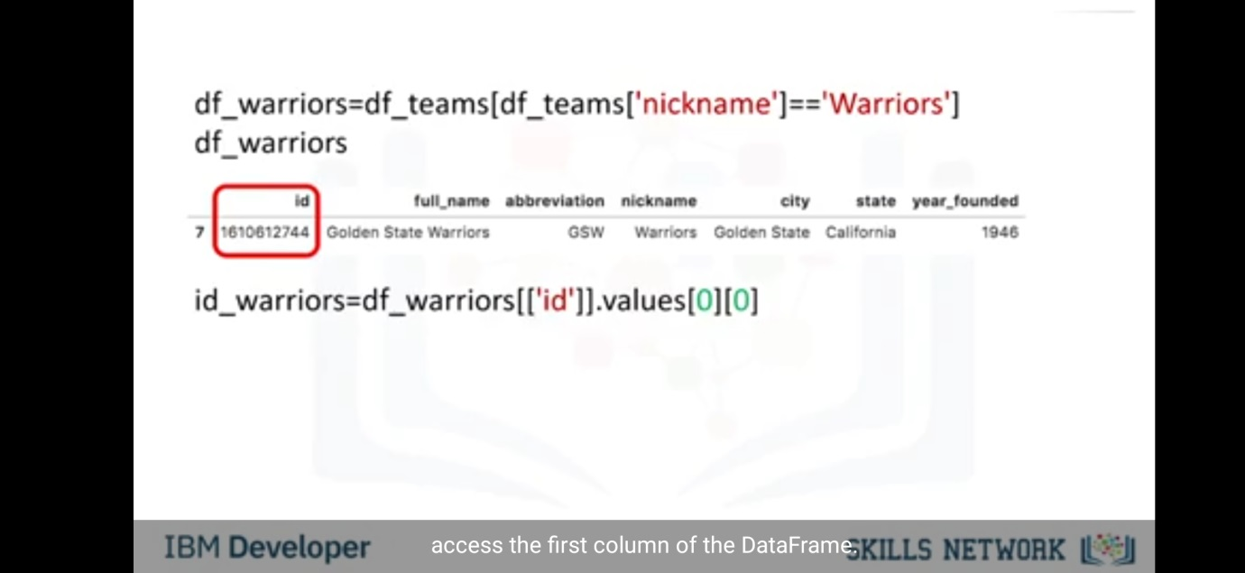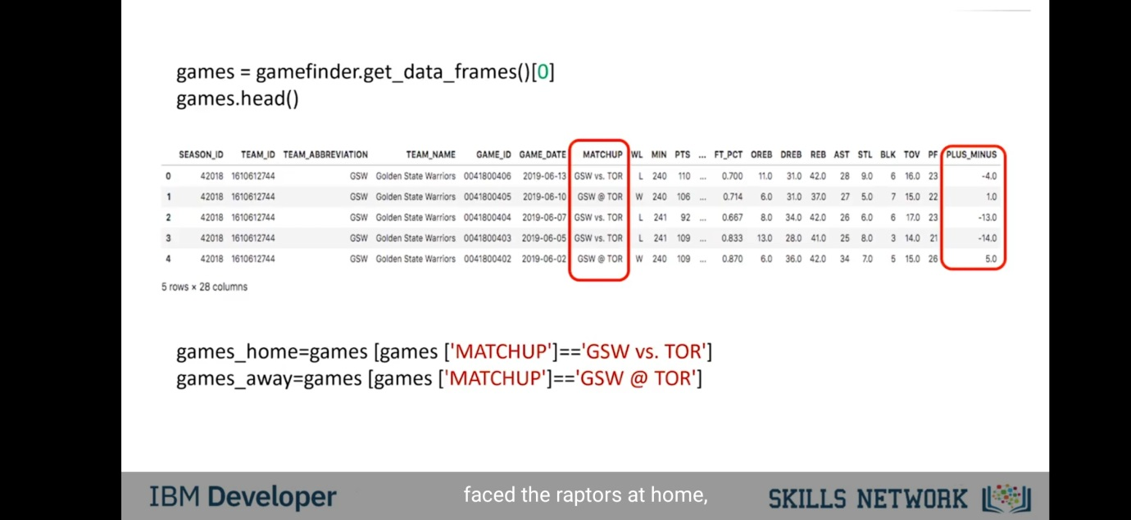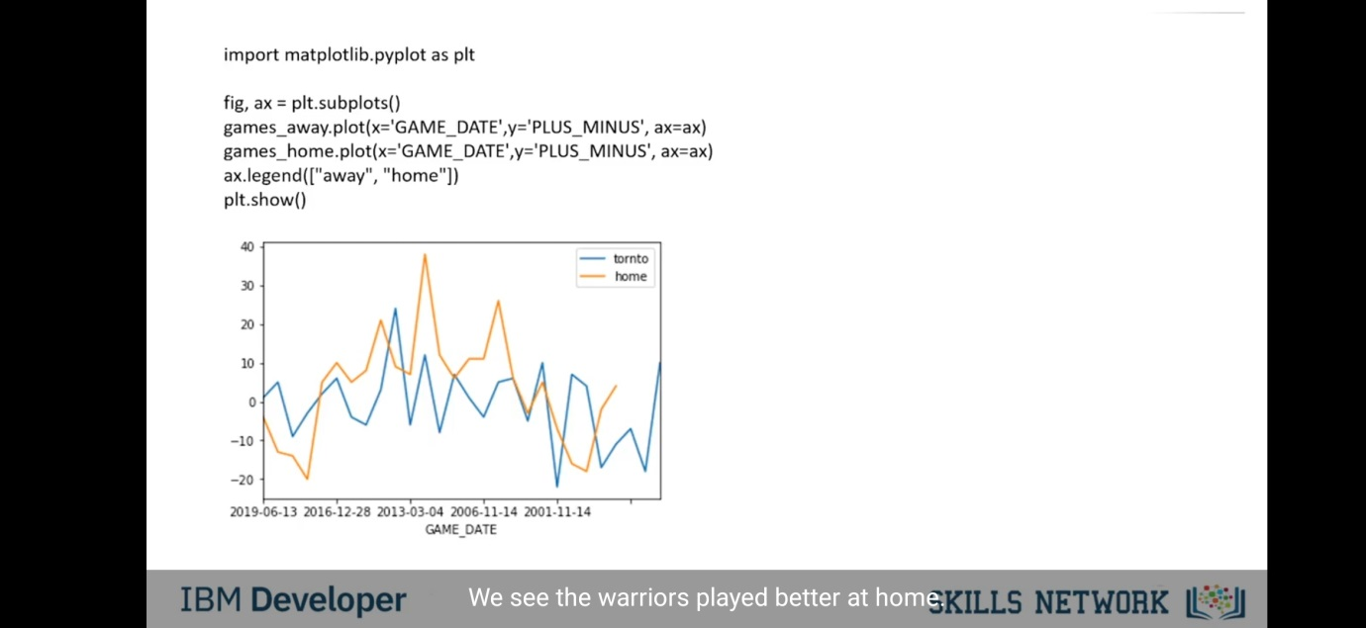

Language translator-

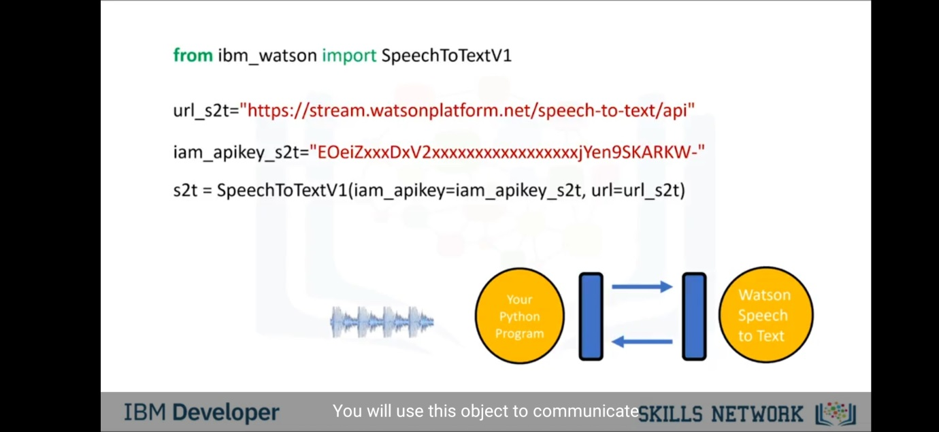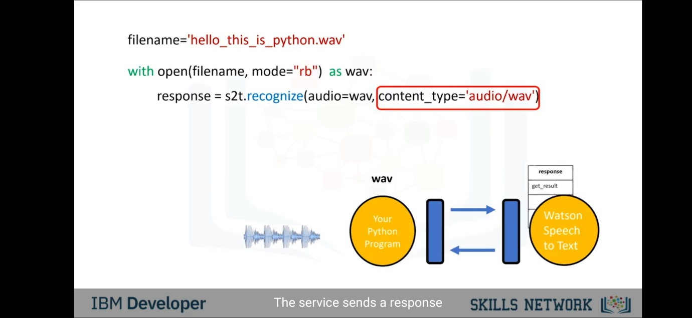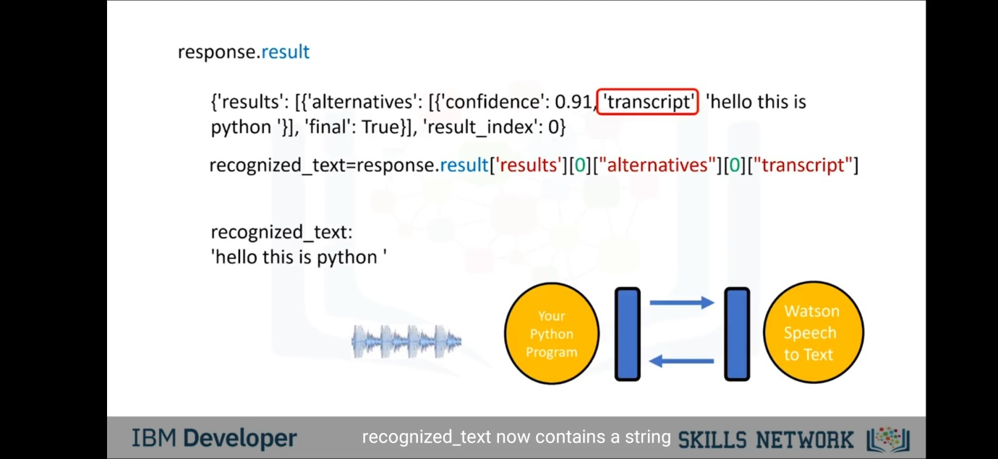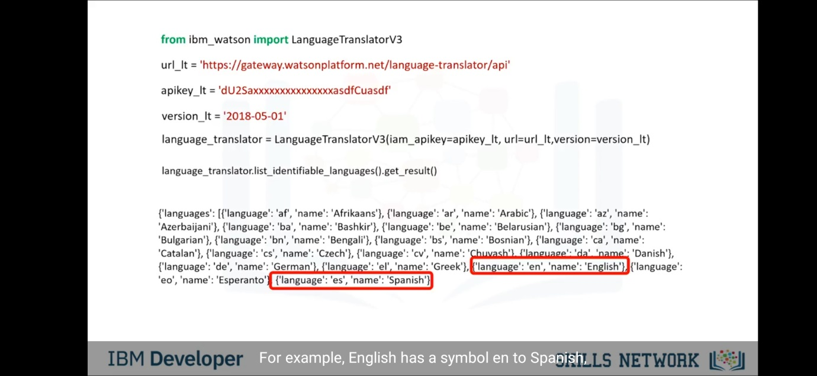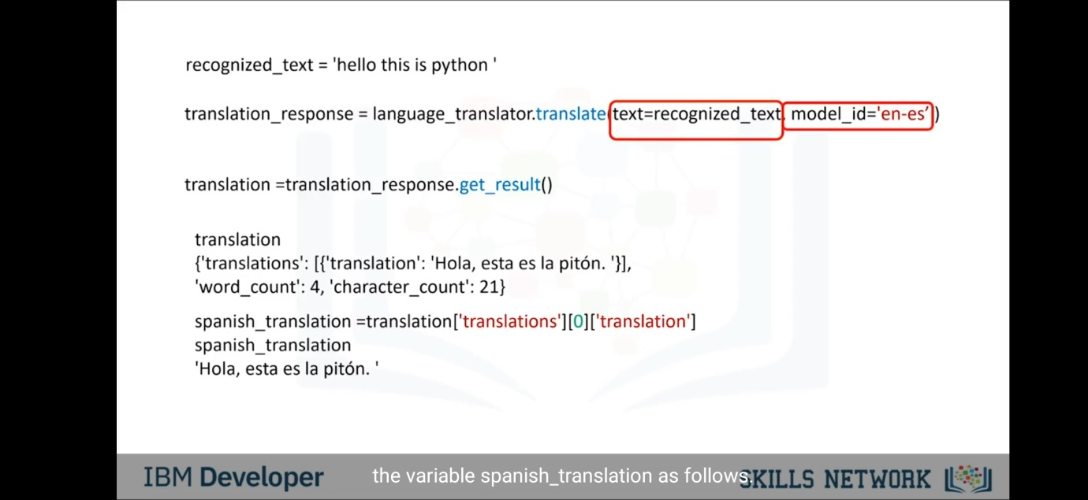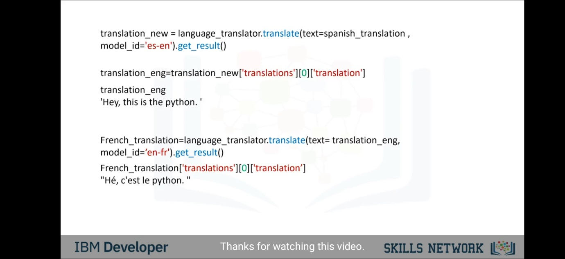

IBM speech to text-

API key-

qRQevebHuYmxunGX6bpSn5-Tsq03Mgas3AXaKsrprT3L

URL-

https://api.eu-gb.speech-to-text.watson.cloud.ibm.com/instances/a0cb7ef6-5a60-46d5-bb07-c4bab026cec2

Project link-

https://eu-gb.dataplatform.cloud.ibm.com/analytics/notebooks/v2/9f0e92bd-9ef3-4839-98d0-a34c4ad9e60f/view?access_token=6e5ad12f199573c7755d44173069d9d9f4b58bbf64cf9ed26940861bc5c04ce9